SUBCOURSE EDITION
OD0973 A

MOTOR POOL OPERATIONS



MOTOR POOL OPERATIONS

SUBCOURSE NO. OD 0973

United States Army Combined Arms Support Command
Fort Lee, Virginia 23801-1809

EDITION A
6 CREDIT HOURS
NEW: 1988

GENERAL

The purpose of this subcourse is to help maintenance managers do their jobs more effectively. It is directed primarily at motor officers--at both company and battalion level. It consolidates much of the information on maintenance management and motor pool operations from many different documents, and presents it in a more usable way.

LESSON 1: TECHNICAL PUBLICATIONS

TASK: Describe the procedures for requesting, recommending changes, and reviewing changes to publications; describe the procedures used to maintain a publications library.

CONDITIONS: You are the motor officer assigned to a battalion motor pool. You are expected to have sufficient training and experience to manage and supervise all functions of the motor pool and maintenance operations, given the necessary references to perform your mission.

STANDARD: Demonstrate your comprehension of the task in accordance with the listed references.

(This objective supports Military Qualification Standard (MQS) task: W3-0001.25-0000 Supervise Use of Publications.)

LESSON 2: SHOP SAFETY

TASK: Identify the potential safety hazards associated with maintenance operations; and describe the requirements for safety education, training, and management.

i

CONDITIONS: You are the motor officer assigned co a battalion motor pool. You are expected to have sufficient training and experience to manage and supervise all functions of the motor pool and maintenance operations, given the necessary references to perform your mission.

STANDARD: Demonstrate your comprehension of the task in accordance with the listed references.

(This objective supports MQS task: W3-0100.25-0000 Supervise Unit Safety Program.)

LESSON 3. POWER GENERATION IN THE FIELD

TASK: Describe the procedures for setting up the power generation site, grounding the generator, connecting and paralleling generators, and operating the power generation site.

CONDITIONS: You are the motor officer assigned to a battalion motor pool. You are expected to have sufficient training and experience to manage and supervise all functions of the motor pool and maintenance operations, given the necessary references to perform your mission.

STANDARD: Demonstrate your comprehension of the task in accordance with the listed references.

(This objective supports MQS task: 02-4890.25-0000 Supervise Power Generation Operations.)

LESSON 4. THE ARMY OIL ANALYSIS PROGRAM

TASK: Describe the methods used to supervise the Army Oil Analysis Program.

CONDITIONS: You are the motor officer assigned to a battalion motor pool. You are expected to have sufficient training and experience to manage and supervise all functions of the motor pool and maintenance operations, given the necessary references to perform your mission.

STANDARD: Demonstrate your comprehension of the task in accordance with the listed references.

(This objective supports MQS task: 03-4960.25-0000 Supervise Unit Oil Analysis Program.)

ii

LESSON 5. MAINTENANCE MANAGEMENT PROCEDURES

TASK: Delineate the methods of maintenance supervision and management used by motor officers in the operation of motor pools.

CONDITIONS: You are assigned as a motor officer for a unit level motor pool. You are expected to have sufficient training and experience to supervise and manage all functions of the motor pool and maintenance operations, given the necessary references to perform your mission.

STANDARD: Demonstrate your comprehension of the task in accordance with the listed references.

(This objective supports MQS tasks: 03-4965.25-0000 Supervise Unit Maintenance Operations and 03-4975.25-0000 Supervise Unit TAMMS Records.)

LESSON 6. RECOVERY OPERATIONS

TASK: Describe the supervisory procedures for monitoring recovery operations.

CONDITIONS: You are assigned as the main support battalion motor pool officer in a command that has both wheeled and tracked vehicles assigned. Your unit is located in a battle area near enemy forces. As the motor officer, you incur an additional duty as the recovery manager, given the necessary references to perform your mission.

STANDARD: Demonstrate your comprehension of the task in accordance with the listed references.

(This objective supports MQS task: 02-4995.25-0000 Supervise Recovery Operations.)

iii

TABLE OF CONTENTS

Section Page

TITLE PAGE i

TABLE OF CONTENTS iv

INTRODUCTION ix

LESSON 1: TECHNICAL PUBLICATIONS 1

Learning Event 1: Describe the procedures for
requesting, recommending changes, and reviewing
changes to publications 2

Learning Event 2: Describe the procedures used to
maintain the publications library 8

Practice Exercise 1 15

Answers to Practice Exercise 1 17

LESSON 2: SHOP SAFETY 18

Learning Event 1: Identify potential safety hazards
associated with maintenance operations 19

Learning Event 2: Describe the requirements for
safety education, training, and management 34

Practice Exercise 2 51

Answers to Practice Exercise 2 53

LESSON 3: POWER GENERATION IN THE FIELD 54

Learning Event 1: Describe the procedures used to
setup the power generation site 55

Learning Event 2: Describe the procedures for
monitoring the grounding of generators 61

iv

Learning Event 3: Describe the procedures used to
connect/parallel power generators 64

Learning Event 4: Describe the procedures used in
operating the power generation set 73

Practice Exercise 3 77

Answers to Practice Exercise 3 79

LESSON 4: THE ARMY OIL ANALYSIS PROGRAM 80

Learning Event 1: Describe the methods used to
supervise the Army Oil Analysis Program 81

Practice Exercise 4 91

Answers to Practice Exercise 4 93

LESSON 5: MAINTENANCE MANAGEMENT PROCEDURES 94

Learning Event 1: Describe the procedures for
preparing briefings and after action reviews on
maintenance matters 95

Learning Event 2: Describe the procedures used when
coordinating maintenance operations and technical
assistance visits with the staff 105

Learning Event 3: Describe the procedures used to
monitor the training of subordinates; including on-
the-job training and cross training 112

Learning Event 4: Describe the procedures used in
supervising preventive maintenance checks and
services (PMCS) 118

Learning Event 5: Describe the procedures used in
supervising the maintenance of TAMMS records; to
include the use of DA Form 2402, DA Form 2408-14, and
the equipment daily log (DA Form 2401) 122

Learning Event 6: Describe the procedures used in
monitoring the application of MWO/PIP and associated
records 130

Learning Event 7: Describe the procedures used to
review the Motor Vehicle Accident Report (SF 91) 135

v

Learning Event 8: Describe the procedures used when
filling out and reviewing the unit Materiel Readiness
Report (DA Form 2406) 140

Practice Exercise 5 147

Answers to Practice Exercise 5 150

LESSON 6: RECOVERY OPERATIONS 151

Learning Event 1: Describe the supervisory
procedures used to monitor recovery operations 152

Practice Exercise 6 166

Answers to Practice Exercise 6 168

vi

INTRODUCTION

Organizational maintenance is that maintenance which is the responsibility of, and is performed by, a using organization on its assigned equipment. This is one of the responsibilities of the motor officer. He is measured by how well the supported user's equipment remains in operation and by how quickly it can be returned to service if it becomes inoperable.

However, another important part of his position is his management capabilities. If personnel lack skill, he must train them. If personnel lack motivation, he must motivate them. If supervision is weak, he must improve it. If management is weak, he must get his house in order. If resources are inadequate, he must find out why and do something about it. If command emphasis is lacking, he must communicate to commanders the importance of their involvement in maintenance.

Maintenance and management skills are equally necessary for the proper development of a professional motor officer. This subcourse is designed to present information to improve both aspects of the motor officer's mission.

vii

OD0973 - Lesson 1/Learning Event 1

LESSON 1

TECHNICAL PUBLICATIONS

TASK

Describe the procedures for requesting, recommending changes, and reviewing changes to publications; describe the procedures used to maintain a publications library.

CONDITIONS

You are the motor officer assigned to a battalion motor pool. You are expected to have sufficient training and experience to manage and supervise all functions of the motor pool and maintenance operations, given the necessary references to perform your mission.

STANDARD

Demonstrate your comprehension of the task in accordance with AR 310-1, DA Pam 25-30, DA Pam 310-10, DA Pam 310-13, FM 29-2, and FM 43-1.

REFERENCES

AR 310-1
DA Pam 25-30
DA Pam 310-10
DA Pam 310-13
FM 29-2
FM 43-1

INTRODUCTION

The Army's maintenance mission requires many supporting publications. Maintenance managers, mechanics, and

1

OD0973 - Lesson 1/Learning Event 1

operators need information about administration, supplies, and maintenance of equipment.

The commander, the unit publications officer, and the unit publications clerk have the primary responsibility for the maintenance of the unit's publications. However, the motor officer should be familiar with the procedures for ordering, suggesting changes, and maintaining the publications and forms used within the motor pool or maintenance shop.

Learning Event 1:
DESCRIBE THE PROCEDURES FOR REQUESTING, RECOMMENDING CHANGES, AND REVIEWING CHANGES TO PUBLICATIONS

THE STANDARD ARMY PUBLICATIONS SYSTEM

The Standard Army Publications System (STARPUBS) is the system that supplies Department of the Army (DA) publications and blank forms Army-wide. This system includes the printing, storage, and distribution of DA publications and blank forms. It also includes the management of all DA and field printing programs.

STARPUBS is managed by the Publications Directorate of The Adjutant General's Office (TAGO) in Alexandria, Virginia.

Publications Centers

There are two U.S. Army AG Publications Centers (USAAGPC): the Baltimore and St. Louis Publications Centers. The centers are supply depots. They stock DA publications and blank forms, and distribute them to units Army-wide.

The Baltimore Publications Center distributes administrative and training publications. The St. Louis Publications Center distributes technical and supply publications.

Both centers distribute blank forms to units that are authorized blank forms accounts. Each center supplies forms to units in different geographical areas. Units must have an account with both centers to receive all needed publications and blank forms. Consult your local SOP, DA Pam 310-10, or your unit's publications officer if an account is needed.

2

OD0973 - Lesson 1/Learning Event 1

Distribution of Publications

Publications are distributed in two ways: initial distribution and resupply.

Initial Distribution. Initial distribution is a one-time issue of new and revised publications and changes to publications. When new or revised publications or changes to publications are printed, copies are sent automatically to the units that previously submitted requisitions for them.

Resupply. Resupply is a system for requisitioning publications. It is used as a back-up to initial distribution. If you need to replace a publication your unit has been issued, use resupply to requisition the copies you need. Resupply is also used to order publications that your unit does not normally receive through initial distribution.

REQUESTING PUBLICATIONS

Resupply is normally the method that the motor officer would use to replace lost or worn-out publications. Also, it can be used to requisition missing current publications for your motor pool reference library. Therefore, the resupply method will be the only method covered in this subcourse.

If you need information concerning initial distribution, the DA Form 12 series, or management of publications accounts, consult DA Pam 310-10, or your unit's publications officer.

DA Pam 25-30

DA Pam 25-30 provides a single reference for all Army publications and blank forms in microfiche format. It identifies Army regulations, special regulations, circulars, pamphlets, posters, Joint Chiefs of Staff publications, and general orders.

It also identifies sources such as field manuals, technical manuals, training circulars, training tests, firing tables and trajectory charts, tables of organization and equipment, tables of distribution, and tables of allowances.

DA Pam 25-30 also lists all changes to the publications listed above.

3

OD0973 - Lesson 1/Learning Event 1

This microfiche should be consulted before requesting any publications or blank forms.

Submitting Resupply Requisitions

DA Form 4569 (figure 1, on the next page) is the only authorized form for requisitioning publications and blank forms directly from the USAAGPC: Baltimore Publications Center. Use DA Form 4569 to requisition all publications and forms, including classified and sensitive-controlled publications.

Reviewing DA Form 4569

There are 63 columns on DA Form 4569. You should ensure that the columns are completed as follows:

COLUMN ACTION
1-5 Enter the five position account number
assigned by the Baltimore Publication
Center. Position 1 should always be a
letter, not a number.

7 Enter a one-position code to show who in
the unit ordered the publication. This
code is usually established by the
publications officer.

9 Leave blank.

11-38 Enter the type of publication or form
you need and its number.

40-42 Use this column for publications only.
Use one of the following codes:

000-Ship only the basic publication.

001-899-Ship only the change listed.
Always use a three digit number (i.e., C1
would be 001, C10 would be 010, etc.).

901-999-Use these numbers for
interim changes. I02 would be 902, I09
would be 909, etc.

ALL-Ship the basic publication and
all changes.

4

OD0973 - Lesson 1/Learning Event 1

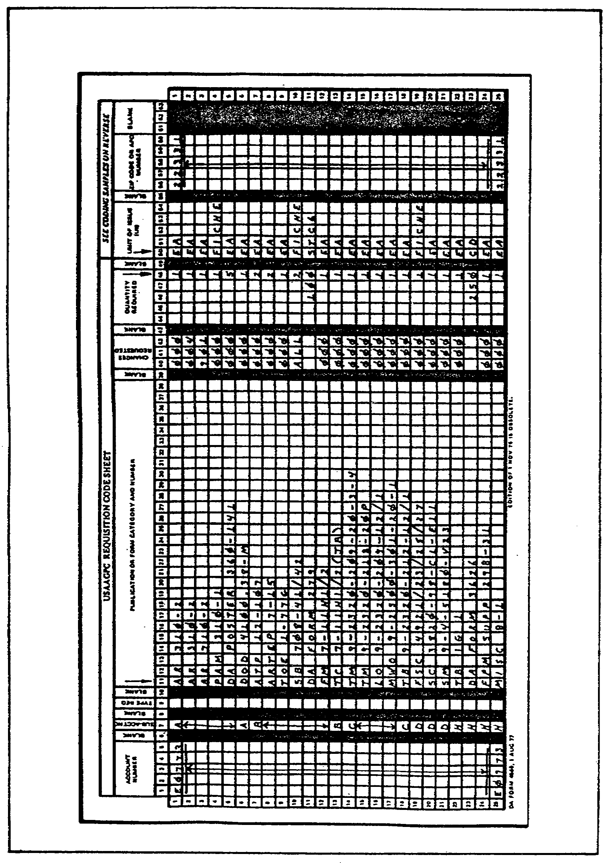

FIGURE 1. COMPLETED DA FORM 4569.

5

OD0973 - Lesson 1/Learning Event 1

COLUMN ACTION

44-48 Enter the number of copies that you
need. Do not put zeroes before any
numbers.

50-54 Enter the unit of issue for the item
requested.

56-60 Enter your zip code or APO number.

The DA Form 4569 is now complete. After processing the form through the publications clerk, the DA Form 4569 will be sent to the USAAGPC.

Ordering Equipment Publications

To order equipment publications, you should know something about the way they are numbered. They have a four part number (for example, TM 55-1520-209-20). The last two-digits indicate the maintenance level covered by the publication. These maintenance levels are as follows:

-10 Operator maintenance.

-20 Unit maintenance.

-30 Intermediate direct support maintenance (IDS).

-40 Intermediate general support maintenance (IGS).

-12 Operator and unit maintenance.

-13 Operator through intermediate direct support
maintenance (IDS).

-14 Operator through intermediate general support
maintenance (IGS).

-23 Unit and intermediate direct support maintenance
(IDS).

-24 Unit through intermediate general support maintenance
(IGS).

-34 Intermediate direct support and intermediate general
support maintenance (IDS/IGS).

6

OD0973 - Lesson 1/Learning Event 1

Some other helpful information on equipment publications is given below.

o A "P" is sometimes added to the number. A "P" means that the manual is a repair parts and special tool list (RPSTL). If a manual has an "& P" added to the last number, it is a maintenance manual that includes a RPSTL.

o Generally, companies and battalions are authorized only operator and unit level maintenance manuals (-10, -12, and -20 manuals). Unless authorized by local commanders, companies and battalions should not order IDS/IGS maintenance manuals (-30, -34, and -40 manuals).

o Instead of ending in a two-digit number, some manuals end with letters. Most of these manuals are for aircraft and aviation units. The meanings of these letters are as follows:

-CL Pilot and crewmember checklist

-ESC Equipment serviceability criteria

-HR Hand receipt

-L List of applicable publications

-LD Laminated diagram

-MTF Maintenance test flight

-OP Operating procedures

-PM Phased maintenance inspection checklist

-PMD Preventive maintenance daily inspection checklist

-PMS Preventive maintenance services

-S Preparation for shipment

POSTING PUBLICATIONS

When changes are received, they are posted to the basic copies of the publications on hand. DA Pam 310-13 provides guidance on posting publications. Since publications should be kept current, maintenance personnel should be trained in these procedures. The basics of posting publications will be discussed in the next learning event.

7

OD0973 - Lesson 1/Learning Event 2

RECOMMENDING CHANGES TO PUBLICATIONS

Publications users are encouraged to submit recommended changes, suggested improvements, and reports of errors. Use a separate DA Form 2028 (Recommended Changes to Publications and Blank Forms) for each publication.

Give a brief reason for each proposed change or comment to ensure a proper evaluation. If there is not enough space on the form for all comments, use blank sheets of paper as continuation pages.

Complete the DA Form 2028 and send it direct to the proponent shown in the publication. If the proponent is not shown and cannot be found in the indexes or other sources, send the DA Form 2028 to HQDA (DDAG-PAP) Washington DC 20314.

This completes the first learning event. You should be familiar with procedures used in requesting publications, recommending changes to publications, and with the importance of posting changes to your publications.

In the next learning event, the methods of maintaining your publications library will be discussed.

Learning Event 2:
DESCRIBE THE PROCEDURES USED TO MAINTAIN THE PUBLICATIONS LIBRARY

Publications should be available for the people who need them. Administrative publications should be kept in the company headquarters. Maintenance manuals should be kept in the shop office and the shop area, and supply manuals in the supply room. A central library may be needed for larger units.

The motor officer should be familiar with the procedures for maintaining the publications that will be used by the maintenance and administrative personnel under his supervision. In this learning event, the procedures for filing and updating these publications will be discussed.

FILING PUBLICATIONS

Usually, publications are filed by two methods: filing all publications of a certain type together, and filing publications according to their function. We will discuss both methods in the following paragraphs.

8

OD0973 - Lesson 1/Learning Event 2

Filing by Type

Generally, publications should be separated and filed by type (all Army regulations together, all pamphlets, all field manuals, all technical manuals). Within each type, they are filed numerically. When letters are added, they are filed numerically-alphabetically. The following is an example of a proper filing arrangement of technical manuals:

TM 9-2320-209-10
TM 9-2320-209-20
TM 9-2320-209-20P
TM 9-2320-253-20-1
TM 9-2320-253-30-1
TM 9-2320-255-20-1-2-1
TM 9-2320-273-BD

Filing by Functional Use

Because of the mission or other requirements, in some units, it may be desirable to file publications functionally. All publications on a given subject may be grouped together.

For example, all publications pertaining to a certain type vehicle may be filed together for easier reference. In this case, all technical manuals, technical bulletins, lubrication orders, and modification work orders for that vehicle would be together in one location.

Use of Ring Binders

Most publications have prepunched holes for filing in ring binders. Three-ring binders are particularly suitable for loose-leaf publications because pages can be removed and inserted easily. This will aid in posting changes. Some bound publications are of such size that they cannot be filed in binders. The number is printed on the spine so the publication can be identified without removing it from the shelf.

If binders are used, label each one to show its contents.

Do not use permanent marking materials on the spine or cover of the binder. Such markings make reuse of the binder difficult if the contents should change. Preferred methods are to use metal slip-on label holders, or attach labels to the spine with transparent tape. Gummed labels may also be used when no other suitable material is available. However, gummed labels are hard to remove when relabeling is necessary.

9

OD0973 - Lesson 1/Learning Event 2

Publications of Different Sizes

Although most publications are 8" x 10 1/2", the Army prints publications in several different sizes because of format requirements or intended usage. Sometimes an odd sized publication cannot be filed in numerical order with other publications in a binder. A sheet containing the number, date, title, and filing location of the odd sized publication should be inserted in the binder in proper sequence.

Publications with Expiration Dates

Some types of publications, such as DA circulars, contain automatic expiration dates after which they are no longer in effect. Files of such publications should be reviewed periodically, or individual items should be flagged, so that expired publications can be removed and destroyed.

POSTING CHANGES TO PUBLICATIONS

Publications lose most of their value if they are not kept up-to-date. For this reason, changes and revisions are issued to furnish new information to the user. To make the reader aware of this information, a publication must be properly posted. Imagine what could happen if a decision was based on a publication that had been changed, but the changes had not been posted. Posting means to read the change and do as it directs. It may require that information be added, deleted, or modified.

Scope of Posting

Although adequate posting is important, elaborate and detailed posting wastes man-hours. Discretion must be used as to the extent of posting. Many times, not all publications on file need to be completely posted. Instead, effort should be directed to the publications which are used with a frequency that warrants the time expended.

It might be sufficient for seldom used publications merely to file the changes with the basic publication. Judgment, based on experience, should help you determine the extent of your posting.

10

OD0973 - Lesson 1/Learning Event 2

Explanation of Terms

Before presenting the information on posting techniques, review the explanation of terms associated with the publication system.

Basic. An original publication, without changes.

Change. A separate publication containing amendments in the form of deletions, alterations, or additions to portions of a basic publication.

Posting. The method of keeping publications up-to-date by entering the directed changes as they occur.

Revision. A complete new edition of a publication. It replaces the previous edition in its entirety, including any changes.

Supersede. To make a substitution. To replace an entire publication, chapter, paragraph, figure, or appendix with something new.

Rescind. To do away with. A publication, or a portion thereof, is rescinded when it has served the purpose for which it was issued, or when the material has become obsolete.

Amend. To change or correct. Any change is an amendment.

Loose-leaf Format. A publication that can easily be taken apart. When changes are necessary, they are normally issued on a replacement page.

Bound Format. A publication in which the pages are securely held together in such a manner that they cannot be easily removed.

11

OD0973 - Lesson 1/Learning Event 2

Posting Actions Affecting the Entire Publication There are two posting actions that pertain to the entire publication and/or its changes; these are rescissions and supersessions.

Rescissions. Notification that an entire publication and its changes is rescinded is usually contained in a DA circular in the 310-series (Military Publications). Upon receipt of a rescission notice, check the list of rescissions against your publications file. Remove those publication that have been rescinded. Destroy all rescinded publications.

Supersessions. An entire publication may be superseded by an updated version of the same publication, or by another publication. This information is contained in a supersession notice in the new publication. You must read the supersession notice carefully to make sure that the publication is superseded in its entirety and not just in part. Destroy all publications that have been superseded in their entirety.

A change to a publication may supersede a previous change or another publication. Check the bottom of the first page of the change for any such supersession notice. Destroy all changes and publications that are totally superseded.

General Rules for Posting

For more detailed information on posting changes to bound and loose-leaf publications, refer to DA Pam 310-13. The following are some general rules for posting changes to publications.

o All posting should be neat and accurate. A publication that is illegibly or incorrectly posted is as worthless as one which has not been posted.

o Only a sharp black lead pencil should be used. Posting can then be easily erased if future changes or corrections are necessary.

o The authority for changing a basic publication should be printed or written in the outside margin of the page near the changed portion (figure 2, on the next page).

12

OD0973 - Lesson 1/Learning Event 2
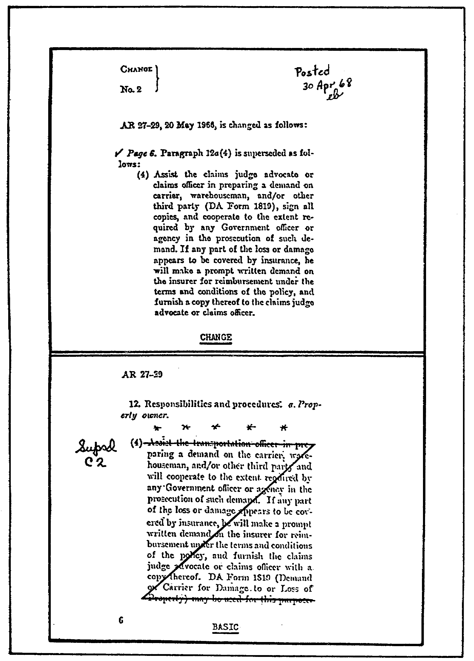

FIGURE 2. POSTING CHANGE TO A PUBLICATION.

13

OD0973 - Lesson 1/Learning Event 2

o When less than three lines of text are affected, a single line should be drawn through the changed or deleted material.

o When three or more lines are affected by the change, the material should. be lined out in the following manner. A single straight line should be drawn through the first and last lines of the text. These lines should be connected with another line from top right to bottom left, forming a "Z" shaped figure (see figure 2, on the previous page).

o Upon receipt of a new change, any previous changes that are affected, as well as the basic publication, should be posted.

o As each change to a publication is received, the change number and the date should be written on the front cover of the basic publication.

Example: C1, 14 Jan 81
C2, 29 Oct 83
C3, 10 Sep 86

o A check mark should be placed by each item on the change as it is posted to the basic. This will prevent overlooking portions of the change if an interruption occurs (see figure 2).

o Upon completion of the posting, the word "Posted", the date, and your initials should be entered at the top of the first page of the change (see figure 2).

o All changes should be filed in front of the basic publication.

As a last reminder, look over all changes after the posting is complete to make sure that everything has been completed. In particular, be sure that any publications that have been superseded or rescinded in their entirety have been removed. Make sure that all posting and filing is performed regularly to keep your publications current. Don't let them accumulate for several weeks. A new publication is worthless to the user if he doesn't know it exists or can't find it.

Now you should be ready to take the practice exercise on the next page. If you have problems with any of the questions, review the text and repeat the exercise.

14

OD0973 - Lesson 1/Practice Exercise 1

PRACTICE EXERCISE 1

INSTRUCTIONS

This practice exercise will show you how much you have learned in this lesson. Answer each question. When you are done, turn the page to check your answers.

SITUATION

You are the new motor officer assigned to a transportation battalion. Upon your arrival, you notice that the publications used for reference in the motor pool have been poorly maintained and are out of date. You take responsibility for updating the publications and starting a working reference publication library.

1. You contact the unit publications clerk for information.
He tells you that the DA 12 series for initial distribution
is up to date. He informs you that it is necessary to use the publications _______________________ system if you need to replace publications that are missing.

2. You must check to see which publications in the motor
pool are current and if any changes have been published.
The primary reference for this information is
____________________ . It provides a single reference for
all Army publications and blank forms in a microfiche format.

3. You are reviewing a DA Form 4569 that your Maintenance
NCO has completed. You have instructed him to order TM 9-2350-252-34 with interim change #3 (IO3). What information should have been placed in column 40 to 42?

A. IO3
B. 003
C. 903
D. 300

15

OD0973 - Lesson 1/Practice Exercise 1

4. You instruct your Maintenance NCO to order manuals for
only operator and unit level maintenance. These are manuals
that end with the last two digits

A. 10, 20, or 30.
B. 10, 12, or 20.
C. 12, 13, or 14.
D. 23, 24, or 34.

5. You have discovered an error in a technical manual that
has recently arrived. To report this error to the proponent
agency, you must use ___________ .

6. Your publications can be filed by two methods. One
method is to file them by the type of publication in
numerical-alphabetical order. The other method is to file
all publications by _______________ ______ . In this
method, all publications on a given subject are grouped
together.

7. Upon review of your publications, you find several
entire manuals that have been superseded or rescinded. What
should be done with these manuals?

8. Your clerk has just completed posting a change to a
technical manual. What three entries should the clerk make
at the top of the first page of the change?

16

OD0973 - Lesson 1/Practice Exercise Answers

LESSON 1. PRACTICE EXERCISE - ANSWERS

1. resupply (page 3, para 3)

2. DA Pam 25-30 (page 3, para 6)

3. C (page 4, para 10)

4. B (page 7, para 3)

5. DA Form 2028 (page 8, para 1)

6. functional use (page 9, para 2)

7. Destroy them (page 12, paras 2 & 3)

8. the word "POSTED", the date, and his initials
(page 14, para 6)

If you had a hard time getting the right answers, go back and review the lesson. If you did well on this practice exercise, you should be ready to start the next lesson.

17

OD0973 - Lesson 2/Learning Event 1

LESSON 2

SHOP SAFETY

TASK

Identify the potential safety hazards associated with maintenance operations; and describe the requirements for safety education, training, and management.

CONDITIONS

You are the motor officer assigned to a battalion motor pool. You are expected to have sufficient training and experience to manage and supervise all functions of the motor pool and maintenance operations, given the necessary references to perform your mission.

STANDARD

Demonstrate your comprehension of the task in accordance with AR 385-30, DA Pam 385-1, and DA Pam 750-35.

REFERENCES

AR 385-30
DA Pam 385-1
DA Pam 750-35

INTRODUCTION

Personnel must always be safety conscious while working in the shop or around equipment. The object of learning event 1 is to familiarize motor officers with the identification of maintenance shop safety considerations and recognition of safety hazards in the shop area.

18

OD0973 - Lesson 2/Learning Event 1

This learning event will also make you aware that accident prevention can be achieved by identifying and eliminating hazardous procedures, operations, or conditions. You should understand how to establish safe practices consistent with military operations.

Learning Event 1:
IDENTIFY POTENTIAL SAFETY HAZARDS ASSOCIATED WITH MAINTENANCE OPERATIONS

ACCIDENT PREVENTION FUNDAMENTALS

Why do so many accidents happen? The following paragraphs will break down what actually causes an accident to happen.

Defining "Accident"

The first step in dealing with any problem is to define it. In its simplest form, "an accident is an unplanned event." For Army purposes, the following phrase is added: "that does damage to persons or property."

It is important to note the distinction between the simple definition and the Army definition. Some accidents do not injure anyone or damage anything, but only causes a delay or interruption to the normal routine. These accidents usually do not have an impact on the mission. Therefore, for accident reporting purposes, the Army is concerned only with accidents that cause injury or damage.

Supervisors, however, must be concerned with interruptions. They are a signal that a problem exists and should be corrected before it results in an accident.

Accident Chain of Events

The chain of events leading to an accident can be visually represented by a domino sequence (figure 3, on the next page). If one domino in the row is pushed, the rest will fall in succession. But if the key domino (UNSAFE ACT OR CONDITION) is removed, the "ACCIDENT" domino does not fall.

In fact, if any one domino coming before the accident domino is removed, the accident does not occur. In the illustration, if the person had not been fatigued, the accident may not have happened.

19

OD0973 - Lesson 2/Learning Event 1

Why was this person performing this task while he was
fatigued? Was he not trained to recognize that fatigue can
cause accidents (lack of safety training)? Did he just not
care (poor attitude toward safety); or was he ordered to do
the job anyway (poor supervision)? These unknown causes
(the domino with the question mark) are factors that good
supervisors consider when they create their safety programs.
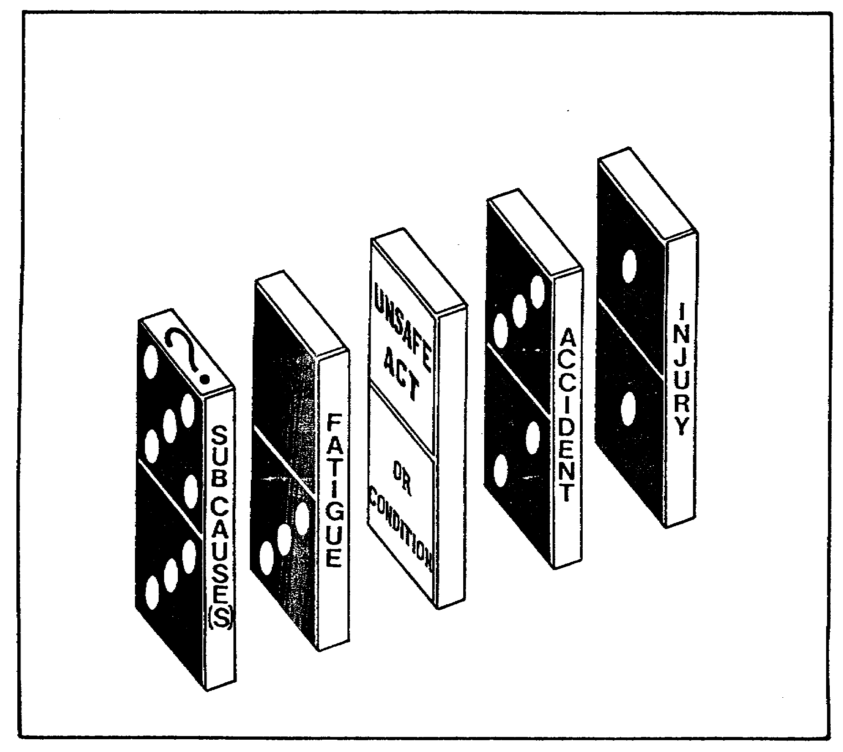

FIGURE 3. ACCIDENT CHAIN OF EVENTS

Chance or Fate

The domino theory points up one of the most important single concepts relating to accident prevention: "most accidents do not occur by chance; they are caused by unsafe actions and conditions." How often have you heard the phrases, "I guess his number came up," or "chalk it up to bad luck"? Such superstitions have no place in accident prevention.

20

OD0973 - Lesson 2/Learning Event 1

Simple or Complex

A second important concept in accident prevention is that accidents are often extremely complex. Usually, an accident has a combination of causes rather than a single cause. Therefore, it is important that each accident be thoroughly investigated to determine all the underlying causes which must be corrected.

CLASSIFYING ACCIDENT CAUSES

There are three basic elements in any accident: the individual injured, the agent (the object or person that caused the injury), and the environment. Any of these three elements, or a combination of them, could be primarily responsible for causing the accident.

The Individual Injured

The "individual injured" is almost always partially to blame when an accident occurs. Safety experts estimate that unsafe behavior accounts for 85 percent of all accidents. Even in the remaining 15 percent of the accidents, human error may be involved.

Why does a stack of heavy cartons in the stock room topple over and crush a man's legs? The answer is because a human stacked the cartons improperly. In addition to being the primary cause of accidents, human behavior is also the most difficult to figure out or change.

The Agent

The "agent" is the object, substance, or person immediately causing the injury. This could include a hammer, cleaning solution, spilt oil, or a person. Remember, determining the agent in an accident is just the first step in accident investigation. To determine the true cause(s) of the accident, it must then be discovered why the agent was involved. Why was the hammer used, or stored, or stored improperly? Why was grease or oil left on the floor?

The Environment

Environment refers to the physical surroundings in which an accident occurs. Hazards or unsafe conditions in the environment are the easiest to detect and correct. Again, it is important to note that human behavior is often

21

OD0973 - Lesson 2/Learning Event 1

responsible for the existence of unsafe conditions. Why is the-lighting in the workshop inadequate? Why is the shop too hot and causing fatigue? For the most part, there are ways to reduce the causes of accidents. Human failures are the cause of these happenings.

ACCIDENT PREVENTION TECHNIQUES

There are three time-proven methods which are effective in reducing accidents and keeping them to a minimum. These methods are commonly referred to as the "Three E's of Safety: " Engineering, Education, and Enforcement.

The first "E" (Engineering) will be discussed in this learning event. Education and enforcement will be discussed in learning event 2.

Engineering

This method can usually be accomplished the fastest. Safety engineering involves the use of qualified personnel. These personnel are familiar enough with a job, a piece of equipment, or an activity to make a decision concerning the safety factors involved.

Principles of Engineering Safety

The five basic principles of engineering safety are:
(1) knowing the hazards, (2) finding the hazards,
(3) eliminating the hazards that can be eliminated,
(4) guarding against those hazards which cannot be eliminated, and (5) avoiding the creation of new hazards.

Knowing the Hazards. Knowing the hazard obviously requires the skill and experience of someone who has worked with a particular job, a piece of equipment, or activity. This person analyzes the specific job and determines the specific safety requirements.

Finding the Hazards. Finding the hazards in a given job, operation, or activity involves the use of supervisory personnel who have the skills and ability to detect the hazards. You would not expect to find a recruit training other recruits in the use of a firearm--you would expect to see a seasoned noncommissioned officer performing this function. The same applies in safety training.

22

OD0973 - Lesson 2/Learning Event 1

Elimination of Unnecessary Hazards. Elimination of unnecessary hazards does not imply that a particular job, operation, or activity must be avoided. Obviously, in the functions of the Army there are many hazardous duties that must be performed.

The objective is to reduce or remove the unnecessary hazards. This can be done by correcting, changing, or modifying a mechanical feature of the job, operation, or activity (such as treating the floor of the shop with a slip-proof compound). Also, emphasizing the human aspect by drawing attention to the hazards, for example by training supervisors that fatigue can lead to accidents in the shop.

Compensating for Hazards. Compensating for hazards which cannot be removed requires the teaching of correct procedures. It also involves making the individual aware of the hazards and ensuring that he has the necessary skills to compensate for them. The most important factor in compensating for hazards is by ensuring there are an adequate number of competent supervisors.

Avoiding the Creation of New Hazards. Avoiding the creation of unnecessary hazards requires constant supervision by competent personnel. These personnel must ensure that the job is performed in the most efficient way possible. The most efficient way is usually the safest way to do it. Periodic evaluation of jobs, operations, and activities is also essential to ensure that hazards "do not creep in."

You should now be acquainted with the basics of accident causes and hazard identification. Because of the many safety hazards around the motor pool, now consider some basic maintenance shop safety precautions.

SAFETY PRECAUTIONS

An effective safety program is essential during all maintenance operations. Personnel must understand the importance of working in a safe environment. Supervisors, and all areas, should have a fire and safety standing operating procedure (SOP). The following subparagraphs are guides for writing an SOP, or checking a published one. The entire chain of command must be safety conscious.

23

OD0973 - Lesson 2/Learning Event 1

Fire Prevention

To establish safety policies governing fire prevention, the following guidelines are recommended:

o No smoking signs will be posted in shop areas, and smoking will be permitted only in designated areas. Smoking will not be permitted within 50 feet of vehicles or stored flammables.

o Store paint, POL products, and cleaning solutions only in designated areas. Never use gasoline as a cleaning solution.

o Segregate oily rags and store them in covered metal containers.

o Ensure that the fuel tanks of power generation or other small engineer equipment are drained before placing them in storage.

o Do not park vehicles within 20 feet of a building. Do not block exits.

o Ensure that equipment is not refueled while the engine is running, inside a building, or hot from operating.

o Maintain good housekeeping to reduce fire and other safety hazards. Require personnel to police and clean the area as they work.

o Train personnel in the proper use of fire extinguishers.

o Oxygen and acetylene will be stored according to AR 700-68.

Vehicle Operations

To establish safety policies governing vehicle operations, the following guidelines are recommended:

o The maximum speed in any motor pool is 5 MPH and must be enforced.

o Ground guides will be used whenever a vehicle is being moved in the motor pool area. Ground guides will never run when guiding a vehicle. When backing any vehicle, two ground guides will be used. Both guides must remain visible to each other at all times and the front guide must always be visible to the driver. Ground guides will know the

24

OD0973 - Lesson 2/Learning Event 1

proper hand and arm signals and will never stand between a moving vehicle and a stationary object (parked vehicle, building, wall, etc.).

o Vehicles will not be left unattended with engines running.

o Personnel riding in track vehicles must have head protection and will not sit on top of the vehicle.

o Rear safety straps will be used when transporting personnel in vehicle cargo beds. Riders must remain seated. Seatbelts must be used when the vehicle is equipped with them.

o Internal combustion engines will never be operated in a closed room, unless the exhaust is vented to the outside.

o Only properly licensed drivers will start or operate vehicles.

o Spacing and arrangement of parked vehicles will provide ready access and fire lanes.

Personnel

To establish safety policies governing personnel working in the maintenance area, the following guidelines are recommended:

o Horseplay will not be permitted in maintenance facilities and areas.

o Hearing protection will be used in areas with high noise levels. All operators and maintenance personnel must have them available at all times.

o Personnel will not lean on, stand, or sit under equipment suspended by recovery vehicles, A-frames, jacks, or other forms of overhead lifts.

o Jack stands or trestles will be used .to support equipment when work underneath is required.

o Face and eye protection must be worn when performing welding, cutting, grinding, sanding, or chipping operations.

o Protective clothing will be used when performing welding operations, or when handling batteries.

25

OD0973 - Lesson 2/Learning Event 1

o All tools will be kept clean, and used only for their intended purpose.

o Ensure all lifting and support devices are well maintained, inspected, and load-tested at regular intervals.

o Ensure motor pool tire cage is adequate and is used when inflating tires.

o Proper use of compressed air and hydraulic equipment will be stressed.

o Personnel will not wear contact lenses when using welding equipment.

o Ensure power generation equipment is properly grounded prior to use.

o Remove all jewelry (i.e., rings, chains, watches) when working on or around any equipment.

Portable Power Tools

To establish safety policies governing the use of portable power tools, the following guidelines are recommended:

o All portable electric tools should be equipped with 3-conductor flexible cords. The third conductor is an electrical ground attached to the chassis of the tool. This must be grounded to a suitable ground source when the plug is connected to the power source. Failure to connect this ground may result in a severe shock to the operator. This will happen if the electrical insulation within the electric motor or portable tool housing should become damaged.

o Never operate any power tool unless you are completely familiar with its operation.

o Make sure there is plenty of light in the work area. Never work with power tools in dark areas where you cannot see clearly.

o Before connecting a power tool to a power source, be sure the tool switch is in the OFF position.

o When operating a power tool, give it your full and undivided attention.

o Never try to clear a jammed power tool until it has been disconnected from the power source.

26
OD0973 - Lesson 2/Learning Event 1

o Do not allow power cords to come in contact with sharp objects, chemicals, or hot surfaces. Never use a power tool that has a damaged cord.

o See that all cables and cords are positioned carefully so they do not become a tripping hazard.

o Never use a power tool around water, or stand on wet ground when using a power tool.

Vehicle Jacks

To establish safety policies governing the use of vehicle jacks, the following guidelines are recommended:

o Keep fingers away from all moving parts.

o Never get under a load that is only supported by a jack; always use a jack stand or trestle if work underneath is necessary. Any jack is subject to failure and personal injury, or death could result.

o When jacking up vehicles, make certain that no one is under the vehicle to be raised.

o Make certain that hydraulic jacks are filled with oil and have no visible oil leaks before using.

o Be aware of the capabilities of the jack, especially its load capacity. Overloading can be hazardous to the jack, the operating personnel, and the load that is being lifted.

SAFETY COLOR CODE MARKINGS

Using the proper paint color and symbols to mark hazards in the workplace is required throughout the Department of the Army. Some color combinations have been found to be effective in preventing accidents and improving production, visual awareness, and housekeeping. In addition, some hazards must be uniformly marked throughout the Army. These topics will be discussed next.

Use of Paint

Paint specifications for marking hazards and making safety signs are listed in AR 385-30. Use high-visibility (fluorescent) paint in the appropriate color when instant recognition is essential. Use luminous (phosphorescent)

27

OD0973 - Lesson 2/Learning Event 1

paint to mark the location of dangerous areas, exits, or emergency equipment in darkened areas. To save money, it is acceptable to use materials other than paint, such as decals and tapes, in the appropriate, similar colors.

Red Markings

The basic red color is used for identifying many things. Some things that are identified by the red color, are considered next.

Fire Detection and Fire Suppression Equipment. This includes:

o Fire alarm boxes (pull boxes).

o Fire blanket boxes.

o Fire extinguishing containers.

o Fire extinguishers, unless painting is unnecessary. For large areas or when the extinguisher is not readily visible to the area occupants, use red on the housing wall or area above the extinguisher to show its location.

o Fire hose locations.

o Fire pumps.

o Fire sirens.

o Sprinkler piping.

o Fire buckets.

o Fire reporting telephone stations.

o Fire exit signs.

Container of Flammable Liquid.

Paint the following containers red with a yellow band around the can. An alternate method is to paint the can red with the name of the contents stenciled in yellow.

o Safety cans.

o Other portable containers of flammable liquids.

28

OD0973 - Lesson 2/Learning Event 1

Danger. This includes:

o Danger signs.

o Fixed or flashing warning lights or reflective material on barricades or temporary obstructions.

o Stop buttons and bars, such as the "emergency stop" button or bars on machinery.

Yellow Markings

The following are examples where solid yellow, yellow and black stripes, or yellow with black checkers may be used. Use the pattern that attracts the most attention in your particular environment, or the pattern called for in the local SOP.

Designating Caution. Examples of where to use yellow markings for caution:

o Handrails, guardrails, bottom edge of overhead doors, and top and bottom treads of stairways.

o Fire hydrant barrels.

o Caution signs.

o Waste containers for combustible material (List the contents, using black letters).

o A hazardous area or a safe aisle in a hazardous area. Designate the area or aisle by marking lines 4-6 inches wide on the floor. Floor lines may be supplemented by caution signs.

Marking Physical Hazards. Examples of where to use yellow markings for physical hazards:

o Lower pulley blocks and cranes.

o Coverings and guards for belts, gears, and other moving parts.

o Pillars, posts, or columns that are physical hazards.

o Fixtures that suspend from the ceiling or the walls and may present a hazard.

29

OD0973 - Lesson 2/Learning Event 1

o Corner markers for storage piles.

o Exposed and unguarded edges of platforms and pits.

o Glass paneled doors.

o Obstructions and barricades.

o Static grounding points.

Green Markings

Use green as the basic color for designating safety equipment and devices to include the location of first aid and first aid equipment (other than fire-fighting equipment). The following are examples where solid green, green and white stripes, green cross on a white background, or white cross on a green background will be used:

First Aid. To mark the location of:

o First Aid Kit.

o Stretchers.

o Emergency showers and eyewash basins.

Other. To mark the location of:

o Protective masks.

o Safety starting buttons on machinery.

o Safety instruction signs.

Machinery. Use green as the basic color for marking machinery such as lathes, presses, milling, and other shop machines. Highlight with yellow the moving parts, operating arms, levers, and so on.

Black and White Markings

Use black and white as the basic colors for designating housekeeping and interior traffic markings. The following are examples where solid white, solid black, single color striping, alternate stripes of black and white, or black and white checkers will be used:

30

OD0973 - Lesson 2/Learning Event 1

Traffic. Examples include:

o Location and width of aisles in nonhazardous areas.

o Dead ends of aisles or passageways.

o Directional signs.

Housekeeping. Examples include:

o Locations for refuse cans.

o Clear floor areas around first aid, fire-fighting, and other emergency equipment.

Blue Markings

Use blue for the outside of switch boxes and electrical controls that are the starting point or power source for hazardous machinery.

Orange Markings

Use orange as the basic color to:

o Designate dangerous parts of machines or energized equipment, including electrical conduits, which may cut, crush, shock, or injure.

o Emphasize hazards in machinery if the enclosure around the gear, belt, or moving equipment is removed, exposing unguarded hazards.

ACCIDENT PREVENTION SIGNS

Accident prevention signs (see figure 4, on the next page) are used to indicate and define specific hazards that could lead to personal accidental injury or property damage. AR 385-30 contains specific details and specifications for these signs.

Categories of Accident Prevention Signs

These signs are placed in categories according to their purpose. The categories and the required sign colors are as follows:

31

OD0973 - Lesson 2/Learning Event 1

o Danger Signs. Red.

o Caution Signs. Yellow.

o Safety Instruction Signs. Green.

o Directional Signs. Black.

o Informational Signs. A variety of colors may be used, except for red, yellow, or magenta (purple).
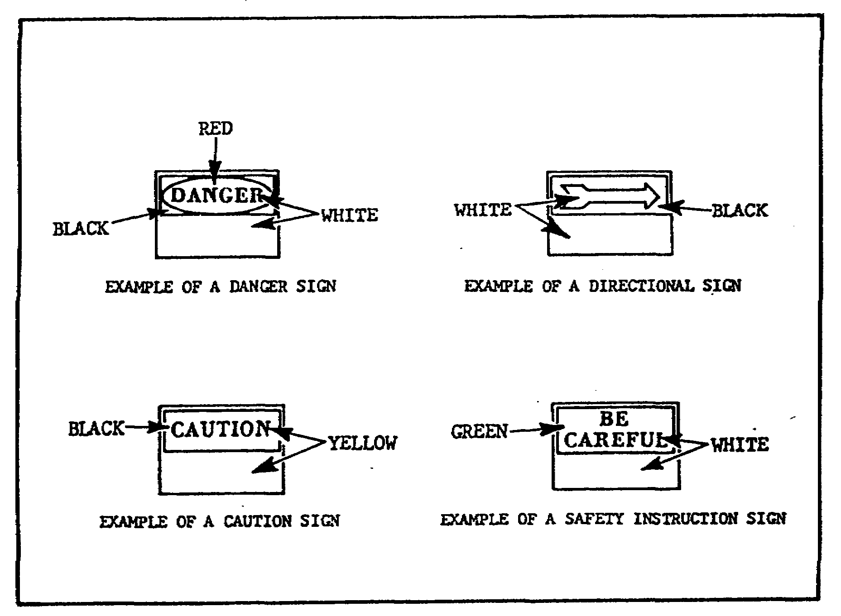

FIGURE 4. ACCIDENT PREVENTION SIGNS.

Uses of Accident Prevention Signs

Accident prevention signs should be used to warn or caution personnel of a hazard; or provide instructions, directions, or information to personnel.

Danger Signs. Danger signs are used only when an immediate hazard exists. There will be no variations in the type or design of signs posted to warn of specific dangers. All personnel will be instructed that danger signs indicate immediate danger and that special precautions are necessary.

32

OD0973 - Lesson 2/Learning Event 1

Caution Signs. Use caution signs only to warn against potential hazards, or to caution against unsafe practices. All personnel will be instructed that a caution sign indicates a possible hazard against which proper precautions will be taken.

Safety Instruction Signs. Use safety instruction signs when there is a need for general instructions and suggestions relative to safety measures.

Directional Signs. Directional Signs should be used in sufficient numbers to indicate the way to specified locations.

Informational Signs. Use informational signs when it is advisable to convey general information on a subject not necessarily of a safety nature.

DA Label 172 (Danger-Hearing Protection Required)

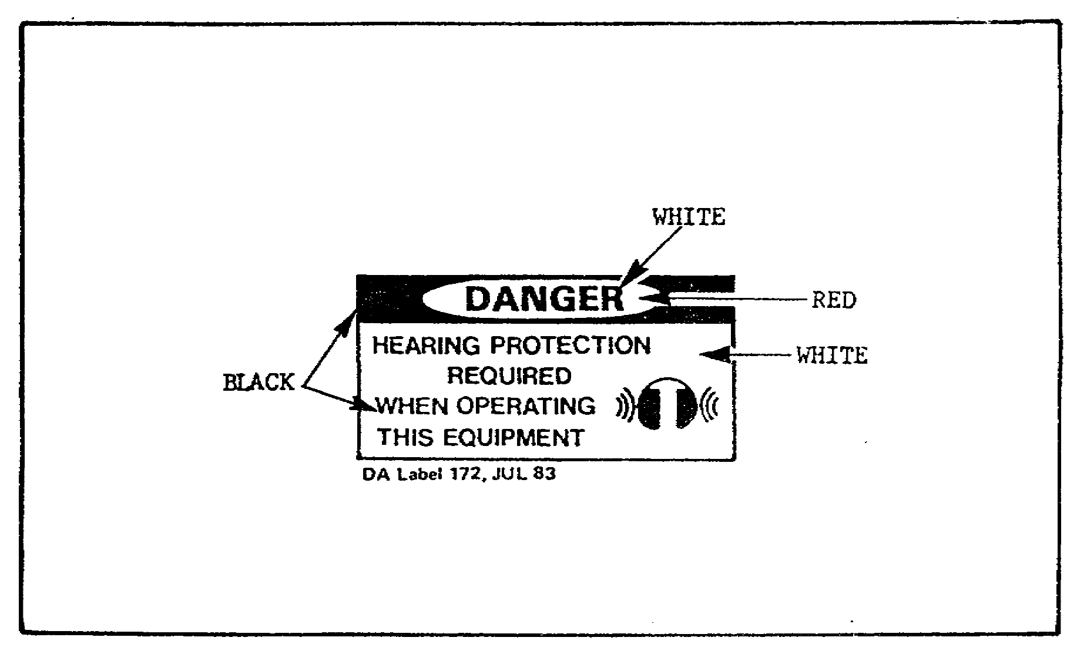
Use the DA Label 172 hearing protection decals (figure 5, below) to warn personnel of noise hazards associated with selected small power equipment. Also, to direct that appropriate protective measures be taken.

FIGURE 5. HEARING PROTECTION DECAL.

33

OD0973 - Lesson 2/Learning Event 2

You have now completed learning event 1. You should be able to identify safety hazards in the shop and be familiar with general shop safety considerations. You should know that accident prevention can only be achieved by identifying and eliminating hazardous procedures, operations, or conditions.

Now move on to learning event 2. Here you will learn about the importance of safety training, and how to conduct safety classes and briefings.

Learning Event 2:
DESCRIBE THE REQUIREMENTS FOR SAFETY EDUCATION, TRAINING, AND MANAGEMENT

The principal requirements for safety and the basis for a successful safety education and training program are covered in the Army Safety Program.

THE ARMY SAFETY PROGRAM

Consider the policies, procedures, and guidelines that are used for implementing the Army Safety Program. These include Occupational Safety and Health Administration (OSHA) and Department of Defense (DoD) safety policies and guidelines. This information is necessary for you to establish a successful shop safety program. It will also assist you in developing necessary safety training and education programs.

Safety Goals

The safety goals of the United States Army are to:

o Reduce to a minimum accidental manpower and monetary losses. This will provide more efficient use of resources and advance the combat effectiveness of the Army.

o Provide a safe and healthful environment at all times for all Army personnel and others exposed to Army operations.

Objectives

The above safety goals are achieved through the following safety program objectives:

34

OD0973 - Lesson 2/Learning Event 2

Prevention of Injury and Occupational Illnesses. Prevention of injury and occupational illnesses reduces the frequency and severity of injuries and illnesses resulting from Army operations. This will improve employee morale and efficiency. It also reduces expenses caused by lost production, sick leave usage, and other related expenditures.

Damage Control. Damage control aims at detecting and eliminating the causes of preventable, unintended damage to property as a result of Army operations.

Accident Prevention. Accident prevention involves the use of special techniques to detect unsafe behavior and conditions and prevent accidents.

Compliance with Statutory and Regulatory Requirements. This uses the specialized experience of the safety staff. They ensure consistent, economical compliance with applicable safety requirements. These safety requirements may be of Federal statutes, Army regulations, host nation, and Status of Forces Agreements.

Liability Limitation. Liability limitation involves prompt action to reduce the likelihood of liability (legal action) against the Army.

Occupational Health. Occupational health involves implementing AR 40-5 to ensure the physical and mental health of all personnel in cooperation with safety personnel.

Policy

The policies below will be followed by safety managers at all levels in implementing the Army Safety Program. The policies listed are basically geared toward the commander. But it is necessary for you, as the shop supervisor, to understand the overall concept. It will help you to develop a working safety program for your area. The policies are:

o The safety program will fully support the Army mission while minimizing adverse impact on operations.

o Accident prevention is a command responsibility. Commanders must ensure compliance with the safety program.

35

OD0973 - Lesson 2/Learning Event 2

They must also establish any additional requirements necessary for the safety of personnel under their control.

o Safety requirements set by higher headquarters will not be waived without the approval of that headquarters. This does not prevent the commander from issuing temporary waivers in emergencies. All waivers must be subsequently reviewed by higher headquarters.

o Problem areas common to several commands will be reviewed centrally. This will ensure efficient accident prevention efforts throughout the Army, and reduce accidents in general. The Army Safety Management Information System (ASMIS) is designed to eliminate duplication of effort. Command safety data managers will coordinate studies and evaluations with commands having similar missions.

o Programs developed centrally should allow subordinate commanders sufficient flexibility to develop alternative approaches to meet their individual needs.

o Hazard analysis procedures will be used to identify and control hazards during the planning stages. Commanders must emphasize the use of such early detection techniques. It is better to determine problem areas prior to the accident occurring than to wait until an accident has occurred.

o Available resources must be applied against hazards on a "worst first" basis. Evaluation of hazard priorities must include consideration of the potential consequences (degree of injury, occupational illness, or damage). Mission, legal, and regulatory implications of each hazardous situation must also be considered.

HAZARD IDENTIFICATION

Review the hazard analysis procedures which were mentioned in the paragraph above. These are the minimum procedures for conducting evaluations of operations and facilities.

Hazard Analysis Procedures

These procedures include:

o Commanders involved in developing Army materiel will comply with the system safety provisions of AR 385-16.

o Other commanders will determine which hazard analysis procedures meet their safety requirements. As a minimum,

36

OD0973 - Lesson 2/Learning Event 2

hazard analysis procedures will be the priority method used to detect accident threats. These threats are those that are likely to produce frequent or severe personnel injuries or high dollar losses. Threats that are likely to produce significant legal action or public discredit to the Army are also considered. Procedures for conducting a hazard analysis can be found in AR 385-16.

EDUCATION AND TRAINING

In the first learning event, the "Three Es of Safety" were mentioned; Engineering, Education, and Enforcement. Consider the second "E," which is education.

Education and training are the means for developing safe behavior. Compared to engineering and enforcement, safety education is a long, slow procedure, and sometimes the results are hard to see. However, it is this "E" (education) which gives the best and the most long-lasting results.

Education Versus Training

Training is the process of developing the skills necessary to do a job, such as performing an operation, or engaging in an activity. Education is the process of teaching a man how to act in the performance of his job, operation or activity.

With this in mind, Army accidents can be classified into two types--operational and nonoperational.

Operational Accidents. Operational accidents are those which occur in the performance of duty. Most operational accidents can be reduced by additional training and close supervision.

Nonoperational Accidents. Nonoperational accidents are those that occur when a soldier is off duty. These accidents require education to teach a man to act safely when he is not under supervision, when he is '"on his own."

Military personnel who have safety responsibilities should be most concerned with the educational aspects of the safety problem. There are three aspects of safety education and training:

o the development of positive safety attitudes;

37

OD0973 - Lesson 2/Learning Event 2

o imparting the knowledge for safe performance; and
o the development of skill to the level necessary for safe performance.

Skill development is developed through training. Safe attitudes and safety knowledge are developed through education.

Safety Knowledge

Knowledge of rules and regulations is essential for safe performance. A high degree of skill in operating a motor vehicle is not enough to make a safe driver. The driver must also have knowledge of traffic regulations, stopping distances at various speeds, warning signals indicating defective brakes or tires, the effect of alcohol and fatigue on alertness and perception, and a long list of other factors.

Having the appropriate knowledge also assists in the proper safety attitudes. Knowledge leads to understanding, and understanding leads to favorable attitudes.

Safety Attitudes

The area of attitudes is the least understood and the most difficult safety problem. An attitude may be simply defined as "The way a person feels about something." All the knowledge in the world does not assure a favorable attitude. Certain needs must be fulfilled before favorable attitudes will develop. They are the need for:

Belonging. A person who feels he is a participating member of the group will develop desirable attitudes toward the objectives of the group (in this case "safety").

Security and Trust. A person who feels secure and is trusted by the group will strive to reach group-determined objectives.

Self-esteem. A person who feels that he is respected by the group will go along with group objectives.

A supervisor should try to meet these needs for all individuals under his supervision. If he can, he is well on his way to establishing a high degree of morale, as well

38

OD0973 - Lesson 2/Learning Event 2

as safe performance on and off duty. A positive attitude toward safety will also lead to greater acceptance of the safety knowledge and skills provided in training.

Safety Training and Education Standards

The Department of the Army (DA) is tasked by OSHA and DOD to provide safety and occupational health training for all personnel. The following are the minimum requirements for implementing a training program at the shop level:

Nonsupervisory Personnel Training. This training includes job safety and health training appropriate to the work performed. This will include OSHA criteria and the hazards associated with any materials or operations in the workplace. It also includes informing employees of OSHA complaint procedures and of their rights and obligations under AR 385-10.

Civilian Employee Training. Civilian employee training should include training to prepare them to assist in maintaining a safe and healthy workplace. This training should be given in addition to training given to other employees during normal work hours.

Supervisor Training. Includes training in the recognition and elimination of hazards. It will also cover the development of other required skills to implement the Army's program at the working level.

Army Sources for Safety Material

The publications mentioned below are the principal Army sources for safety information and training.

DA Pam 385-1. DA Pam 385-1 (Unit Safety Management) is the principal Army publication used for information in establishing and conducting safety education and training. This publication should be used in conjunction with your local safety and training SOPs.

DA Pam 108-1 and DA Pam 108-2. Films and filmstrips suitable for use in safety training and information programs are listed in DA Pam 108-1 and DA Pam 108-2.

39

OD0973 - Lesson 2/Learning Event 2

DA Pam 25-30. DA Pam 25-30 identifies such sources as Army regulations, special regulations, circulars, pamphlets, DA posters, Joint Chiefs of Staff publications, and general orders.

DA Pam 25-30 also identifies sources such as field manuals, Reserve Officer Training Corps manuals, training circulars, Army training programs, Army subject schedules, Army training tests, firing tables and trajectory charts, tables of organization and equipment, tables of distribution, and tables of allowances.

SAFETY MANAGEMENT

The success of the Army Safety Program depends upon command support at all levels. Particular attention should be focused at the "grassroot" level--the unit command. Operations and activities at this level must be examined on a constant and continuing basis. This is where shop supervisors go to work. They must ensure the development, application, and maintenance of appropriate safe practices. This includes eliminating unnecessarily hazardous conditions; this can be accomplished through proper safety management.

Objectives of Safety Management

Safety management consists of planning, organizing, directing, and controlling the accident prevention effort. The primary objective of safety management is to prevent accidents causing injury or property damage. This can be accomplished only by establishing and enforcing safe practices. These include eliminating or controlling hazardous conditions, and educating and training personnel in the routine use of safe operating conditions.

Safety Program Elements

Effective use of the following eleven safety program elements will result in a successful safety management program.

Safety Administration. -Consists of planning, budgeting, directing, evaluating, and re-evaluating the program.

Safety Training. -Involves developing safety habits and skills among Army personnel. Such training must be

40

OD0973 - Lesson 2/Learning Event 2

integrated into every phase of Army operations and activities.

Safety Education. -Involves teaching Army personnel the need to use the skills and habits they have developed through training.

Safety Promotion. -Involves maintaining safety awareness. This is accomplished through the use of mass communications media. This can be in the form of group discussions, safety meetings, news releases, bulletin board notices, posters, and other methods.

Safety Engineering. -Consists of eliminating physical hazards in the environment and guarding against those hazards which cannot be eliminated.

Safety Inspection. -Involves evaluating Army structures, equipment, grounds, programs, and personnel performance. The purpose of these inspections will be to eliminate hazardous conditions and correct unsafe behavior.

Safety Standards and Codes. -These constitute the minimum specifications required to maintain safe equipment, procedures, and performance.

Accident Investigating and Reporting. -Involves evaluating the conditions and actions surrounding an accident. It also involves recording the facts accurately and clearly to enable analysis of the accident reports.

Accident Analysis. -Involves appraising accident reports to determine trends in accident occurrence. Then, applying remedial measures to stop such trends.

Potential Hazard Analysis. -Involves recording and evaluating "near miss" occurrences. These occurrences are ones which, except for luck or unusual skill, could have been an accident. Such appraisals should lead to development of measures to prevent potential accidents.

41

OD0973 - Lesson 2/Learning Event 2

Job Analysis. - Puts the right job, the right machine, and the right person together into an accident-free work situation.

THE SUPERVISOR AND SAFETY

In effect, anyone who has authority over another person is a supervisor. All supervisory personnel must assist the commander in the accident prevention program. The supervisor will ensure that all personnel follow the established safety program.

Safety Supervision

The qualities necessary for effective safety supervision are the same as in any other activity. Effective supervision is in a large measure associated with leadership. Leadership which enlists the cooperation and support of the group works best.

The supervisor has the responsibility of demonstrating the importance of safety through his own actions. As a leader, he cannot ignore safety regulations himself and expect others to follow them. He has to set the example.

It is extremely important that people understand safety rules and the necessity for them. Blind obedience is not enough. No supervisor can keep a close watch on all his men all of the time. If people understand why they are to do something in a certain way, they are more likely to continue working in that fashion; they will continue to perform properly even though the supervisor is not looking over their shoulders.

A group that works with rather than for its supervisor is more effective in its performance. A supervisor has authority. If the soldiers under his authority are not sure of his fairness, they may compete with each other for the supervisor's favor. This can lead to hostility. Hostility will destroy the cooperation needed for effective (safe) group performance. It has been shown that accident rates are lower under supervisors whose leadership ability is superior.

Why do accidents happen?

Research has demonstrated that the following two factors are associated with accidents:

42

OD0973 - Lesson 2/Learning Event 2

Unfamiliarity with the Task. A person engaging in an activity in which he has little prior training or experience.

Isolation. The person is alone when he is performing the task.

Good supervision can prevent these circumstances from arising, and thus prevent accidents.

Basic Ingredients of Safety Supervision

To maintain safe performance among the men under his command, the supervisor must:

o Explain and stress safety rules and the reasons for them.

o Be able to safely perform the task himself, and adequately demonstrate proper performance of the task.

o Train the men in safe performance.

o Make available safe tools and equipment. Maintain tools and equipment in a safe condition.

o Place people in tasks that are within their abilities.

o Develop safe methods for performing tasks.

o Motivate his men to perform safely, and report all unsafe acts, or conditions.

o Promote teamwork among his people.

Supervisory Responsibilities

All supervisory personnel assist the commander in the accident prevention program. They do this by requiring all personnel to follow safe operating procedures. The supervisor orients new personnel, teaches safe practices, and enforces rules and regulations. He investigates accidents, prepares and submits accident reports, and conducts safety inspections and safety meetings as required.

No one is better qualified or in a better position to discover and correct safety hazards and violations than the supervisor. He is the one person who deals directly with both the worker and the job. He is in the best position:

43

OD0973 - Lesson 2/Learning Event 2

to improve the workers attitudes toward the job; to improve the worker's knowledge of the job; to improve the worker's skill; to insist on safe practices on the job; and to correct unsafe conditions involved in the job.

When the supervisor fails in any one of these responsibilities, he can expect inefficient and costly results. Supervision is a method of preventing accidents through continuous instruction, guidance, persuasion, and enforcement. Supervision is a basic accident prevention control. When supervision fails in this accomplishment, constant observation and frequent enforcement become necessary.

THE INDIVIDUAL AND SAFETY

The commanding officer, with the help of his supervisors, conducts a continuous effort to prevent accidents. Does this relieve the individual soldier of any responsibilities for safety? What is the role of the individual soldier in the accident prevention effort?

Individual Responsibilities for Safety

Accident prevention is the responsibility of each soldier and civilian employee in the Army, both on duty and off duty. It is the responsibility of each individual to comply with rules, regulations, and standing operating procedures (SOP). They must correct or report unsafe conditions and report all accidents. They must use protective devices, and warn others of a hazardous condition or practice. By developing an awareness for safety in every activity, on or off duty, the individual makes his greatest contribution to his unit's safety program.

MOTIVATION FOR SAFE PERFORMANCE

The basic problem in accident prevention is getting people to perform safely. A high degree of safety is incorporated into the designs of highways, bridges, automobiles, and all types of equipment. The closest you can come to designing safety into human beings is in getting people to want to be safe.

Definition of Motivation

People are constantly bombarded with appeals to buy things-- clothing, cars, toothpaste. The manufacturers of these

44

OD0973 - Lesson 2/Learning Event 2

items are trying to motivate us to buy their products. Basically, motivation is simply the art of getting people to want to do things your way.

Motives Versus Incentives

A motive is "the emotion or thing that makes us want to do something." How do you appeal to motives? You do this by providing appropriate incentives (e.g., praise, rewards, participation, security) to stimulate desirable motives among persons.

Motivating for Safety

The distinction between needs and incentives is an extremely important one. You must recognize that many needs are common to everyone (i.e., food, drink, self-preservation). But each of us places a different value on other needs, such as safety, respect from others, and creativity. Some individuals have little desire for recognition. Others spend most of their-waking hours seeking such recognition. You, as a supervisor, must understand the nature of human needs. Then, you can motivate the individual or group into thinking your way.

Checking Safety Motivation

The supervisor should be constantly alert to indications that safety motivation remains high among his personnel. He can do this by checking the following factors. If these conditions are not met, he knows there is room for improvement in safety motivation. The factors are:

o There is an increase in the desired learning (in this case, increased safety performance as indicated by a reduction in accidents).

o Individual (or group) efforts toward safety are persistent.

o The individual (or group) expresses interest and satisfaction in attempting to achieve the goal of improved safety performance.

SAFETY INSPECTIONS

A major point to remember is that accidents do not just happen, they are caused by unsafe conditions or acts.

45

OD0973 - Lesson 2/Learning Event 2

Obviously, then, the best way to prevent accidents is to eliminate the unsafe conditions or unsafe acts. Safety inspecting is one way to do this. Safety inspections are a form of preventive maintenance.

Purpose of Safety Inspections

The purpose of the safety inspection is to eliminate accident causes through set procedures established to meet this purpose. A well planned safety inspection will accomplish the following:

o Detect specific unsafe conditions and practices.

o Highlight the need for specific safeguards for men and machines.

o Help to "sell" the safety program to personnel.

o Encourage individuals to inspect their own work areas and work practices.

o Allow safety personnel to come into closer contact with other unit personnel.

o Detect deficiencies in the management of the safety program itself.

Remember, a safety inspection is designed to determine if everything is satisfactory. It should not be conducted primarily to determine "how many things are wrong." It offers a golden opportunity for safety personnel to sell safety to the unit and should be conducted in an atmosphere of cooperation. The purpose of the inspection is to help unit personnel discover unsafe conditions and practices. They should not feel that they are being criticized.

Requirements of a Successful Safety Inspection

Specifically, safety inspections are concerned with conditions of the work area, equipment, personnel practices, and job procedures. To be successful, safety inspections require the following five elements:

o Competent inspection personnel.

o Definite schedules regarding what to inspect and how frequently.

46

OD0973 - Lesson 2/Learning Event 2

o Adequate orderly procedures (such as an inspection checklist).

o Effective supervision.

o Follow-up to ensure that unsafe conditions have been corrected.

Safety Inspection Personnel

Safety inspections should be conducted by qualified personnel. These include the unit safety officer, safety NCO, or shop supervisors.

The installation safety director can assist in safety inspections. He may have his safety engineers or inspectors prepare checklists to assist you in performing your inspection. He may also have them conduct inspections to teach new personnel how it is done and what to look for during the inspection.

The unit commander should participate in the safety inspection. His presence throughout the inspection is an indication of his interest in safety. This will also increase safety interest among the men.

Inspection Committees. Inspection committees should be formed to increase participation in the inspections. This will ensure that the inspections are thorough in their coverage. The committee should consist of personnel representing each of the operations or activities to be inspected. These top quality individuals can assist in developing checklists to be used in inspecting specific areas and activities.

Training Safety Inspectors. The unit safety officer should be the most qualified individual to perform safety inspections. However, each operation and activity has its own peculiar aspects. It is unlikely that the unit safety officer would be familiar with all of them, nor should this be expected of him.

Consequently, personnel competent in each activity should accompany him and assist with the inspecting. These personnel should be familiar with inspecting procedures and be qualified to inspect the total area he is assigned to inspect. They should also be familiar with all publications that contain safety requirements for the activity and equipment that they are to assist in inspecting.

47

OD0973 - Lesson 2/Learning Event 2

Types of Safety Inspections

The two basic types of safety inspections are:

One-call Inspection. The one-call inspection is made by the safety representative from a higher command. The purpose of this type of inspection is to evaluate the safety performance of the unit. It will also determine areas where improvement is needed, and present these facts to the unit commander.

Continuing Inspection. Each activity requires periodic safety inspections geared toward their specific function. The continuing inspection, which might be termed "quality control," is maintained to find safety problem areas. This type of inspection is used to discover conditions, procedures, and practices that might cause accidents if allowed to exist. This is the inspection that you, as the shop supervisor, should regularly schedule and conduct.

Inspection Scheduling

Inspections should be planned to make the most effective use of safety personnel and time. Consideration must be given to inspecting an activity so that normal operations will be disrupted as little as possible.

Safety inspection schedules should not be announced. This allows the inspectors to observe operations under normal conditions. Advanced warning of an inspection allows personnel to "police the area" for an inspection.

Safety Inspection Checklists

A suitable checklist should be used as an inspection guide for each activity. DA Pam 385-1 contains some suggested safety inspection checklists. These can be reproduced locally and should be used during the inspection together with other appropriate references and safety material.

Safety Inspection Records

The following are methods for preparing and maintaining safety inspection records:

During Inspections. Unsafe conditions and practices revealed by the inspection should be recorded on the

48

OD0973 - Lesson 2/Learning Event 2

checklist form. The form should contain useful information, such as the date, time, type of inspection, and names of the inspectors. It should also contain a detailed account of items that failed the inspection and recommendations for correcting these deficiencies.

Maintenance of Inspection Records. Each unit should maintain a master file comprised of reports of all inspections. These inspection reports should be maintained for an indefinite period of time. Each operation and activity should also have copies of the reports of all inspections conducted in their activity. Recommendations based upon the inspections should be followed up until the conditions have been corrected.

ENFORCEMENT

Most accidents can be prevented through adequate safety engineering and education. However, there are some people who are hazards to themselves and others, because of their failure to comply with accepted standards. For these persons, strict enforcement of safety practices (the third "E" of Safety), backed by prompt corrective action, is necessary.

No accident prevention program can be successful without effective enforcement. Accidents are usually the direct result of violations of safety principles.

Many supervisors are hesitant to reprimand a person just involved in an accident. Normally, the reprimand is not for having the accident. It is for violation of a safety order or procedure established to prevent such accidents from happening.

In this lesson, you have learned how to prevent injury, loss of life, and damage to property resulting from accidents. Such accident prevention can be achieved by identifying and eliminating hazardous procedures, operations, and conditions. You have also learned how to train personnel to perform safely.

Repetitious drill will "train" a soldier to repair a truck properly, but he must be "educated" to repair it safely. High quality research and development have produced equipment designed to operate efficiently and safely. Effective supervision will ensure that it is properly used

49

OD0973 - Lesson 2/Learning Event 2

and maintained. Adequate education and training of all personnel will result in safe performance in its use.

Now you should be ready to take the practice exercise on the next page. If you have problems with any of the answers, review the text and repeat the exercise.

50

OD0973 - Lesson 2/Practice Exercise 2

PRACTICE EXERCISE 2

INSTRUCTIONS

This practice exercise will show you how much you have learned in this lesson. Answer each question. When you are done, turn the page to check your answers.

SITUATION:

You are the motor officer assigned to a transportation battalion. The commander has tasked you to perform the necessary research and establish a maintenance shop safety program for the motor pool.

1. In your research, you discover that there are three
basic elements in any accident. These elements are
classified as the ____________________ _____________________ ,
the _________ , and the ____________________ .

2. You are preparing an outline of possible safety
precautions to be used when drawing up the motor pool safety
SOP. You note that "no smoking" signs must be posted to
notify personnel that smoking is not permitted within ______
feet of vehicles or stored flammables.

3. When preparing the section of the SOP concerning vehicle
operations in the motor pool, you must decide where to park
the vehicles that are in the shop for maintenance. The
spacing and arrangement of the parked vehicles must provide
ready access and ______ ____________ .

4. While researching AR 385-30, you find that the basic
color for designating safety equipment and devices to
include the location of first aid equipment is __________ .

5. You want to warn personnel working around the power
equipment to wear some type of hearing protection. This can
be accomplished by posting hearing protection decals near
the equipment. You should order DA Label _________ .

51

OD0973 - Lesson 2/Practice Exercise 2

6. Reduce to a minimum accidental manpower and monetary
losses; and provide a safe and healthful environment at all
times. These are the safety goals of which organization?

7. You are preparing an initial safety briefing for the
command staff. You want to bring to their attention that
there has been an outbreak of off-duty accidents during the
past quarter. These types of accidents are classified as
__________________________ accidents.

8. You are presenting a safety briefing to the command
staff. You relate to them that there is a need to establish
a high degree of morale, as well as safe performance on and
off duty. To do this, all supervisors must instill a safety
attitude in the personnel that they supervise. Certain
needs must be fulfilled before favorable attitudes will
develop. They are the need for ____________________________ ,
_______________________________ , and ________________________ .

9. You request that the command safety officer perform an
inspection of the motor pool to evaluate the safety
performance of your personnel. This inspection will also
determine areas that need improvement. This type of
inspection is known as a ____________________ inspection.

10. You have scheduled your Maintenance NCO to present a
safety training class to the lower enlisted personnel. He
has come to you for advice on where he can find publications
that would list films and filmstrips pertaining to safety.
What two Army publications would you recommend?

52

OD0973 - Lesson 2/Practice Exercise Answers

LESSON 2. PRACTICE EXERCISE - ANSWERS

1. individual injured, the agent, and the environment
(page 21, para 2)

2. 50 feet (page 24, para 2)

3. fire lanes (page 25, para 7)

4. green (page 30, para 6)

5. DA Label 172 (page 33, para 5)

6. United States Army (page 34, para 5)

7. nonoperational (page 37, para 7)

8. belonging, security and trust, and self-esteem
(page 38, para 7, 8, and 9)

9. one-call inspection (page 48, para 2)

10. DA Pam 108-1 and DA Pam 108-2 (page 39, para 8)

If you had a hard time getting the right answers, go back and review the lesson. If you did well on this practice exercise, you should be ready to start the next lesson.

53

OD0973 - Lesson 3/Learning Event 1

LESSON 3

POWER GENERATION IN THE FIELD

TASK

Describe the procedures for setting up the power generation site, grounding the generator, connecting and paralleling generators, and operating the power generation site.

CONDITIONS

You are the motor officer assigned to a battalion motor pool. You are expected to have sufficient training and experience to manage and supervise all functions of the motor pool and maintenance operations, given the necessary references to perform your mission.

STANDARD

Demonstrate your comprehension of the task in accordance with FM 20-31.

REFERENCE

FM 20-31

INTRODUCTION

Electrical power is needed to support the unit mission and maintenance operations. In the field, and for some garrison applications, this is commonly provided by power generators.

Generators are often part of specific communications, weapon, missile, or other equipment systems. These generators are commonly called tactical power generators and usually do not exceed 10kw. Tactical power generators are

54

OD0973 - Lesson 3/Learning Event 1

usually gasoline engine driven. Larger, central power, gasoline or diesel engine driven generators may be used to provide power to a number of equipment systems. When using larger generators, it is important to find an appropriate site for the generator to be set up and operated.

Determining a suitable site for placement of the power generation equipment is dependent on the type and location of the individual power requirements in the area to be served. The location should be selected by studying the area map on which the individual power demands have been plotted, then determine the proper location for the generators.

Learning Event 1:
DESCRIBE THE PROCEDURES USED TO SETUP THE POWER GENERATION SITE

This learning event will discuss some of the factors that must be considered in selecting an adequate site. It will also discuss how to protect the power generators from the elements and/or from enemy action.

SITE SELECTION

The type and location of the individual power demands in the area are the primary considerations in locating a power generation site. Other considerations in selecting the site are:

o The distance to the loads.

o Shelter for the generators.

o Temporary, semi-permanent, or permanent location.

Distance to the Load

The generator should be located as close as possible to the largest loads. This will serve the following functions:

o Reduce the length of the wire required.

o Hold the line loss to a minimum.

o Afford adequate voltage control at the demand ends of the lines.

55

OD0973 - Lesson 3/Learning Event 1

Shelter

Even though the generator is weather resistant, it should be located in an adequate shelter that will protect it from inclement weather. A lean-to, canvas tarp, or other impromptu device may suffice as a temporary shelter for a generator.

If you anticipate that the generators will be in service in one location for an extended period of time, you should plan a semi-permanent installation that includes adequate shelter (figure 6, below). Additional protection is also necessary in hostile fire areas to protect the generator from damage.
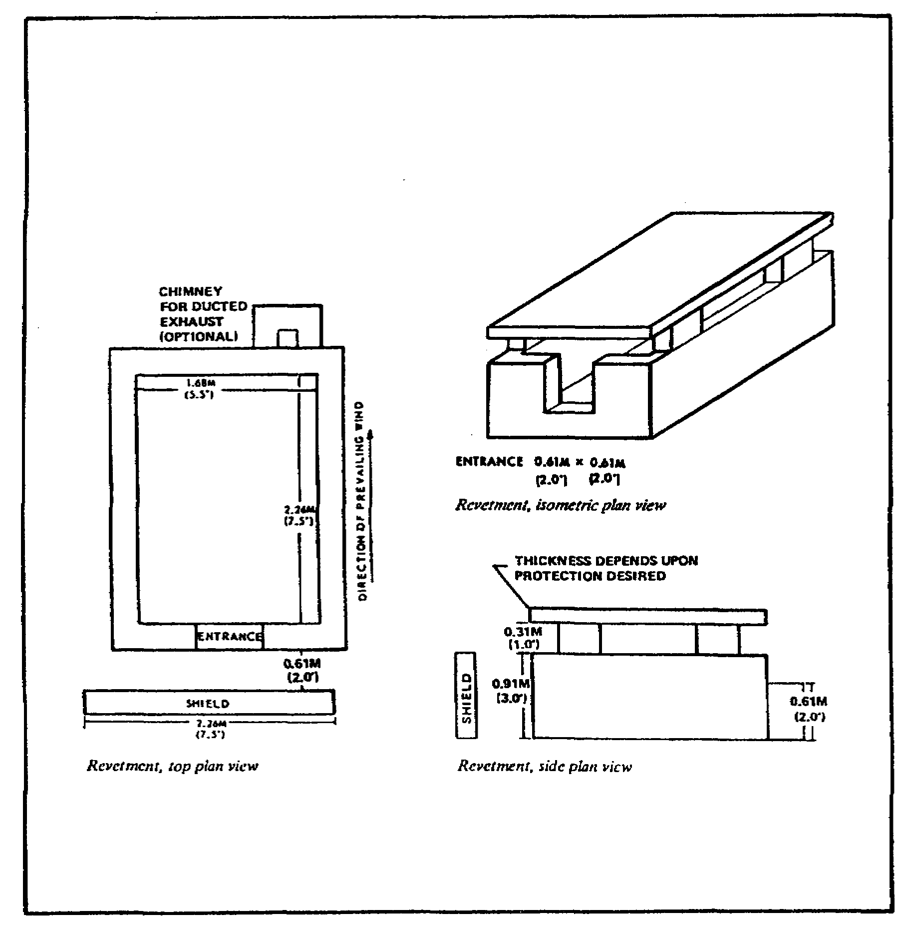

FIGURE 6. GENERATOR SHELTER.

56

OD0973 - Lesson 3/Learning Event 1

Listed below are some factors that must be considered in planning a shelter for the generator.

Orientation. The shelter should be oriented so that its entrance faces the prevailing wind. The generator end of the generator set will be positioned next to the entrance. These instructions are very important and should be observed. Proper orientation is necessary for the adequate cooling and ventilation of the generator when the unit is in operation.

Ventilation. The shelter must be properly ventilated to allow heated air and exhaust fumes to escape. Ventilation is also necessary to maintain a reasonable temperature in the area around the unit.

If you use the generator in a closed building or other enclosed shelter, pipe the exhaust gases to the outside. Use as few bends as possible in the exhaust pipe. A minimum clear space of six inches must be provided between the exhaust pipe and any combustible material.

Construction. Walls of the shelter may be constructed of sand bags, ammunition boxes filled with sand or dirt, or any other material available.

The roof may be supported by any means available. Prepared material for use in roof construction consists of lumber (4x4 inches) or logs 4 inches in diameter. Other pieces of lumber, logs, steel plating, sand bags, etc., may be used to cover the entire roof area. Ensure that the roof is adequately supported to hold the weight of the protective material.

Access. Provide enough clearance around the generator set so that you can operate it and perform maintenance.

Mounting. Select a clean, dry, level, and well drained area. If this is not possible, use planks, logs, ammunition boxes, or other available material to prevent the skids or frame from sinking into soft earth.

In no case should the set be tilted more than 15 degrees in any direction.

In some cases, cargo trucks can be used for mounting generator sets. You can also mount generator sets on

57

OD0973 - Lesson 3/Learning Event 1

two-wheeled trailers for greater maneuverability and maintenance.

Support. Be sure that the surface used can support the weight of the generator set.

Fuel Supply and Storage. Provide an adequate supply of clear fuel to meet the requirements, based on projected operating time. Consider the installation of auxiliary fuel sources underground if the installation will be permanent.

Locate the shelter for the fuel tanks or cans as far from the generator shelter as the auxiliary fuel line will permit. If a metallic fuel line is used, this distance should be approximately 25 feet. Ensure that the bottoms of the tanks/cans are not lower than four feet from the fuel pump on the installed generator.

SETTING UP THE GENERATOR

The set-up and operation of power generators is the responsibility of the using equipment systems teams. Each generator should have an assigned licensed operator. Unit level maintenance is provided by the wheel vehicle and power generation equipment mechanic in the maintenance section. In some units, with a high density of power generators, a power generator equipment repairer may be assigned at the battalion level. This individual performs maintenance, conducts training, and provides technical assistance throughout the battalion.

Preliminary Set-Up Instructions

There are two basic conditions in installing a generator set. Either the set is known to be completely operational, or it was shipped from a supply or maintenance point in an operational ready status, except that it had been drained and preserved. Where the later is the case, the following must be performed before operation.

Inspecting the Equipment. The following checks should be performed on any generator that is not known to be completely operational:

o Inspect the identification plate for positive identification of the generator set.

58

OD0973 - Lesson 3/Learning Event 1

o Make a thorough inspection of the generator set for any damage that may have occurred during shipment.

o Compare the equipment with the packing list to ensure that all items are accounted for and are in serviceable condition.

o Inspect the entire unit carefully for loose or missing hardware.

o Turn the engine over by hand to make certain that all moving parts in the engine and generator move freely.

Servicing the Equipment. The following procedures should be followed prior to starting a generator that is not known to be operational:

o Perform the daily and weekly preventive maintenance services.

o Remove all tags and tape, cloth, and other barrier materials.

o Lubricate the engine of the generator set according to the instructions in the current lubrication order for the engine.

o Correct all deficiencies that are found, or report the condition to unit maintenance.

Before Operations Services

Before operating the generator, certain services must be performed. To ensure that all required checks are performed properly, the motor officer should ensure that the generator operator refers to the technical manual for the generator being used.

These services can normally be found in the Preventive Maintenance Checks and Services chart in the manual. The operator should check the following areas prior to starting any generator:

Fuel. The fuel lines should be checked for leaks. Check the fuel in the tank and replenish it if necessary. If weatherization equipment is being used, check the heater tank.

59

OD0973 - Lesson 3/Learning Event 1

Be careful not to mix fuels. For example, some diesel-driven generators sets have diesel in the main tank of the generator and gasoline in the heater tank.

Some sets have heaters that use diesel fuel from the main tank.

On gas turbine units, the plenum drain fitting must be inspected to make sure that no fuel has accumulated in the plenum chamber.

Water. The radiator water level should be checked and water added if necessary. When filling a cold radiator, allow room for expansion. If cold weather is anticipated, antifreeze should be added.

Batteries. The electrolyte level in the batteries should be checked. Use distilled water and fill to the proper level, which is about 3/8th inch above the plates. Never use water from a metal container.

Tools. The area should be cleared of any loose tools or other objects that may hamper efficient operation.

Lubrication. The engine oil should be checked and oil added if necessary.

Leaks. Particular attention should be paid to the fuel tank, radiator, oil covers, and oil pan in checking for leaks. Check all lines and connections.

Instruments. All generator and engine instruments should be checked to see that they are securely mounted, properly connected, and undamaged.

The fuel gauge should show FULL; other instruments should show no reading at all.

Visual Inspection. The entire unit should be visually inspected for cracks, breaks, and for loose or missing bolts and nuts. All wires and terminals should be inspected for damage and loose connections. On gas turbine units, the air inlet screen assembly should be inspected and obstructions, debris, and other foreign material removed.

60

OD0973 - Lesson 3/Learning Event 2

Load Arrangement. The changeover block or the output selector switch should be set to the proper output voltage.

The main circuit breaker should be in the OPEN, OFF, or TRIP position.

The output service cables should be securely connected to the load panel terminal connections.

Control Positions. All controls should be adjusted according to the technical manual for the generator.

Ground Connection. The ground connections at the equipment and the ground rod should be physically checked for tightness.

You have covered the various factors that the motor officer should consider in selecting and laying out a power generation site. Also, the preparation of the generator at the site has been discussed.

Now consider the requirements for properly grounding the generator.

Learning Event 2:
DESCRIBE THE PROCEDURES FOR MONITORING THE GROUNDING OF GENERATORS

Grounding of power generation equipment is a safety factor.
If a short circuit occurs somewhere in the generator, or in the distribution system, stray electric current can be produced that might cause injury or death to personnel and damage to the equipment.

METHODS OF GROUNDING

There are three basic methods used in grounding tactical portable power generation equipment. They are rod electrodes, pipe electrodes, and plate electrodes.

Rod Electrodes

The standard ground rod used by the military is a 5/8th inch copper rod with three sections of 3 feet each. The rod electrode (figure 7, on the next page) must be driven to a depth of at least 8 feet.

61

OD0973 - Lesson 3/Learning Event 2

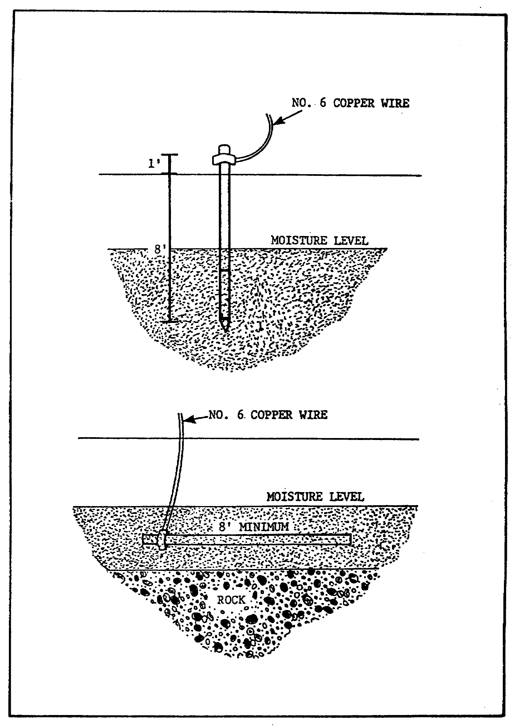

FIGURE 7. ROD OR PIPE GROUND ELECTRODE.

62

OD0973 - Lesson 3/Learning Event 2

If this cannot be done, the electrode may be buried in a horizontal trench. Caution must be taken to ensure that the electrode is placed below the moisture level.

In both cases, the rod must be at least 8 feet long.

Pipe Electrodes

A clean metallic pipe of at least 3/4 inch trade size may be used. The pipe electrode must be driven to a depth of 4 feet.

If this cannot be done, an 8 foot long pipe may be buried in a horizontal trench (see figure 7, on the previous page). Caution must be taken to ensure that the pipe is placed below the moisture level.

Plate Electrodes

A buried plate electrode (figure 8, on the next page) may be used. Plate electrodes shall not be less than 10 inches wide and 10 inches long (100 square inches).

If an iron or steel plate is used, it must be at least 1/4 inch thick. Nonferrous metal plates must be at least 0.06 inch thick. Plates must be buried below the permanent moisture level.

GROUND CONNECTIONS

The ground cable should be copper wire, no smaller than No. 6 AWG. Connect one end of a ground cable to the ground terminal of the set, and tighten the nut securely.

The other end of the cable is connected to the grounding electrode by means of a special grounding clamp.

This learning event should have familiarized you with the proper procedures in monitoring the grounding of a power generator. You should be knowledgeable of the three types of grounding electrodes and how they are used.

In the next learning event, you will learn how to connect generators to the loads, and how to parallel generators for increased power output.

63

OD0973 - Lesson 3/Learning Event 3
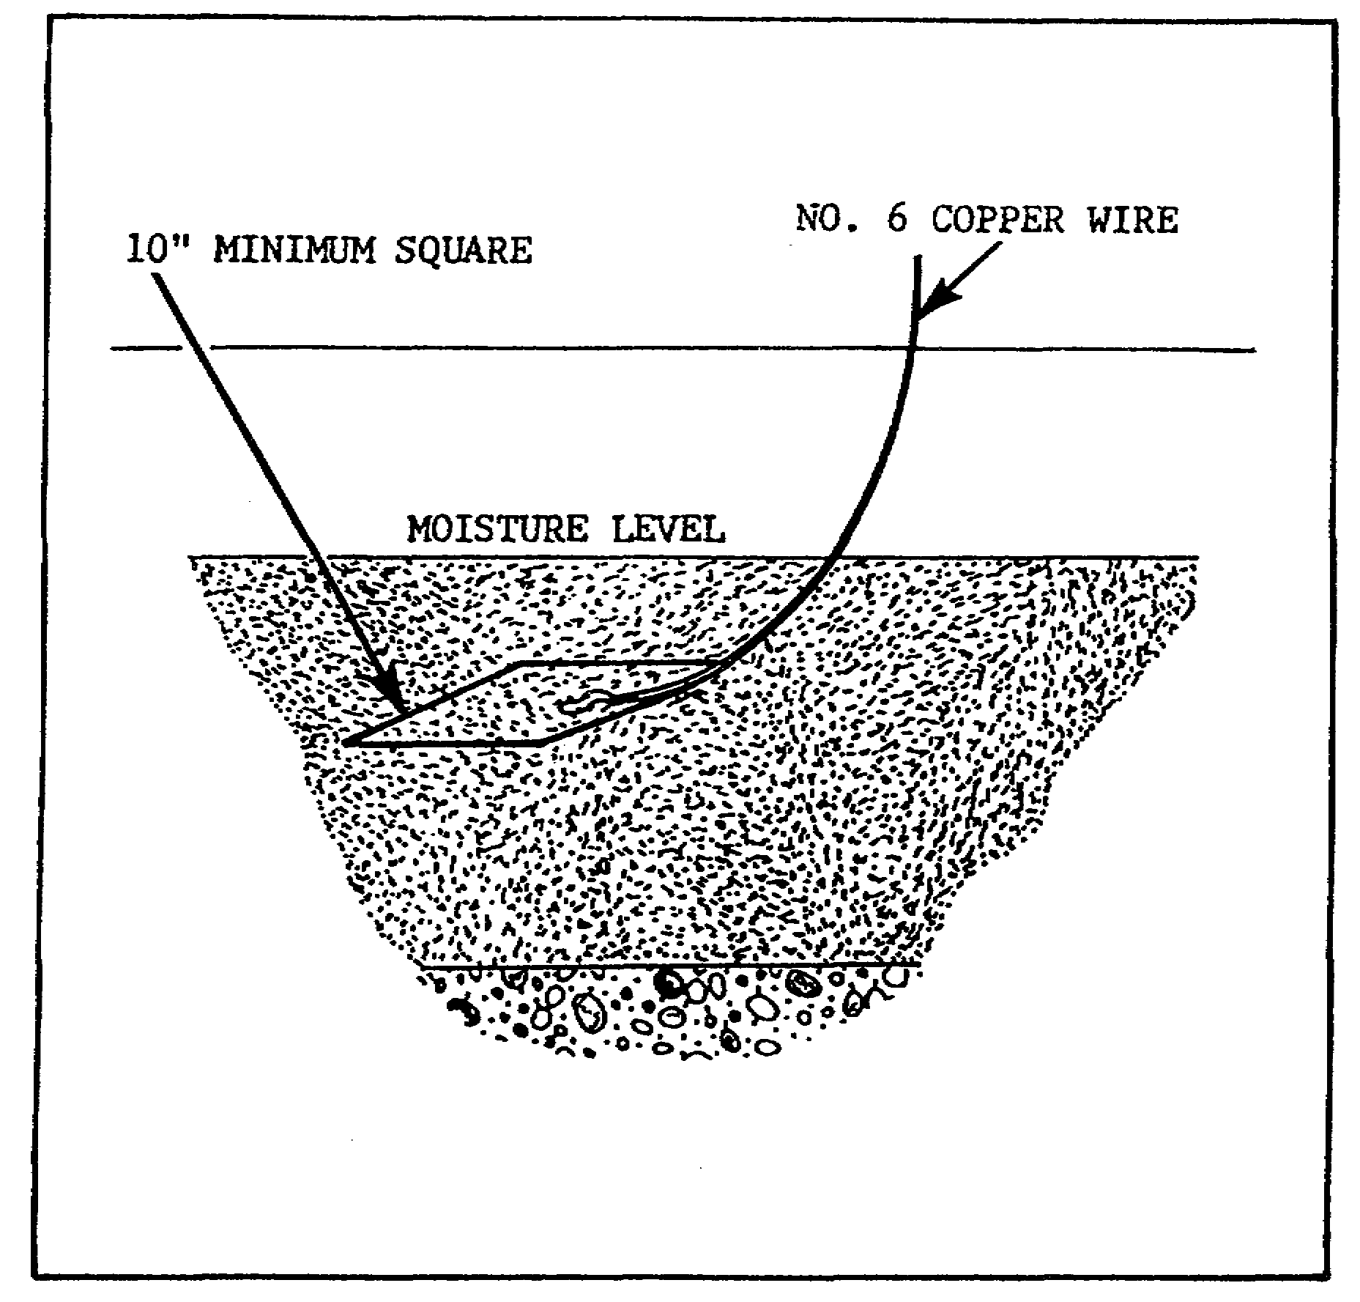

FIGURE 8. PLATE GROUND ELECTRODE.

Learning Event 3:
DESCRIBE THE PROCEDURES USED TO CONNECT/PARALLEL POWER GENERATORS

After the generator is properly set up and grounded, it is necessary to connect the generator to the equipment that will be using the power (power demands). The loads should be computed and the proper cable size should be determined.

This can be done by using the formulas in FM 20-31.

64

OD0973 - Lesson 3/Learning Event 3

It is important that the proper cable size be used. A cable that is too small (in wire gauge) for the load that it is supporting may overheat or melt. Damage to the generator or the equipment that it is supporting may result.

INSTALLING THE LOAD CABLE

Distribution cables used in military-constructed distribution systems can be placed in two categories:

o Cable supplied in predetermined length and size and equipped with quick-disconnect connector plugs.

o Building wire, supplied in rolls.

When installing the load cable, decide whether the cable will be overhead, buried, or laid on the ground. Naturally, the method of installing the cable will depend on the type of material available, as well as upon existing conditions.

Overhead Installation

When conditions dictate the use of an overhead line, make sure it is properly constructed. In most cases, utility poles will not be available.

If poles are not available, 6x6s will be satisfactory if they are long enough to set rigidly in the ground and still provide safe clearance for the wires.

As a last resort, trees may be used for support. However, if trees are used, be sure to select the proper weatherproof cable.

The following precautions must be taken when installing an overhead system:

o When crossing over roads, minimum clearance should be 20 feet for sufficient vehicle clearance.

o A pole should be located at each joint when cable equipped with quick-disconnect plugs is used (figure 9, on the next page), with supports in between as required.

65

OD0973 - Lesson 3/Learning Event 3
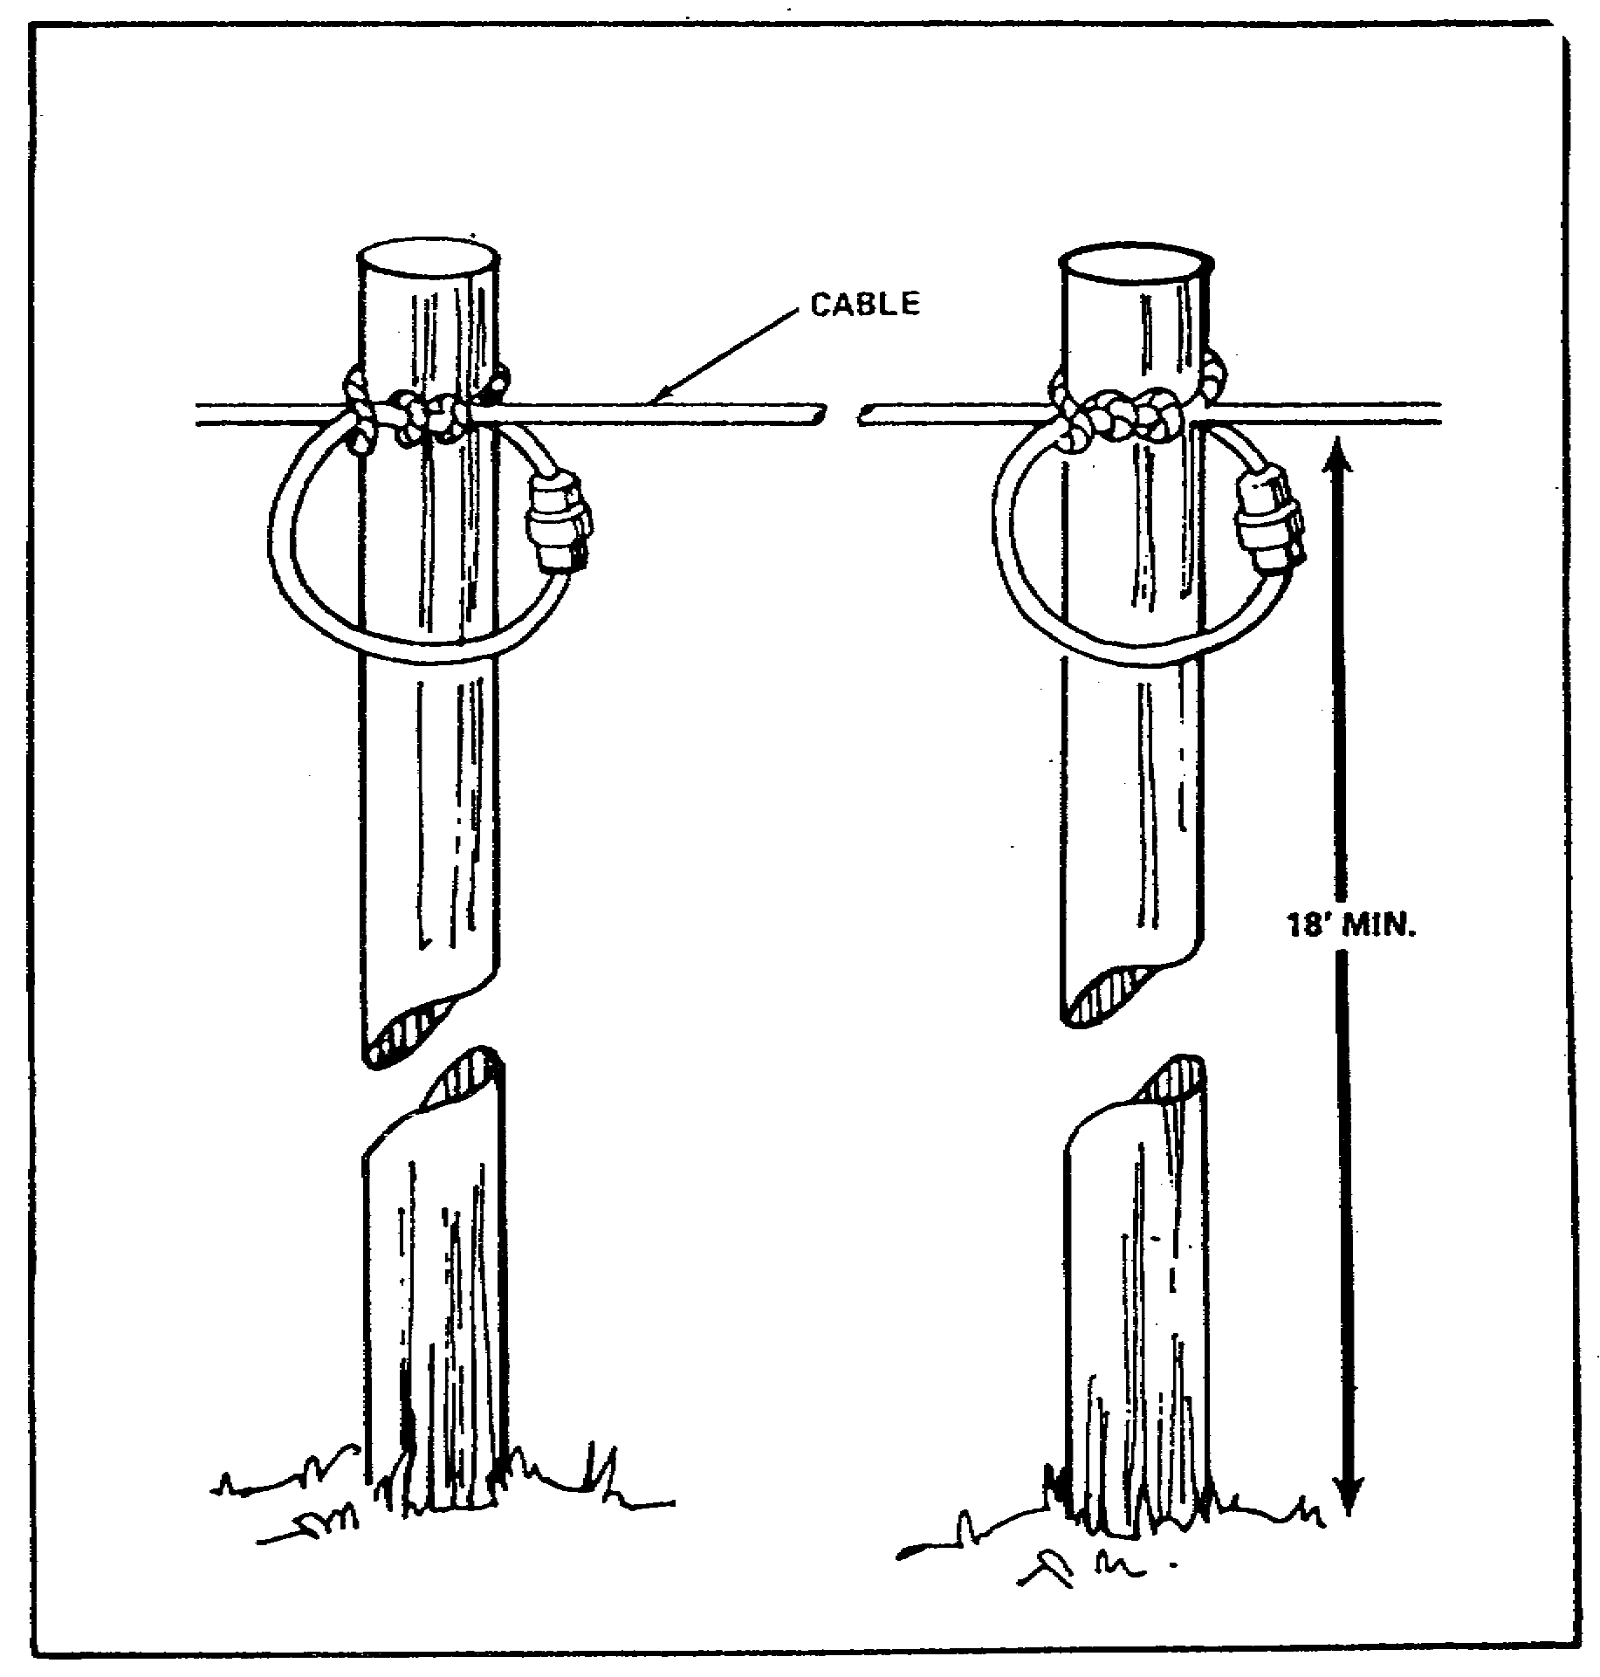

FIGURE 9. OVERHEAD DISTRIBUTION, QUICK
DISCONNECTS ON POLES.

o Tie cables with quick-disconnects together when the connections occur in a span between poles (figure 10, on the next page).

o Take care to ensure proper plug connections when installing multi-phase cable equipped with quick disconnects. Since this type of cable employs a male and female receptacle, the receptacle must be properly aligned to prevent a reverse phase condition in the system. The method of ensuring proper alignment is to match the cable markings, or apply your own markings prior to installation. As a rile, cables are premarked by the manufacturer. These

66

OD0973 - Lesson 3/Learning Event 3

markings may appear as circular or triangular depressions, or raised buttons in the insulation of each receptacle. Most receptacles have one pin and jack larger than the other. This larger pin and jack represent the ground or neutral conductor. Matching these will ensure proper plug connection where markings are nonexistent. When you must mark a cable, painting a color code on the receptacle is recommended.
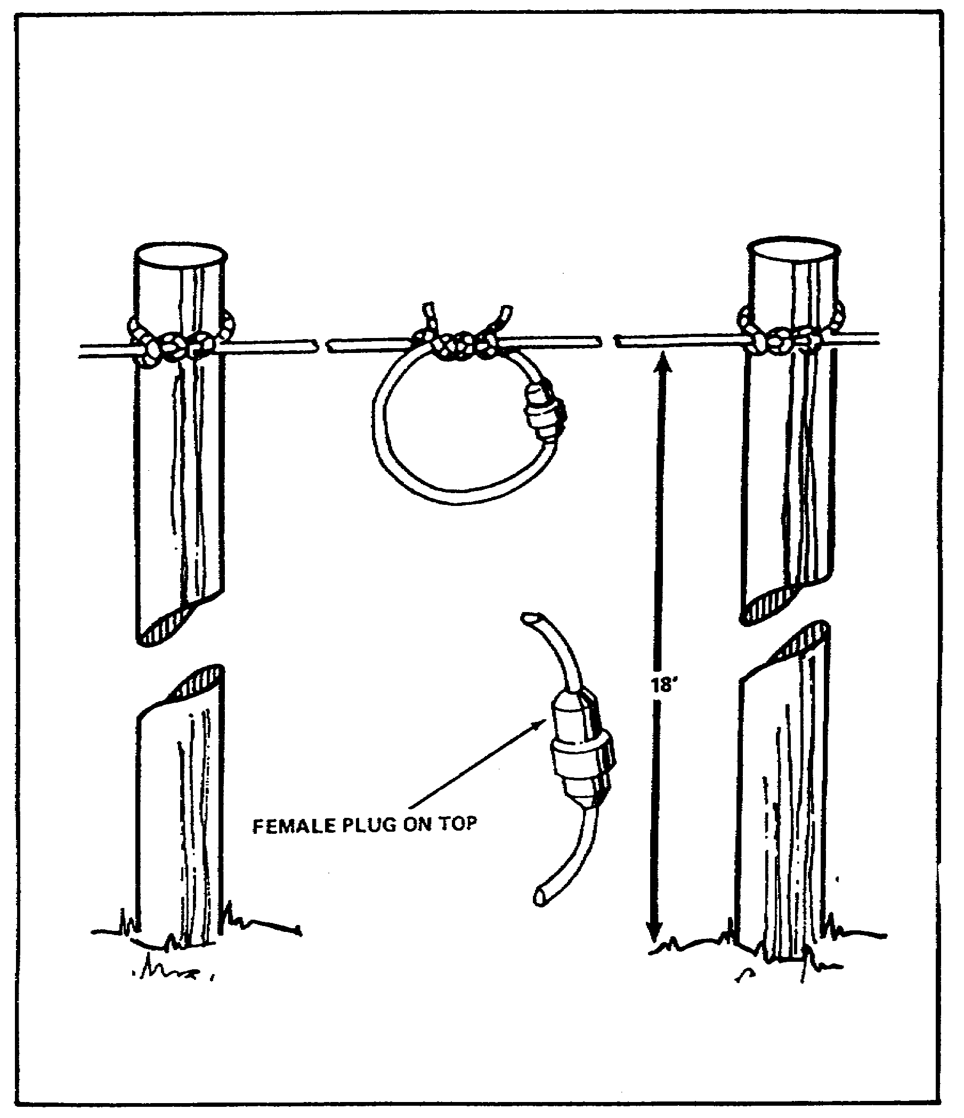

FIGURE 10. OVERHEAD DISTRIBUTION, QUICK
DISCONNECTS BETWEEN POLES.

67

OD0973 - Lesson 3/Learning Event 3

Burial of Cables

Burial of cables is normally done only for a permanent type location. Direct burial of cables requires a few simple precautions to ensure uninterrupted service.

o A trench must be dug so that the cable will be at least 18 inches deep. This will prevent disturbance by subsequent surface digging. Be certain to select a moisture-proof cable.

o Lay the cable over a sand cushion. If this is not practical, loosen the trench base so it is cleared of rocks or stones.

o Uniformly separate the cables. A minimum of 6 inches between centers is desirable (figure 11, below).

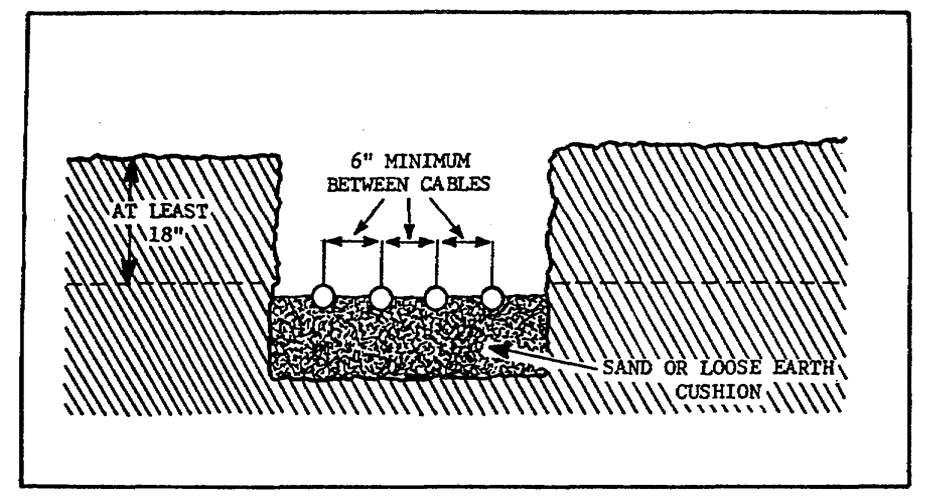

FIGURE 11. BURIED CABLE.

o After laying the cable, cover it with earth free from stones, rocks, or other material that may damage the cable.

o When burying cable equipped with quick disconnects, the joints must be waterproofed. Use whatever method is available.

Laying Cable on the Ground

This method will probably be the most widely used because of the time saving involved. Since most portable generators

68

OD0973 - Lesson 3/Learning Event 3

can be moved almost to the point of use, it may only be necessary to lay the cable over the ground to the load.

Protection in the form of planks or logs will prevent mechanical injury. Normally, the distance from the power plant to the load will determine whether the cable can be placed on the ground.

Lay the cable so that it will create a minimum of interference with normal personnel operation. Provide personnel with warning signs of the cable location. Be certain to select the proper cable, since it must be weatherproof to withstand any inclement weather.

CONNECTING THE LOAD CABLE

In order to distribute the generated power, a direct line between the generator and the load can be used when relatively few items are to be connected.

Or, a distribution center may be appropriate where the phase and voltage requirements vary and loads are scattered. In either case, the loads must be balanced between phases. FM 20-31 contains formulas for balancing various loads.

Load Panel

All sets are equipped with load panels containing four studs marked L1, L2, L3, and LO. These panels make connecting the cable at the generator convenient.

Distribution Center

There are a number of reasons for using a distribution center (figure 12, on the next page) when setting up a portable generation plant.

A generating plant that has sufficient capacity to meet the total power demand of the electrical load may not be available. In this case, it may be practical to use two or more generating units and collect their paralleled outputs at one central point for distribution.

More often, the electrical equipment requiring power from the generator(s) may be scattered in a manner that requires the use of two or more feeder lines. Then the distribution center may be used to control these branches from one central point.

69

OD0973 - Lesson 3/Learning Event 3
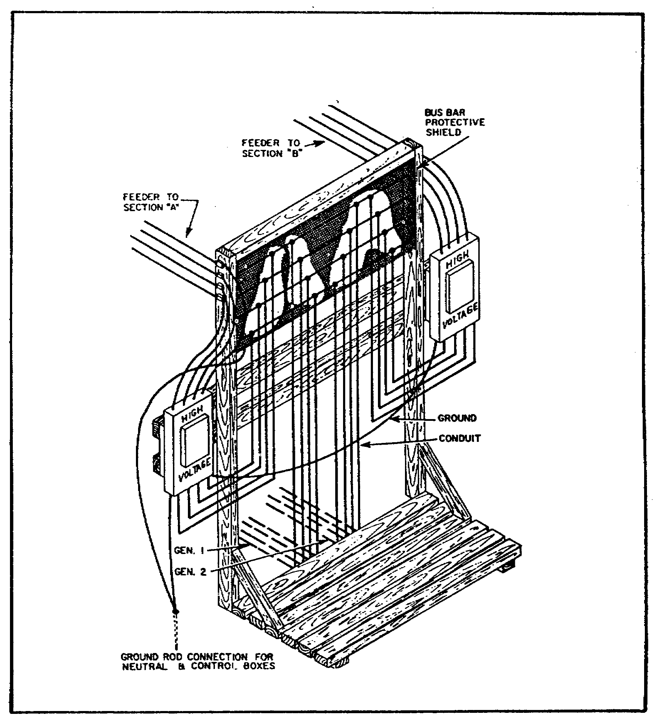

FIGURE 12. BUS BAR DISTRIBUTION CENTER.

PARALLELING GENERATORS

When the load requirements cannot be handled by one generator set, two or more sets can be paralleled. Parallel operations will give the same output voltages, but will increase the available power.

70

OD0973 - Lesson 3/Learning Event 3

Paralleling and Synchronizing

This information is very general; for specific information, refer to the technical manual (TM) for the generating set.

NOTE

Generators to be operated in parallel must have the same electrical characteristics. This does not mean that the KW or speed of the generators must be the same. However the voltage speed droop, phase rotation, frequency, and voltage output must be similar for both generators. This information can be found in the generators' manuals.

o Connect a No. 6 (AWG) copper wire between the ground terminals of both generator sets to provide a common ground connection.

o Set both sets for the same voltage.

o Designate one generator as the operating unit. The other generator set will be referred to as the incoming unit.

o Connect jumper wires between corresponding load terminals of both generator sets (i.e., L1 to L1, L2 to L2, etc.).

o Place the parallel and synchronizing lamp switches of both units in the ON position.

o Place the operating unit in single unit operation (this will be described in the next learning event).

o Place the incoming unit in single unit operation, but do not place the main circuit breaker in the ON position.

o Observe the synchronizing lights of the incoming unit. If they go on and off alternately rather than simultaneously, STOP both generator sets. Reverse any two of the terminals L1, L2, or L3 of the incoming unit. Do not change the load at LO terminal.

o Start both generators again, but do not turn on the circuit breaker to the incoming unit.

71

OD0973 - Lesson 3/Learning Event 3

o Adjust the governor speed control of the incoming-unit to that the synchronizing lights g? on and off at not less than 3-5 second intervals.

o When the synchronizing lights become dark, quickly move the main circuit breaker of the incoming unit to the ON position. The sets are now operating in parallel.

Kilowatt Load Division

Generator sets operating in parallel must divide the kilowatt load in proportion to their ratings.

To divide the kilowatt load between the two generator sets, increase the speed on the unit showing less than its load share on the wattmeter. Reduce the speed of the other unit until the proper load division is indicated.

If the frequency of the system has changed during the load division procedure, adjust both speed controls simultaneously until the correct line frequency is obtained.

Ampere Load Division

Generator sets operating in parallel must divide the ampere loads in proportion to their ratings.

To divide the ampere load between the two generator sets, turn the voltage control clockwise on the unit showing less than its share on the alternating current ammeter. Turn the voltage control counterclockwise on the other unit until the proper load division is indicated.

If the voltage of the system has changed during the load division procedure, turn the voltage controls on both generators simultaneously until the correct line voltage is obtained.

In this learning event, the proper procedures for connecting the generator set to the equipment that it is supporting has been discussed. You have also learned how to monitor the paralleling of generators to provide more power. If needed, refer to FM 20-31 for additional information relating to paralleling, connecting parallel generators to the bus bar, and restarting parallel units after a forced shutdown.

In the next learning event, the procedures for proper operation of the generator set will be discussed.

72

OD0973 - Lesson 3/Learning Event 4

Learning Event 4:
DESCRIBE THE PROCEDURES USED IN OPERATING THE POWER GENERATION SET

General information concerning the installation and operation of generators can be found in FM 20-31. The operator should have the technical manual for the generator set on hand before operating any power generator. For more detailed information, the technical manual should be consulted.

STARTING AND STOPPING THE GENERATOR

The general instructions outlined in this learning event pertain to both diesel and gasoline driven generators.

Preparation for Starting

Open the control panel, generator, and engine doors. Then proceed with the following steps:

Step 1. Perform the before operation services as described in learning event 1, starting on page 59.

Step 2. Make the necessary load connections to the generator set as described in learning event 3, starting on page 71.

Step 3. Place the fuel selector valve in the SET TANK or AUXILIARY position.

Step 4. Set the fuel distribution valve to the ENGINE position.

Fuel System Priming

Priming the fuel system is necessary when the generator set is being started for the first time, or when the unit has been allowed to run out of fuel. Priming may also be necessary when air has entered the fuel line during maintenance.

Starting the Engine

The generator should be started in accordance with the instructions found on the starting and stopping instruction

73

OD0973 - Lesson 3/Learning Event 4

plate. This plate is located inside the main control panel cover of the generator.

Check Engine Operation

As soon as the engine starts, the coolant temperature and oil pressure should be checked. Refer to the equipment manual for cold operation readings. If the readings are not within the normal range, the engine should be stopped and the cause determined.

Run the engine at rated speed, without loading, for about 5 minutes to allow the engine to warm up. Turbine engines may be fully loaded immediately upon reaching the rated speed.

Check the coolant temperature and oil pressure again. For gas turbine units, check the exhaust temperature and the oil pressure. Refer to the equipment manual for normal operation readings.

The battery-charging ammeter should show a slight positive charge.

Applying the Load

The load should be applied by following the ten steps listed below:

Step 1. Place unit parallel synchronize lamp switch in the off position.

Step 2. Place ammeter-voltmeter switch in any phase setting except the L-3-LO OFF position.

Step 3. Adjust the voltage control until the voltmeter indicates the desired voltage.

Step 4. Adjust the governor speed control until the desired frequency is indicated by the frequency meter.

Step 5. Turn the ammeter-voltmeter switch to other phase positions and check the voltmeter to ensure the voltage is correct.

Step 6. Apply the load by placing the main circuit breaker in the ON position.

Step 7. Turn the ammeter-voltmeter switch to each phase position and observe the ac ammeter. If the rated load is

74

OD0973 - Lesson 3/Learning Event 4

exceeded for any phase position, reduce the load, or report the condition to unit maintenance personnel.

Step 8. Check the kilowatt meter reading. If the rated load is exceeded, reduce the load, or report the condition to unit maintenance.

Step 9. Adjust the governor speed control until the correct reading is indicated on the frequency meter.

Step 10. Adjust the voltage control until the voltmeter indicates the desired voltage.

Stopping the Engine

The method for stopping diesel or gasoline driven generators is basically the same. For any special stopping instructions, consult the starting and stopping instruction plate.

o Trip or open the circuit breaker or the main switch.

o Operate the generator with no load until the temperature has stabilized.

o Turn all switches to the OFF position.

o Close all fuel valves.

GENERATOR MAINTENANCE

Generator sets usually contain two generators which are operated alternately. This permits performance of preventive maintenance checks and services (PMCS) on the one not in use. When using only one generator, it must be pulled out of service to have maintenance performed. This must be done in accordance with the technical manual, and the lubrication order for that generator.

Taking short-cuts by not using proper procedures often leads to faulty repairs. The motor officer should check to ensure that generator personnel are properly trained in the operation and repair of the generator.

Using 55 gallon drums as auxiliary fuel tanks on tactical generators can lead to operator maintenance neglect because of the long periods between maintenance.

A common cause of engine malfunction is contaminated fuel. Contamination starts with improper fuel storage. The

75

OD0973 - Lesson 3/Learning Event 4

appropriate publication on the storage of fuels and lubricants should be checked.

Preventive Maintenance

To ensure that the generator set is ready for operation at all times, it must be inspected systematically. Defects are thereby discovered early and corrected before they result in serious damage or failure.

The preventive maintenance checks and services to be performed are normally listed and described in the operator's manual for the generator.

Defects discovered during operation should be noted for future correction to be made as soon as operation has ceased. Stop operation immediately if a deficiency is noted that would damage the equipment, or endanger a life.

Faults that cannot be corrected by the operator, or those that can be corrected only by replacing parts, should be recorded on DA Form 2404. DA Pam 738-750 should be consulted for information on the use of DA Form 2404.

You have now completed this lesson on power generation. You should be ready to take the practice exercise. If you have problems with the exercise, review the text and repeat the exercise.

76

OD0973 - Lesson 3/Practice Exercise 3

PRACTICE EXERCISE 3

INSTRUCTIONS

This practice exercise will show you how much you have learned in this lesson. Answer each question. When you are done, turn the page to check your answers.

SITUATION

You are the motor officer monitoring the initial planning, set-up, and operation of generators at a field site.

1. The site for the generator has been determined, and you
are monitoring the building of a shelter for the generator.
The shelter entrance should be oriented so that the entrance
faces which direction?

A. Toward the prevailing wind

B. Away from the prevailing winds

C. Toward the east

D. Toward the west

2. When mounting the generator in the shelter, you notice
that the ground is not level. You tell the generator
operator to make sure that the generator is leveled-so that
it does not tilt more than ________ degrees?

3. You have been informed by the generator operator that
the standard military ground rod for the generator has
inadvertently been forgotten at garrison. You advise the
soldier that a ______________ electrode or a ______________
electrode may also be used.

4. You are supervising the installation of overhead cable
to the power loads. The cable must cross over a roadway.
You tell the soldier to make sure the cable is at least
feet above the road to allow for sufficient
vehicle clearance.

77

OD0973 - Lesson 3/Practice Exercise 3

5. You calculate that the load requirements cannot be
handled by one generator set. You decide to parallel two
generators. This will give you the same output
____________ , but will increase the available ______________ .

6. You are monitoring the starting procedure for the
generator. After starting the generator, the operator
should check the _____________________________ and the
________ _________________to ensure it is safe to operate the
generator.

78

OD 0973 - Lesson 3/Practice Exercise Answers

LESSON 3. PRACTICE EXERCISE - ANSWERS

1. A. toward the prevailing wind (page 57, para 2)

2. 15 degrees (page 57, para 9)

3. pipe electrode or plate electrode (page 61, para 9)

4. 20 feet (page 65, para 10)

5. voltages, power (page 70, para 1)

6. coolant temperature, oil pressure (page 74, para 2)

If you had a hard time getting the right answers, go back and review the lesson. If you did well on this practice exercise, you should be ready to start the next lesson.

79

OD0973 - Lesson 4/Learning Event 1

LESSON 4

THE ARMY OIL ANALYSIS PROGRAM

TASK

Describe the methods used to supervise the Army Oil Analysis Program.

CONDITIONS

You are the motor officer assigned to a battalion motor pool. You are expected to have sufficient training and experience to manage and supervise all functions of the motor pool and maintenance operations, given the necessary references to perform your mission.

STANDARD

Demonstrate your comprehension of the task in accordance with AR 750-22, DA Pam 750-5, TB 43-0210, and TB 43-0211.

REFERENCES

AR 750-22
DA Pam 750-5
TB 43-0210
TB 43-0211

INTRODUCTION

The Army Oil Analysis Program (AOAP) is part of a DoD-wide effort. This effort is geared to detect impending equipment component failures and lubricant condition. This is accomplished through periodic evaluation of oil samples.

Oil analysis is a diagnostic tool. It is used to determine the internal condition of engines, gearboxes, transmissions,

80

OD0973 - Lesson 4/Learning Event 1

and other oil-lubricated systems. Oil analysis also permits on-condition oil change (OCOC). This is where the oil is changed on the basis of oil quality rather than at a fixed period of time.

Learning Event 1:
DESCRIBE THE METHODS USED TO SUPERVISE THE ARMY OIL ANALYSIS PROGRAM

Just as the doctor checks your blood for diseases, AOAP laboratory technicians analyze your oil samples to determine what is going on inside your engine.

THE ARMY OIL ANALYSIS PROGRAM

Oil analysis is simply a maintenance tool, but AOAP is a mandatory program. As with any other maintenance tool, it must be used properly to be effective.

All Army commands, both active and reserve components, participate in it. They sample several hundred different types of Army aircraft and ground equipment.

The oil analysis principle is simple: residue suspended in the oil of a component indicates the parts that are wearing out and the degree of wear.

The Purpose of AOAP

The purpose of AOAP is as follows:

o To detect potential component failure.

o To determine oil serviceability and the necessity for oil change.

o To extend oil life and conserve resources.

o To reduce maintenance costs through preventive maintenance. This decreases the need for major repair.

o To develop a data bank relating to component wear or failure.

The time it takes to draw an oil sample can save hours of maintenance downtime. A sample, properly taken and submitted, can provide the motor officer with information about the condition of his equipment and the quality of his maintenance.

81
OD0973 - Lesson 4/Learning Event 1

Equipment reliability is improved through AOAP. For aircraft, this results in an increased safety factor. For ground equipment, actual design changes and product improvements have been proposed solely on the basis of oil analysis findings.

By detecting the signs of impending failure at an early stage, maintenance can be performed at a lower level. In the short term, this decreases maintenance support costs. In the long run, it improves readiness by reducing the number of items not operationally ready due to maintenance.

SAMPLING PROCEDURES

As a leader, in most cases, you will not be taking oil samples personally. However, you should know how and when they are taken. You should also be familiar with the supplies that are needed, what constitutes a good sample, and what paperwork is involved.

Supplies

The sampling supplies your motor pool will need for AOAP include:

8125-01-082-9697 Sampling Bottle

6515-00-727-0008 50 cc Syringe

4720-00-580-6055 Nonmetallic Tubing,
3/8th inch inside diameter

8105-00-290-0340 Shipping Sack

8105-00-837-7754 Plastic Bag

Some supplies, such as the bottle, sack, and tubing are not reusable. Therefore, units should maintain a 90 day supply.

Taking a Sample

To ensure getting a representative sample, it is always necessary to bring the component to operating temperature.

Sampling can then be done by one of two methods: the valve method and the tube method. No matter which method is used, care must be taken because the oil could be hot enough to burn bare skin.

82

OD0973 - Lesson 4/Learning Event 1

The Valve Method. To make sampling easier, sampling valves have been authorized for installation on the following equipment:

o Tanks--AVDS 1790-series engine and CD 850 transmission.

o M113A1-series vehicles--6V53 engine.

o SP Artillery and M578--8V71T engine.

o Tactical Wheeled Vehicle Engines.

To sample with a valve, drain a small amount of oil into a clean container. Then, fill the sample bottle from the valve. Fill the bottle to the bottom of the neck. Seal the bottle and return the excess oil to the component.

The Tube Method. Drawing a sample from a vehicle that doesn't have a valve is more complicated. First, cut a length of tubing to the length of the dipstick. Cutting the tubing at an angle rather than straight across helps prevent contamination. Remove the dipstick and insert the tubing. Avoid scraping the bottom of the crankcase with the tubing. The sludge on the bottom of the crankcase will ruin the sample.

Then, connect a 50 cc syringe to the end of the tubing. Pull the syringe plunger out as far as it will go. Oil will be drawn into the tube. Make sure that no oil is drawn into the syringe. Empty the oil into the sample bottle. Repeat this process until the bottle is filled to the bottom of the neck. Do not overfill the bottle.

What is Sampled and When?

When is your equipment sampled? There is no one answer. Hundreds of different end items are included in AOAP. They are identified and listed individually in TB 43-0106 and TB 43-0210.

Although these listings show when to take routine samples, you will also be required to supply the laboratory with special samples. Special samples are made:

o At the laboratory's request.

o Before an oil change.

o Before maintenance on any oil-wetted part.

83

OD0973 - Lesson 4/Learning Event 1

o Before removal of any major oil-lubricated assembly.

o After indication of internal damage to an oil-lubricated assembly.

o After maintenance, overhaul, or replacement of an oil-lubricated assembly.

o When a vehicle is removed from storage and before use.

If you are forced to take a sample from a cold engine (if it won't run at all), there is a space to note that fact on the form that accompanies the sample (DD Form 2026).

Preparing the Sample for Shipment

Complete the label on the bottle with a pencil or ball-point pen. Special samples should be banded with red tape or something similar, per TB 43-0210. Prepare DD Form 2026 (Oil Analysis Request Form). Place the sample bottle in the plastic bag. Place the DD Form 2026 and the oil sample bottle with plastic bag into the shipping sack. Address the sack to your oil analysis laboratory.

Mailing the Sample

Once the sample is taken and the bottle sealed, it is up to your unit to get it to the laboratory as quickly as possible. It does little good to sample a vehicle which is nearing a deadlining fault and then hold the sample up until there are several bottles ready to go. Although that might save some postage or courier time, it could cost the government an engine or transmission.

AOAP FORMS

Most of the communication between your unit, the laboratory, and various maintenance echelons is done with paperwork. There are only six forms involved, but some serve dual purposes. We will discuss the purpose and disposition of these forms. Procedures for filling out the forms are contained in AOAP reference publications. A chart showing the AOAP paperwork cycle is shown in figure 13, on the next page.

84

OD0973 - Lesson 4/Learning Event 1
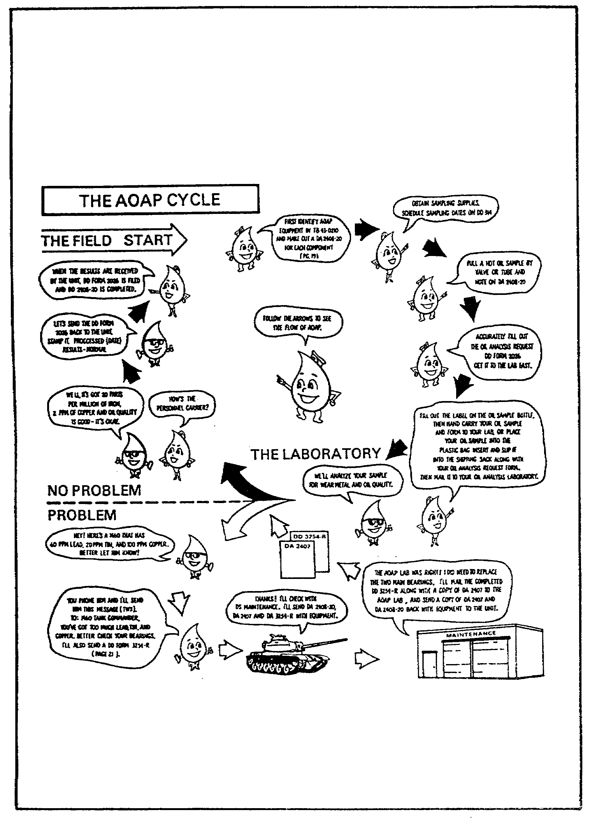

FIGURE 13. THE AOAP CYCLE.

85

OD0973 - Lesson 4/Learning Event 1

DA Form 2408-20

DA Form 2408-20 (Oil Analysis Log) is the historical record of oil samples taken and the results of lab analysis.

o A separate DA Form 2408-20 will be maintained for each component in AOAP.

o This form will he kept with the equipment's DD Form 314.

o The completed DA 2408-20 will be kept for a period of 6 months after the last entry is made, and then destroyed.

o If a component is removed, the DA 2408-20 will accompany the component.

o TB 43-0210 tells you how to fill out this form.

DD Form 314

DD Form 314 (Preventive Maintenance Schedule and Record) is used to schedule oil samples. If the laboratory has detected a problem in your equipment, it may schedule samples at intervals shorter than normal. This allows the laboratory to monitor the equipment's condition. If this is the case, suspend the use of DD Form 314 until your equipment is returned to a normal shipping interval.

DA Pam 738-750 is the reference concerning use of this form.

DD Form 2026

DD Form 2026 (Oil Analysis Request) is the form sent to the laboratory along with the oil sample. Any special information from you to the laboratory goes in the REMARKS block. This may include the symptoms that indicate that there is a problem, or special maintenance performed since the last sample was sent. Too much information is better than too little.

Be sure to indicate the method by which the sample was taken. If the sample was taken by the valve method, check the block labeled DRAIN. If the sample was taken by the tube method, check the block labeled TUBE.

If your sample is normal and no potential trouble is found, the laboratory tells you by returning the DD Form 2026 stamped NORMAL.

86

OD0973 - Lesson 4/Learning Event 1

If there is something wrong with your oil sample, the laboratory will request another sample by telephone. They will follow up the telephonic request with the annotated DD Form 2026.

When maintenance action is called for, your unit will be notified immediately by telephone and they will receive a DA Form 3254-R suggesting specific action.

DA Form 3254-R

DA Form 3254-R (Oil Analysis Recommendation and Feedback) is used by the laboratory to report its findings and suggest what work may be necessary. This information is based on the laboratory's analysis of the sample.

Repair the equipment as necessary. If your equipment must be overhauled by support, be sure to send a copy of DA Form 2407 and DA Form 3254-R with the component.

After repair, complete the bottom of the DA Form 3254-R and send it back to the lab, together with a copy of DA Form 2407. This must be accomplished within 5 days after completion of the repairs.

This feedback is used to refine evaluation criteria, to increase the accuracy of predictions, and to recommend equipment design changes.

DA Form 2407

DA Form 2407 (Maintenance Request) accompanies the DA Form 3254-R if the equipment must go to a higher level of maintenance for repair. Support shops must include cost and man-hour data.

SF 368

SF 368 (Quality Deficiency Report) is used only on aircraft. It is used to report to the Army Troop Support and Aviation Materiel Readiness Command in cases of laboratory-directed component removal. This form serves as an Equipment Improvement Recommendation.

RESPONSIBILITIES

The most important ingredient in the AOAP "mix" is people-- people who believe in the importance of the program and are

87

OD0973 - Lesson 4/Learning Event 1

willing to spend their time and energy to make it successful.

The burden falls on several individuals in a unit's chain of command. It starts with the crew chief or NCO in charge of a piece of equipment and ends with the support maintenance officer.

Consider the responsibilities of the personnel in a company-level chain of command.

Crew Chief/NCOIC

The Crew Chief/NCOIC's responsibilities include:

o Ensures that personnel who draw samples are properly trained in the procedures.

o Ensures that samples are drawn according to the schedule set up on DD 314.

o Checks all entries made on the DD Form 2026.

o Ensures that all laboratory-directed maintenance is performed.

o Completes the bottom of DD Form 3254-R within 5 days of the completed maintenance.

o If the required maintenance is above his shop level, ensures that the DA Form 3254-R, 2407, and 2408-20 are sent along with the equipment to support maintenance.

o Ensures that annotated copies of both DA Form 2407 and DA Form 3254-R are sent to the laboratory through the AOAP monitor at company level.

Company-Level Monitor

Each unit from company through division/installation, has an AOAP monitor appointed by the appropriate commander. At company level, it might be the motor sergeant. However, any responsible person can be given the job. The duties of the AOAP monitor are as follows:

o Acts as the liaison between the unit and the laboratory.

o Checks all paperwork and samples prior to sending them to the laboratory.

88

OD0973 - Lesson 4/Learning Event 1

o Ensures the units AOAP is organized correctly.

o Makes sure that an adequate amount of sampling supplies and forms are always on hand.

o When notified of an abnormal sample and advised to perform some laboratory-directed maintenance action, gets the word to the user immediately.

o Ensures that the maintenance is performed and that the Crew Chief/NCOIC forwards DA Form 3254-R to the laboratory within 5 days.

o When laboratory-directed maintenance must be performed 'by a higher level of maintenance, ensures that the Crew -Chief/NCOIC forwards the proper paperwork with the ,equipment.

o Makes sure that the 2408-20 historical record is posted.

In short, the AOAP monitor responsibility is to monitor all .phases of the program. This includes the training performance and follow-through of the AOAP program within the unit.

Motor Officer

The duties of the Motor Officer are as follows:

o Acts as the head of unit level maintenance.

o Initiates DA Form 2408-20 for each component to be sampled.

o Establishes a sampling schedule on the DD Form 314 for each piece of equipment.

o Prepares or reviews the DD Form 2026 for each sample taken.

o Records the results of all oil analyses on the DA Form 2408-20.

o Reviews the feedback going to the laboratory on the DA Form 3254-R.

o Ensures that all equipment going to higher maintenance is properly marked and accompanied by the proper forms.

89

OD0973 - Lesson 4/Learning Event 1

Unit Commander

The unit commander's responsibilities to the AOAP are to make sure that:

o AOAP training is being performed.

o The monitor maintains an adequate supply of sampling supplies.

o DA Forms 2408-20 are initiated by the maintenance officer.

o The maintenance officer has scheduled sampling on DD Form 314.

o All samples are taken.

o The monitor has forwarded samples with a properly prepared and posted DD Form 2026.

o The maintenance officer properly records analysis results on the DA Form 2408-20.

o Prompt and proper action is taken when an abnormal report is received.

o Maintenance feedback is being supplied to the laboratory as required.

o When the unit can't perform the maintenance, properly prepared DA Forms 2407 and DA Forms 3254-R are sent to the laboratory and the Direct Support (DS) unit.

You have now completed this lesson on the Arm: Oil Analysis Program. It should have answered any questions you may have had concerning what supplies are needed, or how an oil sample is taken. It also answered questions as to what paperwork is needed and the responsibilities of the chain of command in implementing the AOAP.

Now you should be ready to take the practice exercise on the next page. If you have problems with any of the answers, review the text and repeat the exercise.

90

OD0973 - Lesson 4/Practice Exercise 4

PRACTICE EXERCISE 4

INSTRUCTIONS

This practice exercise will show you how much you have learned in this lesson. Answer each question. When you are done, turn the page to check your answers.

SITUATION

You have just been assigned as the motor officer for Company D, a Transportation Battalion. The company has recently received additional vehicles to augment their expanded mission requirements. The commander asks you to ensure that the new vehicles and the other vehicles in the command are covered under the Army Oil Analysis Program.

1. You observe a wheeled vehicle mechanic drawing an oil
sample from a tactical wheeled vehicle's engine. What
sampling method should this soldier be using?

2. You need to know what vehicles must be included in the
AOAP. There are two publications that lists all vehicles
and components that are covered under the AOAP. What are
they?

3. You have identified which of your vehicles must be
included in the AOAP. Now you must initiate a form to
establish a sampling schedule for each piece of equipment.
What form would you use to schedule oil sampling.

4. Another form that the maintenance officer must initiate
and maintain is _____________________ . This form is the
historical record of oil samples taken and the results of
the lab analysis.

5. You are visiting with the unit's AOAP monitor. On his
desk, you notice two oil samples that are ready to be sent
to the lab. You ask him why the oil samples have not been
mailed. He tells you that he saves the oil samples until
there are enough to send together in a small box, so it will
save on postage. Should you accept his explanation? Why?

91

OD0973 - Lesson 4/Practice Exercise 4

6. You are reviewing a DD Form 2026 (Oil Analysis Request)
that was completed by your Motor sergeant. You know that
the engine that the sample was drawn from has recently had
new valves installed. Should this special maintenance
information be included on the DD Form 2026? Where?

7. You received a DA Form 3254-R from the laboratory
recommending that one of your vehicles have major repairs.
You forward the vehicle, the DA Form 3254-R, and a DA Form
2407 (Maintenance Request) to support maintenance. After
the vehicle is repaired, what action must be performed?

8. During an inspection of the supply room, you notice
that the supply of oil sampling materials is low. Who is
responsible for ensuring that there is always an adequate
amount of sampling supplies and forms?

92

OD0973 - Lesson 4/Practice Exercise Answers

LESSON 4. PRACTICE EXERCISE - ANSWERS

1. The valve method. (page 83, paras 5 & 6)

2. TB 43-0106 and TB 43-0210 (page 83, para 9)

3. DD Form 314 (Preventive Maintenance Schedule and Record)
(page 86, para 7)

4. DA Form 2408-20 (Oil Analysis Log)(page 86, para 1)

5. No, holding samples may result in damage to the engine
or transmission due to the delay in the lab analysis.
(page 84, para 7)

6. Yes, in the REMARKS block. (page 86, para 8)

7. The bottom of the DA Form 3254-R must be completed.
The completed DA Form 3254-R and a copy of the completed DA
Form 2407 must be returned to the oil analysis lab within 5
days. (page 87, para 5)

8. The company-level AOAP monitor. (page 89, para 2)

If you had a hard time getting the right answers, go back and review the lesson. If you did well on this practice exercise, you should be ready to start the next lesson.

93

OD0973 - Lesson 5/Learning Event 1

LESSON 5

MAINTENANCE MANAGEMENT PROCEDURES

TASK

Delineate the methods of maintenance supervision and management used by motor officers in the operation of motor pools.

CONDITIONS

You are assigned as a motor officer for a unit level motorpool. You are expected to have sufficient training and experience to supervise and manage all functions of the motor pool operations, given the necessary references to perform your mission.

STANDARD

Demonstrate your comprehension of the task in accordance with AR 700-138, AR 750-1, DA Pam 738-750, FC 25-20, FM 25-3, FM 29-2, FM 29-12, FM 43-1, and FM 101-5.

REFERENCES

AR 700-138
AR 750-1
DA Pam 738-750
FC 25-20
FM 25-3
FM 29-2
FM 29-12
FM 43-1
FM 101-5

94

OD0973 - Lesson 5/Learning Event 1

INTRODUCTION

In this learning event, the procedures for preparing military briefings and after-action reviews will be discussed. The motor officer will have many opportunities to brief audiences of peers and staff alike. He will also be responsible for reviewing the performance of personnel in both mission and training situations. Begin by considering the purpose, types, and procedures for conducting military briefings.

Learning Event 1:
DESCRIBE THE PROCEDURES FOR PREPARING BRIEFINGS AND AFTER ACTION REVIEWS ON MAINTENANCE MATTERS

BRIEFINGS

Briefings are a means of presenting information to commanders, staffs, or other audiences. The techniques used are determined by the purpose of the briefing, the desired response, and the role of the briefer.

Types of Briefings

There are four types of military briefings. They will be discussed separately.

Information. The information briefing is intended to inform the listener and to gain his understanding. The briefing does not include conclusions, recommendations, or require decisions. The briefing deals primarily with facts.

The briefer states that the purpose of the briefing is to provide information and that no decision is required. The briefer provides a brief introduction to define the subject and to orient the listener. He then presents the information.

Decision. The decision briefing is intended to obtain an answer or a decision. It is the presentation of the briefers recommended solution to a problem.

Decision briefings vary as to their formality and the amount of detail to be presented. In situations where the person receiving the briefing has prior knowledge of the problem, less information needs to be presented. The briefing may then be limited to a statement of the problem, essential

95

OD0973 - Lesson 5/Learning Event 1

background information, and a recommended solution. However, the briefer should be prepared to present his assumptions, facts, and possible alternate solutions if required.

When the person being briefed is unfamiliar with the problem, then a more detailed briefing will be required. In this case, the briefing should also include additional information. The briefing should include any assumptions used in analyzing the problem and all facts bearing on it. A discussion of the alternatives, conclusions, and the coordination involved is usually presented.

At the beginning of the briefing, the briefer must state that he seeking a decision. At the conclusion of the briefing, if the presenter does not receive a decision, he should ask for one.

Mission. The mission briefing is used under operational conditions. This briefing is used to provide information, to give specific instructions, or to instill an appreciation of the mission. The mission briefing reinforces orders, provides detailed instructions, and provides an explanation of the significance of individual roles.

Staff. The staff briefing is intended to secure a unified effort. This may involve the exchange of information, the announcement of decisions, the issuance of directives, or the presentation of guidance. The staff briefing may contain characteristics of the information, decision, and mission briefings. The staff meeting is usually attended by all staff members and is presided over by the Chief of Staff or the Executive Officer. He calls on staff members to present matters that interest those involved, or that require a coordinated staff action. Each staff officer should be prepared to brief on his area of responsibility.

Another type of staff briefing is the presentation of staff estimates. These staff estimates are used in the commander's decision to adopt a specific course of action. In this type of briefing, staff officers involved follow the general pattern prescribed for the staff estimate being presented.

Briefing Format

There are four basic steps in preparing and giving a military briefing. They are as follows:

96

OD0973 - Lesson 5/Learning Event 1

Analyzing the Situation. This step includes analyzing the audience and the occasion, by determining:

o Who is to be briefed and why?

o How much knowledge of the subject does the audience have?

o What is expected of the briefer?

Before briefing an individual the first time, the briefer should inquire as to the particular official's desires. The briefer must understand the purpose of the briefing. Is he to present facts or make a recommendation? The purpose determines the nature of the briefing.

The time allocated for the briefing will dictate the style, physical facilities, and the preparatory effort needed. The availability of physical facilities and visual aids must also be considered.

The briefer should prepare a detailed presentation plan and coordinate with his assistants, if used. The preparatory effort is carefully scheduled. The briefer should make a "briefing outline" (figures 14 and 15, on the next pages).

He then makes an initial estimate of the deadlines for each task. He schedules facilities for practice and requests critiques.

Constructing the Briefing. The construction of the briefing will vary with its type and purpose. An analysis provides the basis for that determination. The following are the major steps in preparing a briefing:

o Collect material.

o Know the subject thoroughly.

o Isolate the key points.

o Arrange the key points in logical order.

o Provide supporting data to validate the key points.

o Select visual aids.

o Establish the wording.

o Rehearse before a knowledgeable person who can critique the briefing.

97

OD0973 - Lesson 5/Learning Event 1
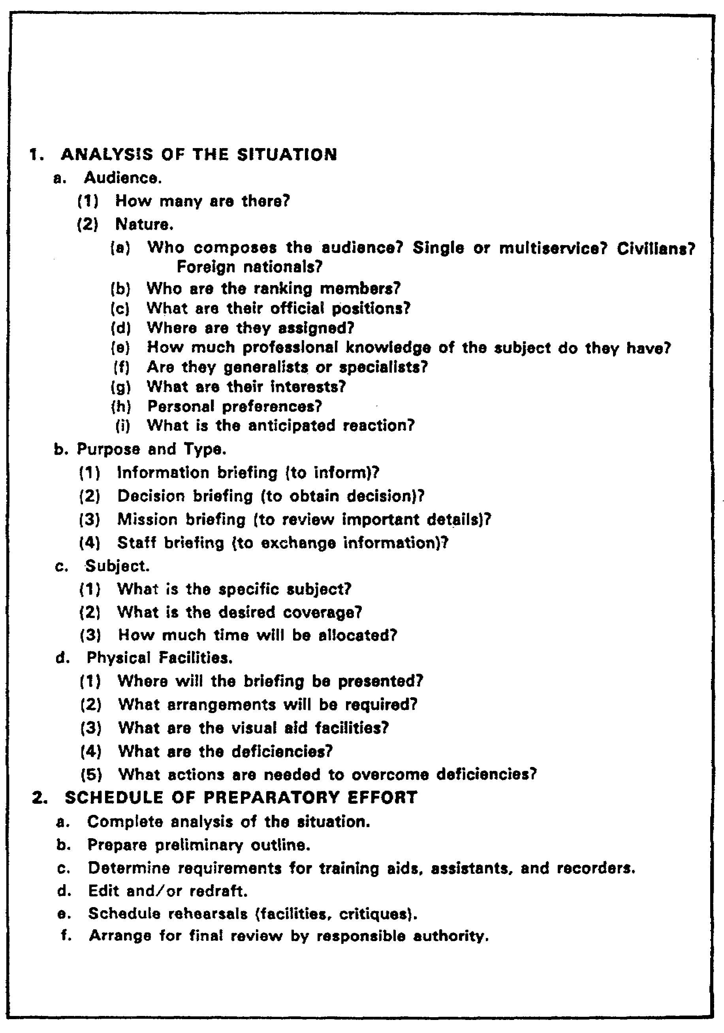

FIGURE 14. BRIEFING OUTLINE.

98

OD0973 - Lesson 5/Learning Event 1
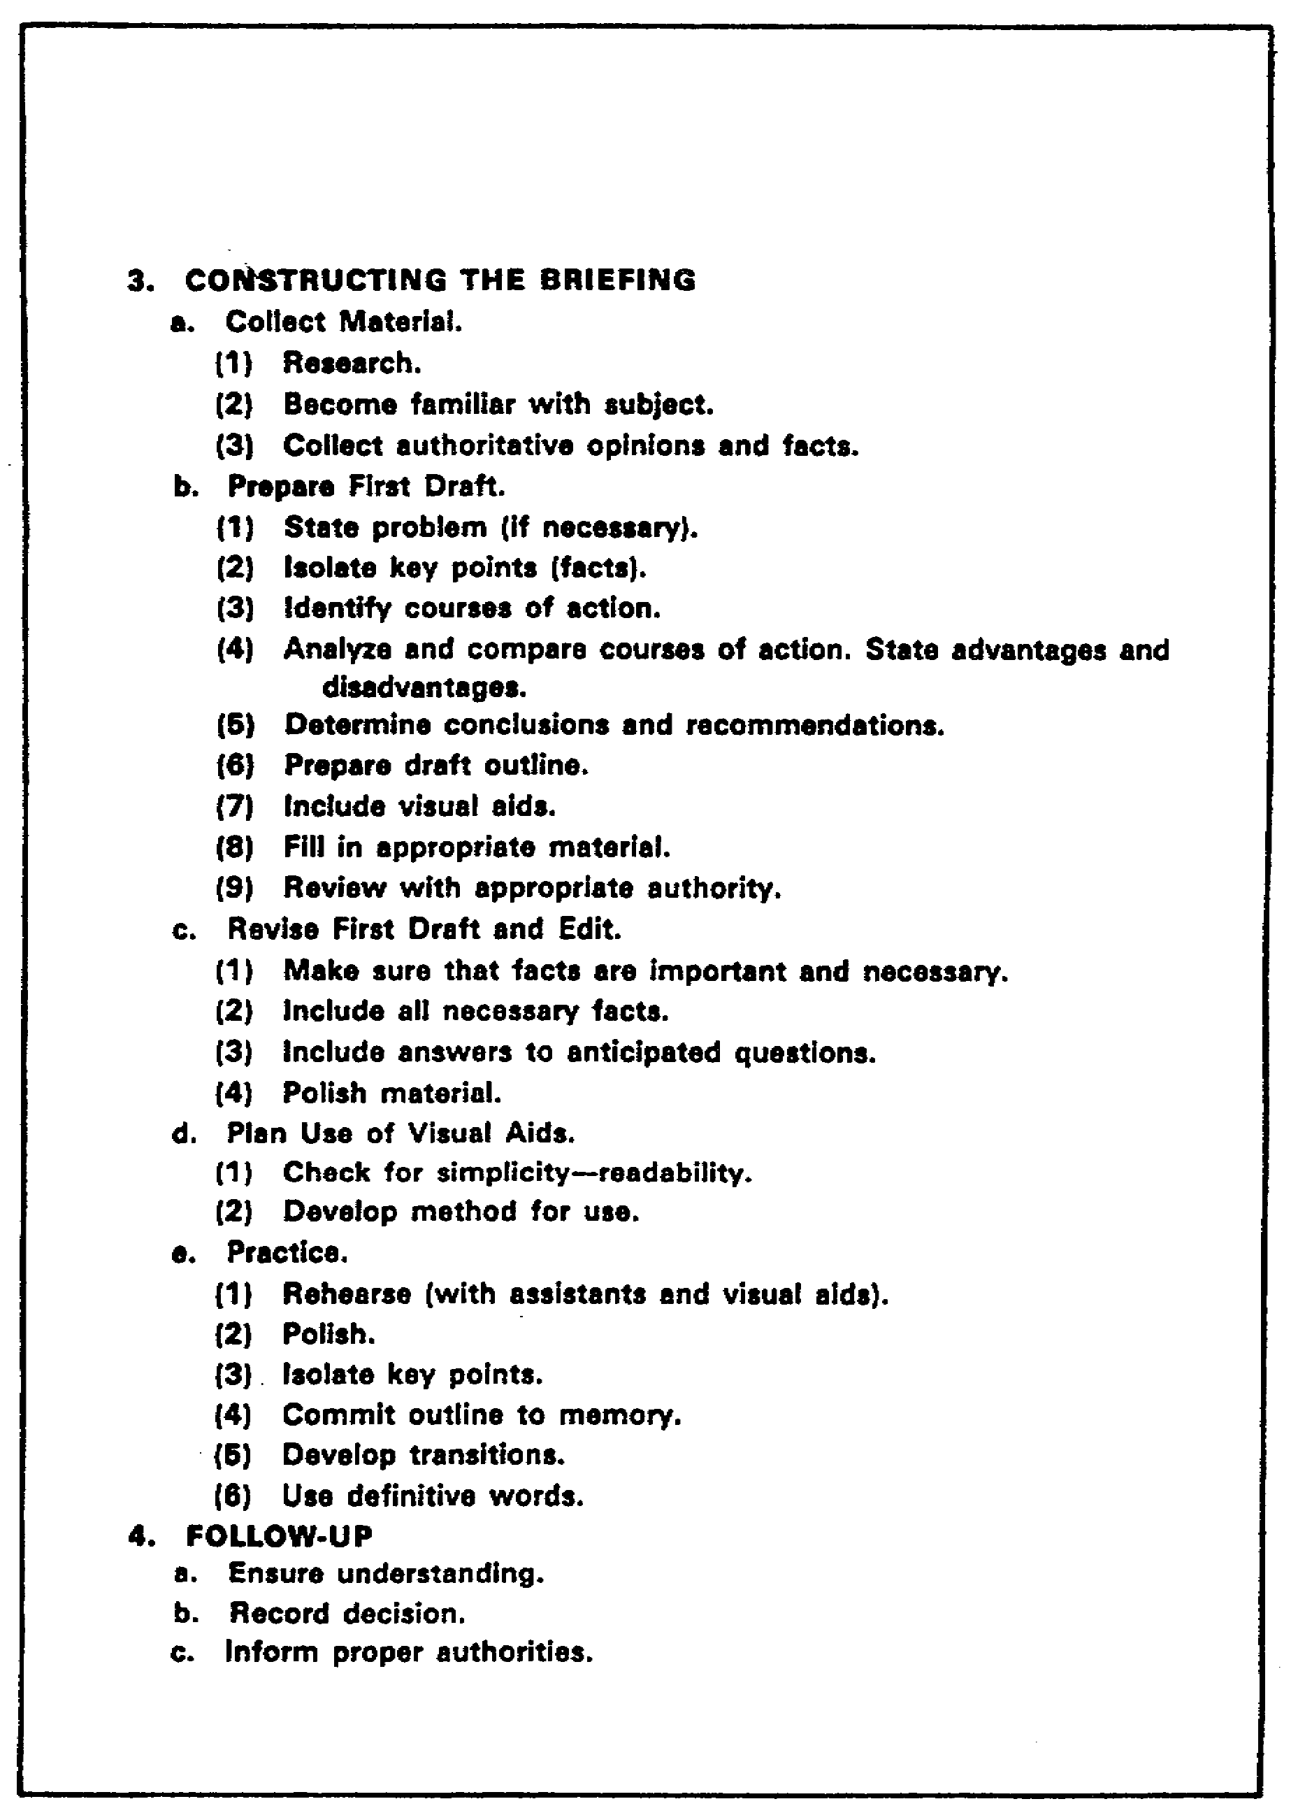

FIGURE 15. BRIEFING OUTLINE (CONTINUED).

99

OD0973 - Lesson 5/Learning Event 1

Delivering the Briefing. A successful briefing depends on how it is presented. A confident, relaxed, forceful delivery, clearly enunciated, and obviously based on a full knowledge of the subject, helps convince the audience. The briefer maintains a relaxed but military bearing. He uses natural gestures and movements, but avoids distracting mannerisms. The briefer's delivery is characterized by conciseness, objectivity, and accuracy. He must be aware of the following:

o The basic purpose is to present the subject and to ensure that it is understood.

o Keep the introduction and summary brief and concise.

o Logic must be used in arriving at conclusions and recommendations.

o Interruptions and questions may occur at any point. The briefer should answer questions as they occur, or tell his audience that the question will be answered later in the briefing. In this case, the briefer should make specific reference to the earlier question when he introduces the material. The briefer does not permit questions to distract him from his planned briefing. He must be prepared to support any part of his briefing. He anticipates possible questions and is prepared to answer them.

Follow-up. When the briefing is over, the briefer prepares a memorandum for record (MFR). This MFR should record the subject, date, time, and place of the briefing. It should also include the ranks, names, and positions of those present. The briefing's substance is recorded in a concise form. Any recommendations, approvals, disapprovals, or approvals with modifications should be recorded. Also, any instructions or directed actions, and who is to take action, must be included.

When a decision is involved, and there is doubt as to the intent of the decision maker, a draft of the MFR is submitted to him for corrections. After all corrections are made, the MFR should be prepared in final form. The MFR is then submitted to all staff or agencies that are influenced by or must take action on the decision.

This concludes the portion of the learning event pertaining to conducting military briefings. Another important method of disseminating information is the after action review; this will be discussed next.

100

OD0973 - Lesson 5/Learning Event 1

AFTER ACTION REVIEW

As a leader, you are responsible for training your soldiers. The after action review (AAR) is a powerful tool that can assist you in training your personnel. To effectively use the AAR, you must be familiar with the methods, techniques, and procedures in its use. They can be used at all levels of command, both in garrison and in field environments.

We will discuss the importance of conducting AARs and give a brief overview on how to conduct an AAR. For more detailed information and procedures, refer to FC 25-20 (A Leader's Guide to After Action Reviews).

What is an AAR?

In any training event, the critical link between training and evaluation is the after action review (AAR). An AAR is a review of collective training that allows soldiers to discover for themselves what happened in the training and why. It is a professional discussion that includes the training participants and focuses on the training objectives. Soldiers learn much more by identifying what went right and wrong than when lessons are dictated.

An AAR is not a critique, and has the following advantages over a critique:

o It does not judge success or failure.

o It attempts to discover why things happened.

o It focuses directly on key training objectives.

o It encourages soldiers to surface important lessons.

o More soldiers participate, so more of the training can be recalled and more lessons learned can be shared.

Purpose of AARs

The emphasis in training is to achieve specified standards. The AAR is a method of providing immediate feedback to the soldiers being trained. This feedback will:

o Reinforce and increase the learning that took place as a result of the training exercise.

o Increase soldier and leader interest and motivation.
l01

OD0973 - Lesson 5/Learning Event 1

o Identify and analyze both strengths and weaknesses.

This, in turn, will improve the quality of the training and bring the training results closer to the specified standards.

Planning for an AAR

There are several items that must be accomplished prior to the start of the training that is to be reviewed. The AAR leader should ensure that the following details are planned and incorporated into the training exercise:

Select Qualified Observers. Whenever possible, select observers who will not be involved in the training. Observers should not have other duties which would detract from their observation. If this cannot be done, leaders in the chain of command should evaluate their subordinate elements. Observers should be briefed on how and where to observe the training and what input is needed from them during the AARs.

Review Training and Evaluation Plan. The observers you have selected will not be capable of observing and evaluating every action in the exercise. You must tell them specifically what you intend to accomplish in the training. Your training and evaluation outline (T&EO) list the mission, drills, and tasks which require special attention.

Determine Attendance. Specify who must attend each AAR. You, as the AAR leader, may recommend additional participants based on specific observations. Select as many participants as you can reasonably expect to handle at the AAR site.

Plan Stopping Points During the Exercise for AARs. It would be difficult for an observer to review an entire exercise at one AAR. In planning your training, you must also allow time to conduct AARs. Schedule AARs at the end of each essential task or major event.

Make Potential Site Selections. The sites you select for holding the AARs should be as close as possible to the training area. Allow space for participants to gather in easy sight and hearing range of the AAR leader. The site should be as free as possible from outside distractions.

102
OD0973 - Lesson 5/Learning Event 1

You may not want to hold an AAR in the middle of your maintenance area, unless you are reviewing that area.

Select Training Aids. Training aids can add to the AAR's effectiveness. Blow-ups of terrain or road maps, terrain tables, or a chalk board can be extremely useful.

Review the Plan. The AAR plan is not a final product. You should review and adjust the plan as necessary during the preparation for training.

Preparing for the AAR

As you prepare to observe and evaluate your squad or elements, you will follow a series of steps to prepare your AAR. You must start before the training and continue to prepare until the actual review. Several distinct actions must occur to ensure the AAR is effective. These actions are:

o Review the training objectives, orders, and doctrine. You must be thoroughly familiar with the training goals.

o Observe the training. Make sure you and/or your selected observers are properly positioned to evaluate the training without interfering with or detracting from the exercise.

o Take notes. You and/or your observers should keep written records of what is seen or heard. As a minimum, record the time of the observation and a quick description of what happened.

o Organize the AAR site. Set up tents, training aids, and other necessities needed to conduct your AAR.

o Collect information from the observers. You must have a complete picture of what happened during the training before conducting the AAR.

o Organize your notes in a chronological sequence so you can visualize the flow of events. Next, select the critical events and sequence them in order of their relevance to the training objectives. You are now prepared to conduct an AAR.

103

OD0973 - Lesson 5/Learning Event 1

Conduct an AAR

Your personnel have just finished the portion of the training exercise that is to be reviewed. You have completed your AAR preparation and your personnel are gathered at the AAR site. You are ready to begin.

Before you start, make sure that all the participants are present. The soldier who is absent or late may have the key piece of information critical to reconstructing what happened. Insist that all key players attend.

Opening the AAR. Start with a brief restatement of the exercise's training objective. The AAR leader then calls upon other key personnel to participate with comments concerning the training exercise. This will encourage participation. From this point on, the AAR leader will guide the discussion, keeping the focus on the objectives. He should also attempt to keep the discussion flowing in an orderly sequence.

Guiding the Discussion. The most difficult task you face as an AAR leader is to avoid turning the discussion into a critique or lecture. You can avoid this pitfall by entering the discussion only when necessary. Limit yourself to asking questions. Ask why certain actions were taken, how personnel reacted to situations, and when was the action initiated. Limit your input to sustaining the AAR, guiding the discussion, or bringing out new points.

Below are techniques which will help you guide the discussion:

o Ask leading and thought-provoking questions that focus on the training objectives. Ask leaders what factors influenced their decisions.

o Have the unit members describe what happened in their own words and from their own point of view. They should be free to discuss what took place, how it took place, and why it took place.

o Relate tactical events to the subsequent results.

o Explore alternative courses of action that might have been more effective (How could it have done better?).

o Avoid detailed examination of events not directly related to the training objective.

104

OD0973 - Lesson 5/Learning Event 2

Discuss Leaders Errors. Frequently, the discussion will focus on errors made by leaders. This discussion should be frank without embarrassing the leaders involved. Emphasize the positive as much as possible so that lessons can be learned without destroying confidence or respect. Remind the unit that anyone in the unit could become the leader in combat. They too must learn to make decisions.

Ending the AAR. Once all the key points have been discussed and related to future training, you should leave the immediate area. This allows the leaders and soldiers the opportunity to discuss the events in private.

You have now been presented with the fundamental tools you need to conduct an after action review. This will assist you in providing your soldiers with the constructive feedback they need to improve their performance. The AAR provides the link between evaluation and training. Through open and honest discussion of events, all soldiers can share their experience and the lessons they learned in training.

Learning Event 2:
DESCRIBE THE PROCEDURES USED WHEN COORDINATING MAINTENANCE OPERATIONS AND TECHNICAL ASSISTANCE VISITS WITH THE STAFF

Technical assistance ensures that maintenance and supply policies and directives are used correctly and applied uniformly. This, in turn, will improve operations and conserve resources. Experience shows that for every manhour devoted to effective technical assistance, many manhours of repair are saved at a later date. Technical assistance may be provided by the supporting maintenance unit, by the maintenance assistance and instruction team (MAIT), or by the formal logistics assistance program.

Review these three types of maintenance assistance visits and the staff coordination that must be considered prior to and during the visits.

TECHNICAL ASSISTANCE TEAM

The supporting intermediate direct support (IDS) maintenance unit is the most readily available source of technical assistance. The maintenance unit may offer technical assistance based on:

o The number and condition of items received for maintenance.

105

OD0973 - Lesson 5/Learning Event 2

o Observation made during periodic liaison visits.

o Request from the supported unit or its higher headquarters.

Functions and Services

Technical assistance functions and services provided by the IDS maintenance unit's technical assistance team include the following:

o Conducting courtesy inspections of the user's equipment to determine the condition.

o Scheduling future support maintenance service requirements.

o Review the status of outstanding maintenance requests or supply requests.

o Coordinating procedural changes, SOP revisions, DX lists, etc.

o Interpreting new technical procedures.

o Assisting in establishing or updating prescribed load lists (PPLs).

o Advising the commander on accomplishing the unit maintenance and repair parts supply function.

o Advising the commander on the efficient use of materiel.

o Following up on supply requirements. This is performed to ensure that the unit has all repair parts and cleaning and preserving materials needed.

o Providing technical instruction and training assistance to unit maintenance and supply personnel.

Visits

Liaison visits to supported units should be made as often as the situation permits, or no less than once a quarter. These visits should be arranged by IDS with the using units. They should be scheduled when the maximum number of personnel and equipment are present. Emphasis is placed on visits to units whose materiel readiness reports indicate substandard conditions. The liaison team remains alert to

106

OD0973 - Lesson 5/Learning Event 2

indicators that suggest a need for technical assistance.
These include:

o An unexplained increase in job orders or supply requests.

o A high number of rejections during initial inspections.

o A high error rate in unit repair parts requests.

o A high number of maintenance discrepancies.

o General discontent among repairers concerning working relationships or working conditions.

o Future operations of the unit that may place heavy demands on equipment or personnel.

Periodic liaison visits offer the unit commander and the maintenance managers a chance to discuss their maintenance problems. These visits should never be considered as inspections, but as a tool in maintaining and upgrading the maintenance system.

MAINTENANCE ASSISTANCE AND INSTRUCTION TEAM PROGRAM

The Maintenance Assistance and Instruction Team (MAIT) program complements the technical assistance described above. It also helps commanders identify and solve materiel readiness problems.

The MAIT program provides the unit with a ready source of technical assistance. The program emphasizes maintenance assistance and gives commanders needed tools to maintain a high state of readiness. Technical experts are used to identify and solve continuing maintenance problems.

MAIT Indicators

The MAIT visit may be requested by a unit requiring assistance or by a higher headquarters. When arranging for the team visit, the team chief should be advised of known problem areas. This allows him time to select a team made up of experts in the particular problem area.

The need for MAIT assistance may be determined from review and analysis of readiness reports and the results of spot inspections. A MAIT visit may also be requested prior to,

107

OD0973 - Lesson 5/Learning Event 2

or after, an annual general inspection or other technical proficiency inspection.

Need for assistance may be further shown by results of equipment acceptance inspections or Army training tests. Critiques and observations from staff visits may also indicate the need for assistance.

Conduct of the MAIT

The conduct of the MAIT visit emphasizes what to do and how to do it in those areas where improvements are needed. The MAIT assistance and instruction include:

o Equipment conditions and serviceability.

o Use of tools and test equipment.

o Repair parts supply to include direct exchange.

o Maintenance personnel management and training.

o Records and reports management.

o Publications.

o Facilities/shop layout.

o Quality control procedures.

o New doctrine and techniques.

o Shop operations.

o Preventive maintenance and equipment repair.

o Unit readiness reporting.

o Modification work orders (MWOs).

o Calibration.

o Administrative storage.

o Unit training.

o Safety.

o Unit SOP.

108
OD0973 - Lesson 5/Learning Event 2

After the visit, the team chief gives the unit commander a list of problem areas and recommended actions. He does not evaluate or score the maintenance program. Arrangements may be made for follow-up actions to ensure logistics readiness improvement.

MAIT follow-up visits are done as needed to accelerate the progress of units experiencing special logistic problems. Details on the MAIT program can be found in AR 750-51.

FORMAL TECHNICAL ASSISTANCE PROGRAM

This source of assistance is authorized by AR 700-4. This regulation explains how to obtain the services of military and civilian technical specialists. These specialists are provided by the commodity commands. They are available to using units and supporting maintenance units. The services of such personnel must be requested and justified by major Army commands (MACOMs). Individual units requiring such services must make their requirements known through command channels.

STAFF FUNCTIONS AS THEY RELATE TO THE MAINTENANCE PROGRAM

When scheduling the visit of a technical assistance team, coordination with commanders and various staff members is necessary. The following is a list of officers who relate directly or indirectly to the maintenance program. This list provides information on how these officers can assist you in preparing for an maintenance team visit. It also includes other functions of the motor officer as they relate to the maintenance area.

Battalion Commander

The specific maintenance responsibilities of the Battalion Commander include:

o Assuring the preparation and supervision of maintenance training programs for units under his command.

o Advising and assisting in the unit maintenance program.

o Recommending the establishment and supervision of schools for the training of maintenance personnel.

o Advising higher headquarters on all aspects of maintenance.

109

OD0973 - Lesson 5/Learning Event 2

o Directing the maintenance policy of the battalion.

Battalion S1 (Adjutant)

Although the adjutant's duties are not technically maintenance-related, he plays an important role in the maintenance mission. The adjutant is responsible for the coordination of the administration of all units organic to the battalion. S1 should be contacted when problems occur in the following areas:

o Personnel assignments, classification, transfers, promotions, and demotions.

o Publications and blank forms.

o Awards.

o Maintenance of files and publications.

Battalion S2 (Intelligence)

The battalion S2 should be contacted any time special security clearances are necessary for members of the inspection team. This is only needed when the team must enter a security restricted area, or have access to classified materiel or documents.

Battalion S3 (Operations)

The battalion S3 officer is responsible for developing plans and training programs. His functions are both technical and tactical. S3 should be contacted to arrange for any training aids, briefing rooms, or other requirements necessary for the incoming and outgoing briefings. S3 also exercises responsibility for the following maintenance areas:

o Establishing and supervising maintenance training programs. This includes operating battalion level schools, as necessary.

o Preparing, authenticating, and publishing standing operating procedures (SOPs).

o Establishing priorities and allocating resources for functions r elating to maintenance training.

110

OD0973 - Lesson 5/Learning Event 2

Battalion S4 (Logistics)

The battalion S4 officer is the person responsible for ensuring that the equipment and supplies authorized for the battalion are provided. He is also responsible for maintenance, transportation and services. S4 should be contacted for transportation needs, berthing, and mess facilities for the assistance team, if necessary. The battalion S4 is also responsible for the following maintenance areas:

o Monitoring equipment shortages.

o Monitoring vehicle age and mileage.

o Coordinating with the battalion maintenance officer/motor officer for issue and turn-in of equipment.

o Allocating funds for supplies, tools, and equipment.

o Consolidating unit supply and maintenance requirements.

o Advising the battalion commander on unit supply and maintenance problems.

Battalion Maintenance Officer

The battalion maintenance officer (BMO) is appointed by the battalion commander. He supervises the work of the battalion maintenance element and manages the overall maintenance program. His responsibilities include:

o Analyzing maintenance situations.

o Planning, developing, and evaluating the maintenance program.

o Coordinating equipment repair and turn-in with higher maintenance.

o Writing the SOP for the battalion maintenance section.

Company Commander

The company commander is responsible for all matters relating to his unit. He should always be contacted prior to any assistance team visit. His maintenance-related responsibilities include:

o Ensuring the materiel readiness of his unit.

111

OD0973 - Lesson 5/Learning Event 3

o Planning and executing the unit maintenance program.

o Providing sufficient time for operator/crew preventive maintenance.

o Integrating maintenance operations into the company SOP.

o Inspecting unit maintenance operations.

This concludes this section on technical assistance team visits and staff functions as they relate to the maintenance program.

The next learning event will focus on monitoring the training of subordinate personnel, including on-the-job training and cross training.

Learning Event 3:
DESCRIBE THE PROCEDURES USED TO MONITOR THE TRAINING OF SUBORDINATES; INCLUDING ON-THE-JOB TRAINING AND CROSS TRAINING

The Army Training System provides leaders with the resources needed to prepare for combat and to sustain combat readiness. The system starts with basic combat training for individual soldiers and ends with unit field exercises that simulate actual warfare.

ORGANIZATION FOR TRAINING

The training system is organized into individual and collective training. This provides a training progression from individual soldiers, through teams and sections, to entire units, demonstrating their ability to perform the mission.

Individual Training

Individual training develops skills in the tasks found in the soldier's manual for each MOS. Individual training includes basic combat training and advanced individual training.

Basic Combat Training (BCT). This includes the procedures which provide the fighting skills needed to survive and function in a combat environment. These skills are

112

OD0973 - Lesson 5/Learning Event 3

important to maintenance personnel since they must participate in their unit's defense. Also, their mission may bring them in or near the battle area.

Advanced Individual Training (AIT). This training leads to an award of an individual MOS. AIT produces apprentices whose training continues after they join their units. Commanders, managers, and supervisors must continue individual training with their maintenance personnel. This increases the unit's combat potential. It also satisfies the supervisor's responsibility for the professional growth of his soldiers.

Collective Training

Collective training involves tasks which must be performed by several individuals or the entire unit. Examples include maintenance team support or the overall maintenance operation to support the unit's mission. Collective training builds on the skills learned in AIT. The collective tasks for each unit are listed in the Army Training and Evaluation Program (ARTEP).

PERFORMANCE-ORIENTED TRAINING

The training objective is mission accomplishment. How the training is conducted is not as important as doing the task correctly. Performance-oriented training:

o Is conducted as the unit will fight.

o Emphasizes what soldiers must do, not what they must know.

o Uses hands-on practice reinforced with timely critiques.

o Has clearly stated performance objectives which tell what is to be done, under what conditions, and how well.

o Ends with a performance test which is the same as the training objective.

o Corrects deficiencies in soldier and unit performance.

o Is paced to the needs of soldiers or units, rather than to time schedules.

113

OD0973 - Lesson 5/Learning Event 3

TRAINING SUPPORT MATERIALS, RESOURCES, AND PROGRAMS

Establishing and maintaining a good unit training program is difficult. The conduct of the training must be decentralized since it involves the entire chain of command and the individual soldier. To help in this task, many different training support materials, resources, and programs are available. The following discussion addresses those that apply to maintenance training.

Soldier's Manual

This is the bible for individual training. It is reference that contains descriptions of critical tasks in a given MOS.

Soldier's manuals are used by:

o Soldiers to prepare themselves to do their jobs.

o Trainers to conduct individual training.

o Soldiers and trainers to prepare for skill qualifications tests (SQTs).

o Training managers to evaluate training and check proficiency.

Job Book

This is a record of a soldier's ability to do the tasks in the soldier's manual. Each job book has a space for the date and go/no-go entries. This shows if the soldier has performed the task to the required standards. The job book is a management and training document for the first line supervisor. It provides an inventory of the soldier skills available. Using the job book, the supervisor can:

o Determine the skills and qualifications of newly assigned personnel.

o Identify skill shortages for training.

o Assign work based on the skills of individuals.

o Support OJT by assigning less experienced soldiers to work with more experienced ones.

o Maintain and check progress of soldiers preparing for their SQT.

114

OD0973 - Lesson 5/Learning Event 3

Commander's Manual

This manual helps commanders close the gap between the apprentices they receive from AIT and fully qualified skill level 1 individuals. It lists the tasks learned in Army schools and tasks which must be trained in the unit.

Skill Qualification Test (SQT)

The SQT determines if soldiers can perform tasks in their MOS. First line supervisors should use SQT results to determine which individuals need to be trained and on what tasks. The results of the SQT should be noted in the soldier's job book.

Training Extension Courses (TEC)

These courses include printed texts, job aids, audio-visual, and audio-only lessons aimed at increasing soldier proficiency. They are available at most active Army and reserve component battalions and at installation education centers. Many maintenance TEC lessons are used in the shop, using actual equipment.

Army Correspondence Course Program (ACCP)

This program offers most courses taught in Army schools in a nonresident mode. Soldiers may take courses on their own time, as part of supervised on-the-job training (SOJT), or as a group. Soldiers may receive promotion points for courses taken. Reserve component soldiers can receive retirement points for ACCP courses. ACCP can help raise SQT scores in the unit and help to cross-train soldiers.

Extension Training Materials

The Army has developed special packages of training materials. These include trainer instructions, soldier instructions, audio-visual materials, and printed material. Using these packages, trainers can provide system-specific operator and maintenance SOJT with minimum preparation.

Basic Skills Education Program (BSEP)

This program is designed to give soldiers basic educational skills like mathematics and reading. The Army Continuing Education System (ACES) is a broader program designed to
115

OD0973 - Lesson 5/Learning Event 3

help soldiers complete their civilian education. The Army believes that a better educated soldier is a more effective soldier.

Unit Learning Center

The learning resource center is the trainer's primary source for training materials. Usually, each battalion has its own learning resource center. It should have a library of ARTEPs, soldier's manuals, field manuals, and training circulars.

Training Aids Support Center (TASC)

The installation TASC has access to audio-visual materials and can order certain types of custom-made training aids. TASCs publish a periodic catalog of the materials available.

Maintenance Assistance Teams

Maintenance and technical assistance teams from your intermediate direct support (IDS) unit, or from the Maintenance Assistance and Instruction Team (MAIT), will provide training assistance to supported units. IDS may also provide an opportunity for unit mechanics to OJT in support unit shops.

Supervised On-the-Job Training (SOJT)

Commanders may use SOJT to cross-train soldiers into another MOS for professional development. Cross-training will also provide soldiers' additional capabilities in critical skill areas such as PLL or TAMMS. SOJT is conducted formally and informally during normal duty hours, and tasks are taught based on the soldier's manual. Local schools and classes conducted by maintenance supervisors, as well as study assignments from the soldier's manual, are used to assist in the training. Performance, oral, and written testing are used to measure success.

Certification Program

A local certification program may be established as a quality control measure for key personnel. Certification in TAMMS or PLL procedures may result in improved maintenance operation. A certification program should include the following:

116

OD0973 - Lesson 5/Learning Event 3

o A training program must be established with the S3.

o A time limit for certification should be established, such as 90 days after assignment to the job.

o Challenge testing should be provided for trained personnel.

o Certificates should be given on successful completion of testing. Personnel should be encouraged to display them in the work area.

TRAINING MANAGEMENT

The training management cycle (figure 16, below) is central to the conduct of training in units. The steps in this cycle, as well as the principles of unit training management, are covered by TC 21-5-7 and the FM 25 series.
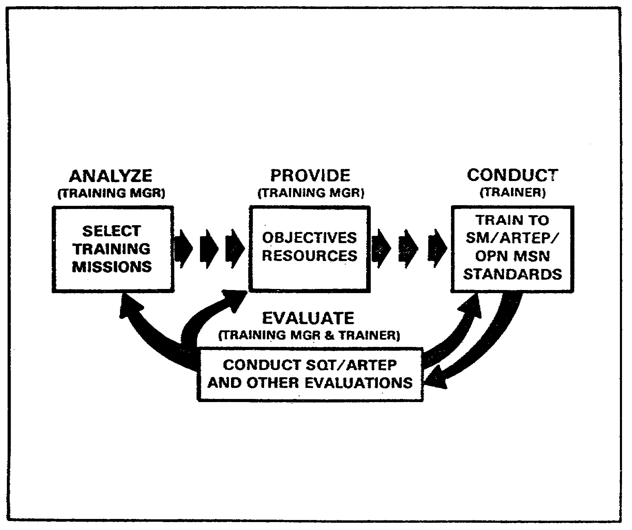

FIGURE 16. TRAINING MANAGEMENT CYCLE.

117

OD0973 - Lesson 5/Learning Event 4

Long-Range Plan

Commanders and training managers should plan training at least 12 months in advance. A complete review of the long-range plan should be reviewed yearly, after budget and ammunition guidance. documents ·are issued. The plan should then be periodically updated. For additional guidance on establishing and maintaining long-range training calendars, refer to FM 25-2.

Short-Range Plan

For the development of training schedules, managers need short-range plans. These generate a mid-range (usually about 3 months) training calendar. This is done by analyzing training and resources in detail. Short-range planning is an ongoing process with a continuous flow of new information about training needs, directives, and resources. FM 25-2 contains additional information on short-range planning.

Training Schedule

Although formats differ, unit training schedules are based on the short-range plan. It provides company level guidance for the training which will take place during a given period.

Learning Event 4:
DESCRIBE THE PROCEDURES USED IN SUPERVISING PREVENTIVE MAINTENANCE CHECKS AND SERVICES (PMCS)

Preventive maintenance is the keystone of the unit's maintenance program. The basic philosophy of preventive maintenance is that if you take care of equipment, it will last longer than if you don't. The actions of the operator/crew and the unit personnel will influence the time that the equipment can be kept operational. Failure of preventive maintenance leads to early failure of equipment.

PREVENTIVE MAINTENANCE CHECKS AND SERVICES (PMCS)

Equipment operators/crews are required to make before, during, and after operation checks on their assigned equipment. They are also required to perform weekly and monthly preventive maintenances checks. These checks are performed according to procedures in -10 level operator's manuals. Maintenance supervisors may also designate special maintenance during scheduled maintenance periods.

118

OD0973 - Lesson 5/Learning Event 4

The operator/crew has the greatest familiarity with the maintenance condition of their equipment. They are the "first line of defense" against maintenance faults. However, operator/crew diagnostic skills are limited, and operators/crews are not always motivated to uncover or report maintenance problems.

PMCS Indicators

How does the motor officer know when PMCS is not being performed properly? He doesn't have time to personally supervise the PMCS on every vehicle dispatched. However, the lack of an effective preventive maintenance program can be easily observed. Listed below are common indicators of preventive maintenance failure:

o Absence of operator's publications on the equipment. Maintenance publications and publications indexes missing from the maintenance areas.

o High equipment nonoperational rate.

o Abuse of the priority system.

o High prescribed load list (PLL) zero balance rate.

o Low usage of consumable and operator-installed items, such as grease, oil, filters, fuses, lamps, and belts.

o Unsatisfactory results on roadside spot checks, technical inspections, MAIT checks, or Annual General Inspections (AGIs).

o Excessive replacement of batteries, engines, meters, clutches, generators, starters, etc.

o Equipment that is incomplete, dirty, or improperly stored.

o Unauthorized methods of obtaining parts; i.e., "scrounging".

o Failure to start maintenance or supply action in a timely manner.

CORRECTIVE ACTIONS

When the motor officer notices that preventive maintenance is lacking, he should immediately take action to correct the problem. Is the problem in the unit's maintenance

119

OD0973 - Lesson 5/Learning Event 4

management techniques? Does the operator/crew have a poor attitude toward maintenance, or do they lack the necessary training? Below are listed some suggestions for finding the problem area:

o Is the commander scheduling sufficient time for PMCS on the training schedule?

o Are specific maintenance objectives assigned for each scheduled period of preventive maintenance?

o Are operator/crews present during scheduled periods of preventive maintenance?

o Are vehicle commanders/unit leaders present to supervise scheduled periods of preventive maintenance?

o Do 2404's reflect complete PMCS before, during, and after operation?

o Do operator/crew use the -10 level TM in performing preventive maintenance?

o Are 2404's completed properly?

o Are discovered faults listed on the 2404 and promptly reported?

o Are units conducting inspections of equipment?

Types of PMCS Inspections

General Bruce Clarke often said "People only do what the boss checks." People may do more--but they will certainly pay more attention to things that they-know will be inspected. Maintenance inspections are important from a supervisory position for determining whether PMCS are being performed. These inspections should be conducted by various levels of command. Inspections can take a variety of forms. Some of the most common checks/inspections will be discussed below:

Unit/Vehicle Commander Spot Checks. These are informal inspections which provide indications of maintenance status. The commander may, for example, visit the motor pool daily and make a different check each time he visits. Such checks demonstrate the importance he places on maintenance. This is a way of providing command emphasis.

120

OD0973 - Lesson 5/Learning Event 4

Dispatch Inspections. Vehicles are inspected prior to dispatch. The depth of these inspections, and who performs them, will vary with location. Typically, they are performed by battalion maintenance personnel. They can provide regular information on equipment condition. Dispatch inspections will also give a true indication if PMCS is being correctly performed.

Roadside Spot Checks. At many installations, the commander authorizes installation maintenance personnel to conduct roadside checks. Operators and vehicle commanders are gigged for defects. The report card is then sent to the company and battalion commanders. The information from these checks can be useful to the motor officer.

Battalion Inspection Program. In some units, the battalion maintenance section conducts periodic inspections. Equipment may be scheduled or selected at random for inspection. There is considerable variation in these programs, but many have these features in common:

o All equipment is inspected at least once between services.

o Incentives are involved (naming best crew, vehicle of the week, etc.).

o Inspections confirm operator/crew maintenance.

o The program is designed, in part, to motivate operators/crews to perform maintenance.

Other Inspections. Other inspections such as the MAIT, materiel readiness checks, IDS acceptance inspections, and Annual General Inspections will also locate PMCS deficiencies. These inspections provide important information that should not be overlooked when enforcing your PMCS program.

You have now been oriented on procedures used in supervising preventive maintenance checks and services (PMCS). In the next learning event, the procedures used in maintaining various maintenance forms will be discussed.

121

OD0973 - Lesson 5/Learning Event 5

Learning Event 5:
DESCRIBE THE PROCEDURES USED IN SUPERVISING THE MAINTENANCE OF TAMMS RECORDS; TO INCLUDE THE USE OF DA FORM 2402, DA FORM 2408-14, AND THE EQUIPMENT DAILY LOG (DA FORM 2401)

Any organization that depends on equipment or vehicles for accomplishment of its mission must maintain records for that equipment. These records are used for keeping track of the location and availability of vehicles, equipment, and repair parts assigned to or used in the motor pool. The Army Maintenance Management System (TAMMS) provides the necessary information for keeping these records. TAMMS records are required by AR 750-1. Procedures for using TAMMS forms are explained in DA Pam 738-750.

Figure 16a (below) illustrates how these TAMMS forms help you manage the flow of equipment and parts in the motor pool.
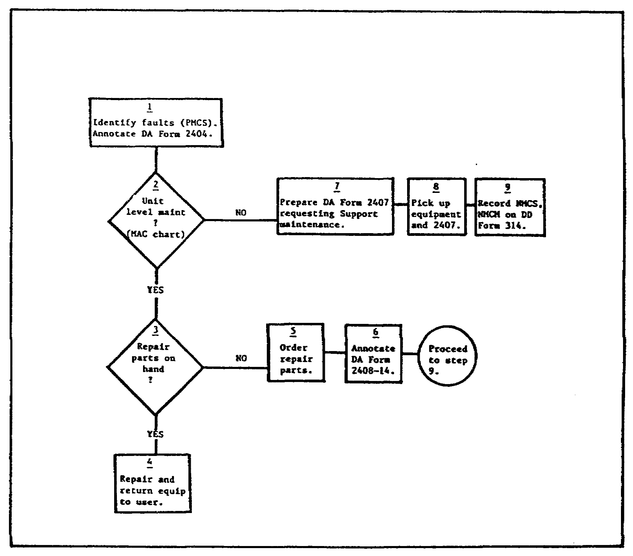

FIGURE 16A. FLOW OF TAMMS FORMS IN THE MOTOR POOL.

122

OD0973 - Lesson 5/Learning Event 5

This learning event will concentrate on three forms used by the motor officer in his routine duties.

EXCHANGE TAG (DA Form 2402)

DA Form 2402 (Exchange Tag)(figure 17, on the next page) is used as an identification tag. It is used to identify items that are being held for pending warranty claims, or other defective items held pending quality deficiency report or equipment improvement recommendations. This form may also be used to identify other items as needed.

General Instructions

A separate DA Form 2402 will be used for each item. The DA Form 2402 has four copies:

o Copy I is normally used as a receipt for the unit.

o Copy 2 is a receipt for the battalion level, except for warranty claim items. When the form is used to identify warranty claim items, send copy 2 to the supporting Warranty Control Office. The Warranty Control Office will use the form to close out or complete any needed warranty actions or claims.

o Copy 3 serves as a receipt for support units.

o Copy 4 stays with the item until it is repaired and issued. After repair is done, the tag identifies the item as fixed. This form will go with each item sent to supporting maintenance shops for warranty repairs.

o Depending on the item, repair needed, and the level of maintenance, not all copies may be needed.

Disposition

The following dispositions for DA Form 2402 should be followed:

o When the form identifies a warranty claim or SF 368 exhibit, the DA Form 2402 stays on the exhibit until the item is no longer needed.

123

OD0973 - Lesson 5/Learning Event 5
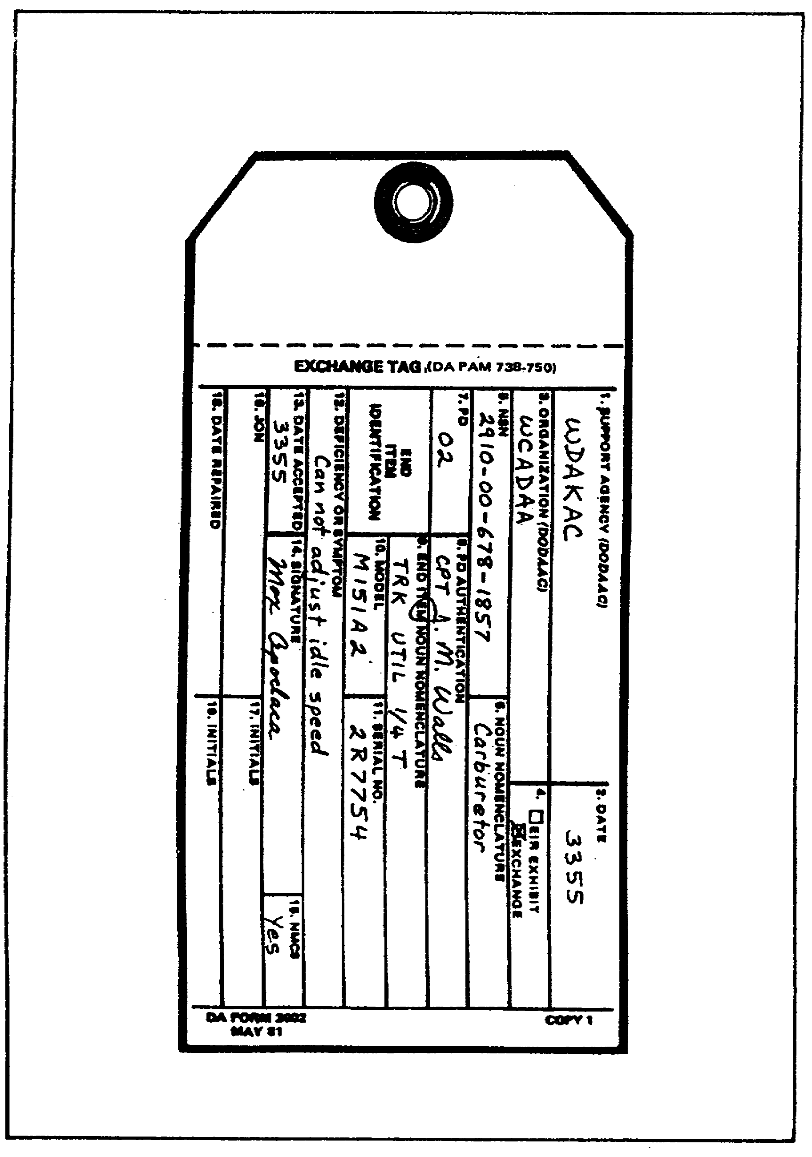

FIGURE 17. EXCHANGE TAG (DA FORM 2402).

124

OD0973 - Lesson 5/Learning Event 5

o Throw away the DA Form 2402 when the part or component it applies to is installed or disposed of.

o After the action is completed, destroy copies used as a receipt.

UNCORRECTED FAULT RECORD (DA Form 2408-14)

The Uncorrected Fault Record (DA Form 2408-14)(figure 18, on the next page) is a record of uncorrected faults and deferred maintenance actions on equipment. Deferred maintenance actions are authorized delays of repairs or maintenance.

Deferred or delayed maintenance can affect operation of the equipment, mission performance, and safety. Therefore, the commander or the commander's designated representative must make a decision. He must determine when a fault will be transcribed to DA Form 2408-14, and when a fault will remain open on the DA Form 2404. Status symbol X (inoperable) faults will not be entered on DA Form 2408-14.

A DA Form 2408-14 will be kept on any item or group of items that has an open deferred maintenance action. This form is not required when an automated system provides you with a list or printout of deferred maintenance or uncorrected faults. However, the list or printout must provide all the elements included on the DA Form 2408-14.

General Instructions

The following are general instructions for the use of DA Form 2408-14:

The following deferred status symbols may be entered on the DA Form 2408-14:

o Circled X ( X )(operation under set limitations)

o Dash (-)(inspection or component replacement needed)

o Diagonal (/)(fault that does not affect operation)

125

OD0973 - Lesson 5/Learning Event 5

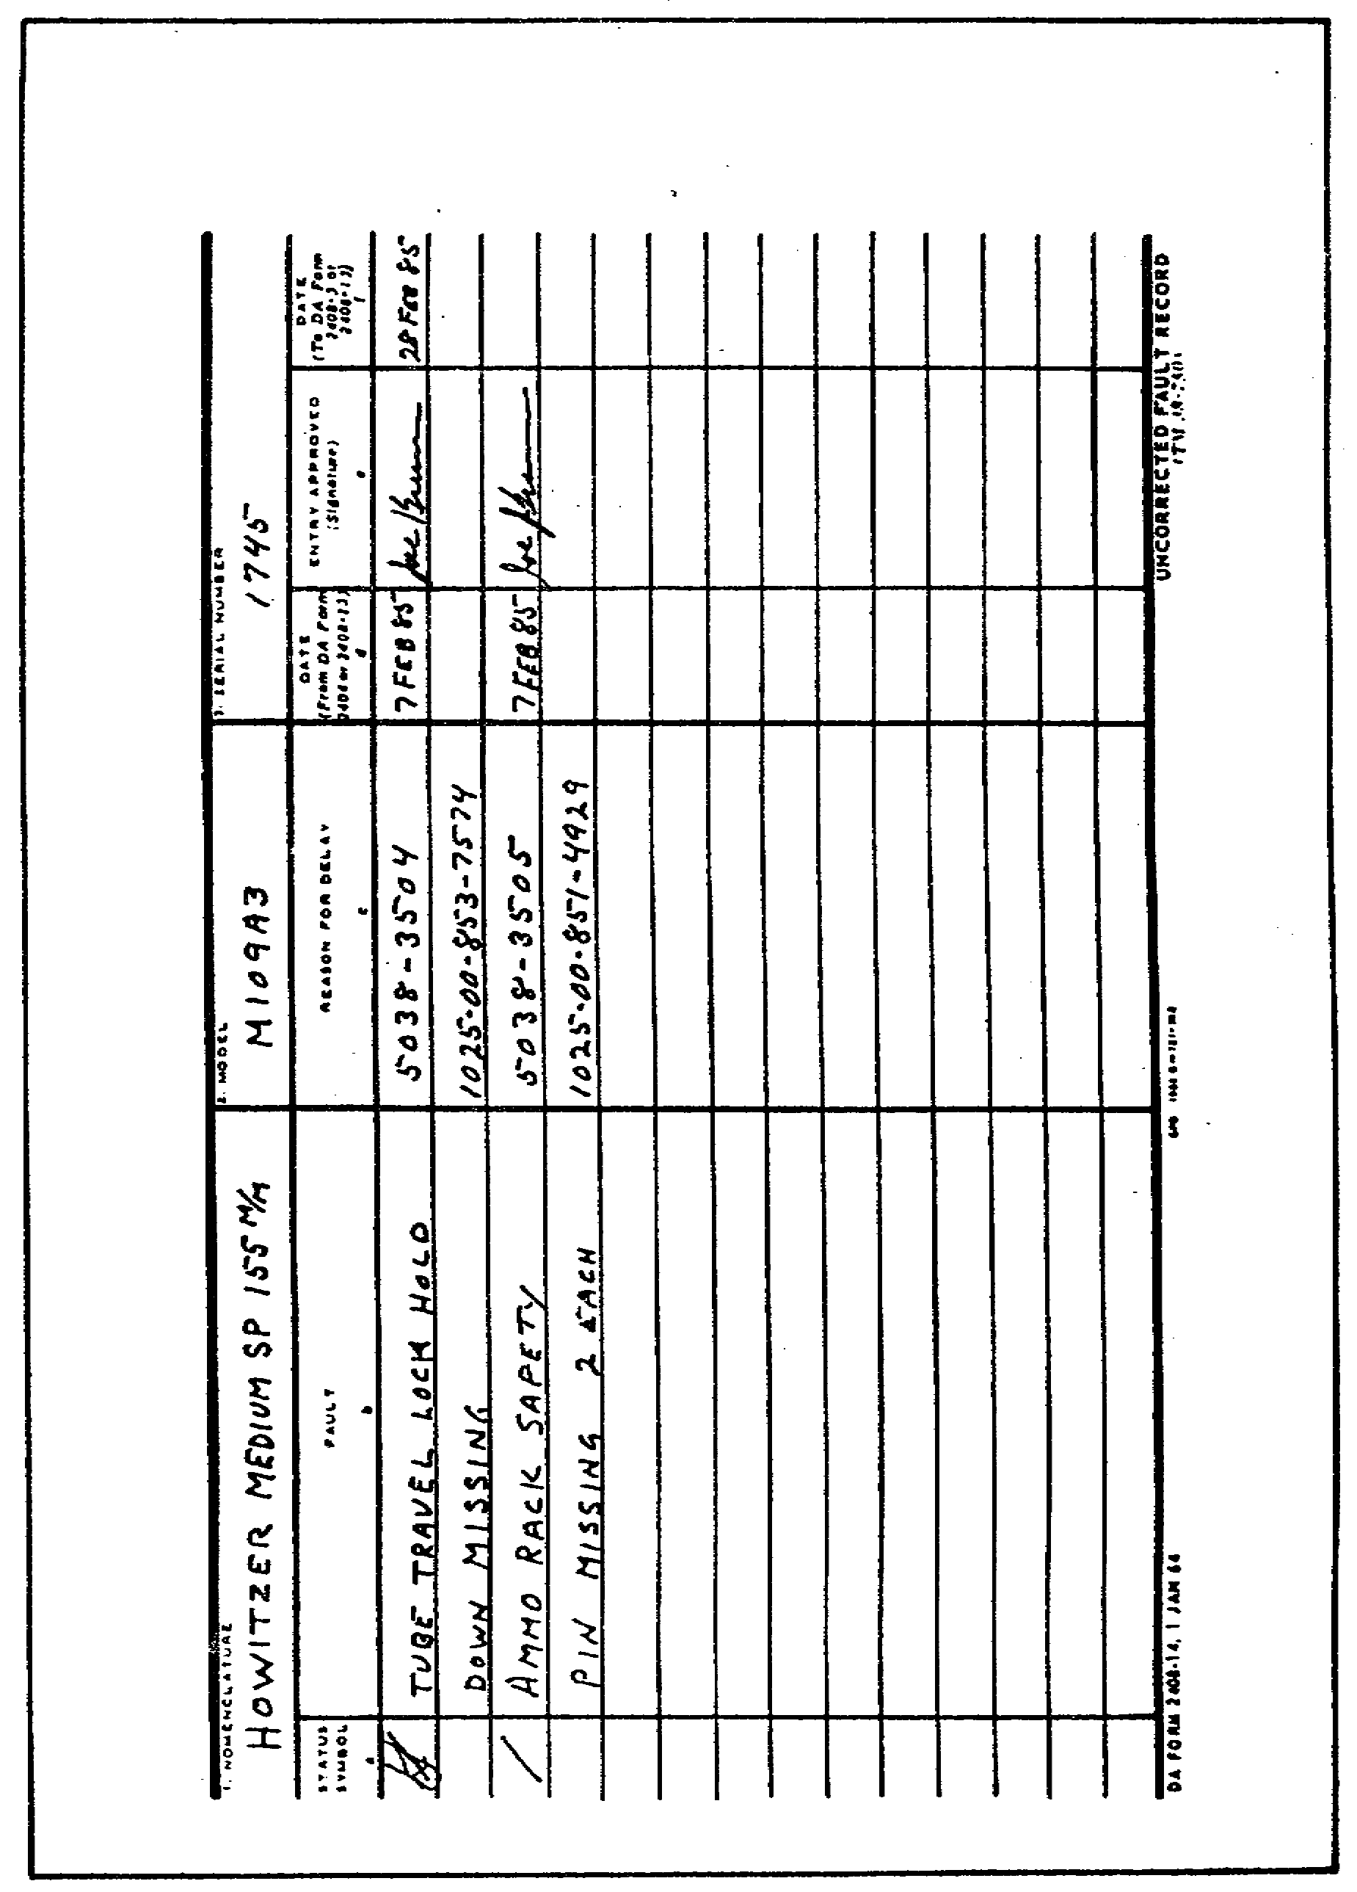

FIGURE 18. UNCORRECTED FAULT RECORD
(DA FORM 2408-14).

126

OD0973 - Lesson 5/Learning Event 5

Status symbol "circle X" deficiencies will be entered only for strictly limited periods of time. This period will usually not exceed seven calendar days.

When a deferred maintenance action exists on an item of equipment, the DA Form 2408-14 will be kept in the Equipment Record Folder or in a protective cover. The DA Form 2408-14 will be with the equipment at all times. This includes when the equipment is undergoing maintenance, on dispatch, under operation, or undergoing a service or inspection.

Operators or crews will check the 2408-14 before each dispatch. They will look for faults that may affect the mission and faults that are overdue to be fixed.

Maintenance supervisors will review the DA Form 2408-14 periodically (not less than every two weeks). They will: check on the status of parts on order; look for any faults that have been corrected, but not closed out; check for any faults overdue to be fixed.

Do not start a DA Form 2408-14 until there is something to defer.

A second copy of the DA Form 2408-14 may be kept wherever and whenever needed for the maintenance supervisors.

Parts on order and actions pending for items anticipated not mission capable (ANMC) may be entered on the DA Form 2408-14 with a diagonal status symbol. Line out the entry if the item status should change to not mission capable (NMC). The status condition then changes to "X" and the entry can no longer stay on the DA Form 2408-14. Enter the NMC code on the current DA Form 2404 for the item.

Disposition

Destroy the DA Form 2408-14 after the form has been filled up, all the faults have been fixed, or have been moved to a new DA Form 2408-14 or other maintenance form.

ORGANIZATIONAL CONTROL RECORD FOR EQUIPMENT (DA Form 2401)

The DA Form 2401 (figure 19, on the next page) is a record of operators and location of equipment on dispatch or in use.

This form tells commanders and dispatchers who is asking for and using equipment; it also lets them know where the equipment is and when it should return.

127

OD0973 - Lesson 5/Learning Event 5

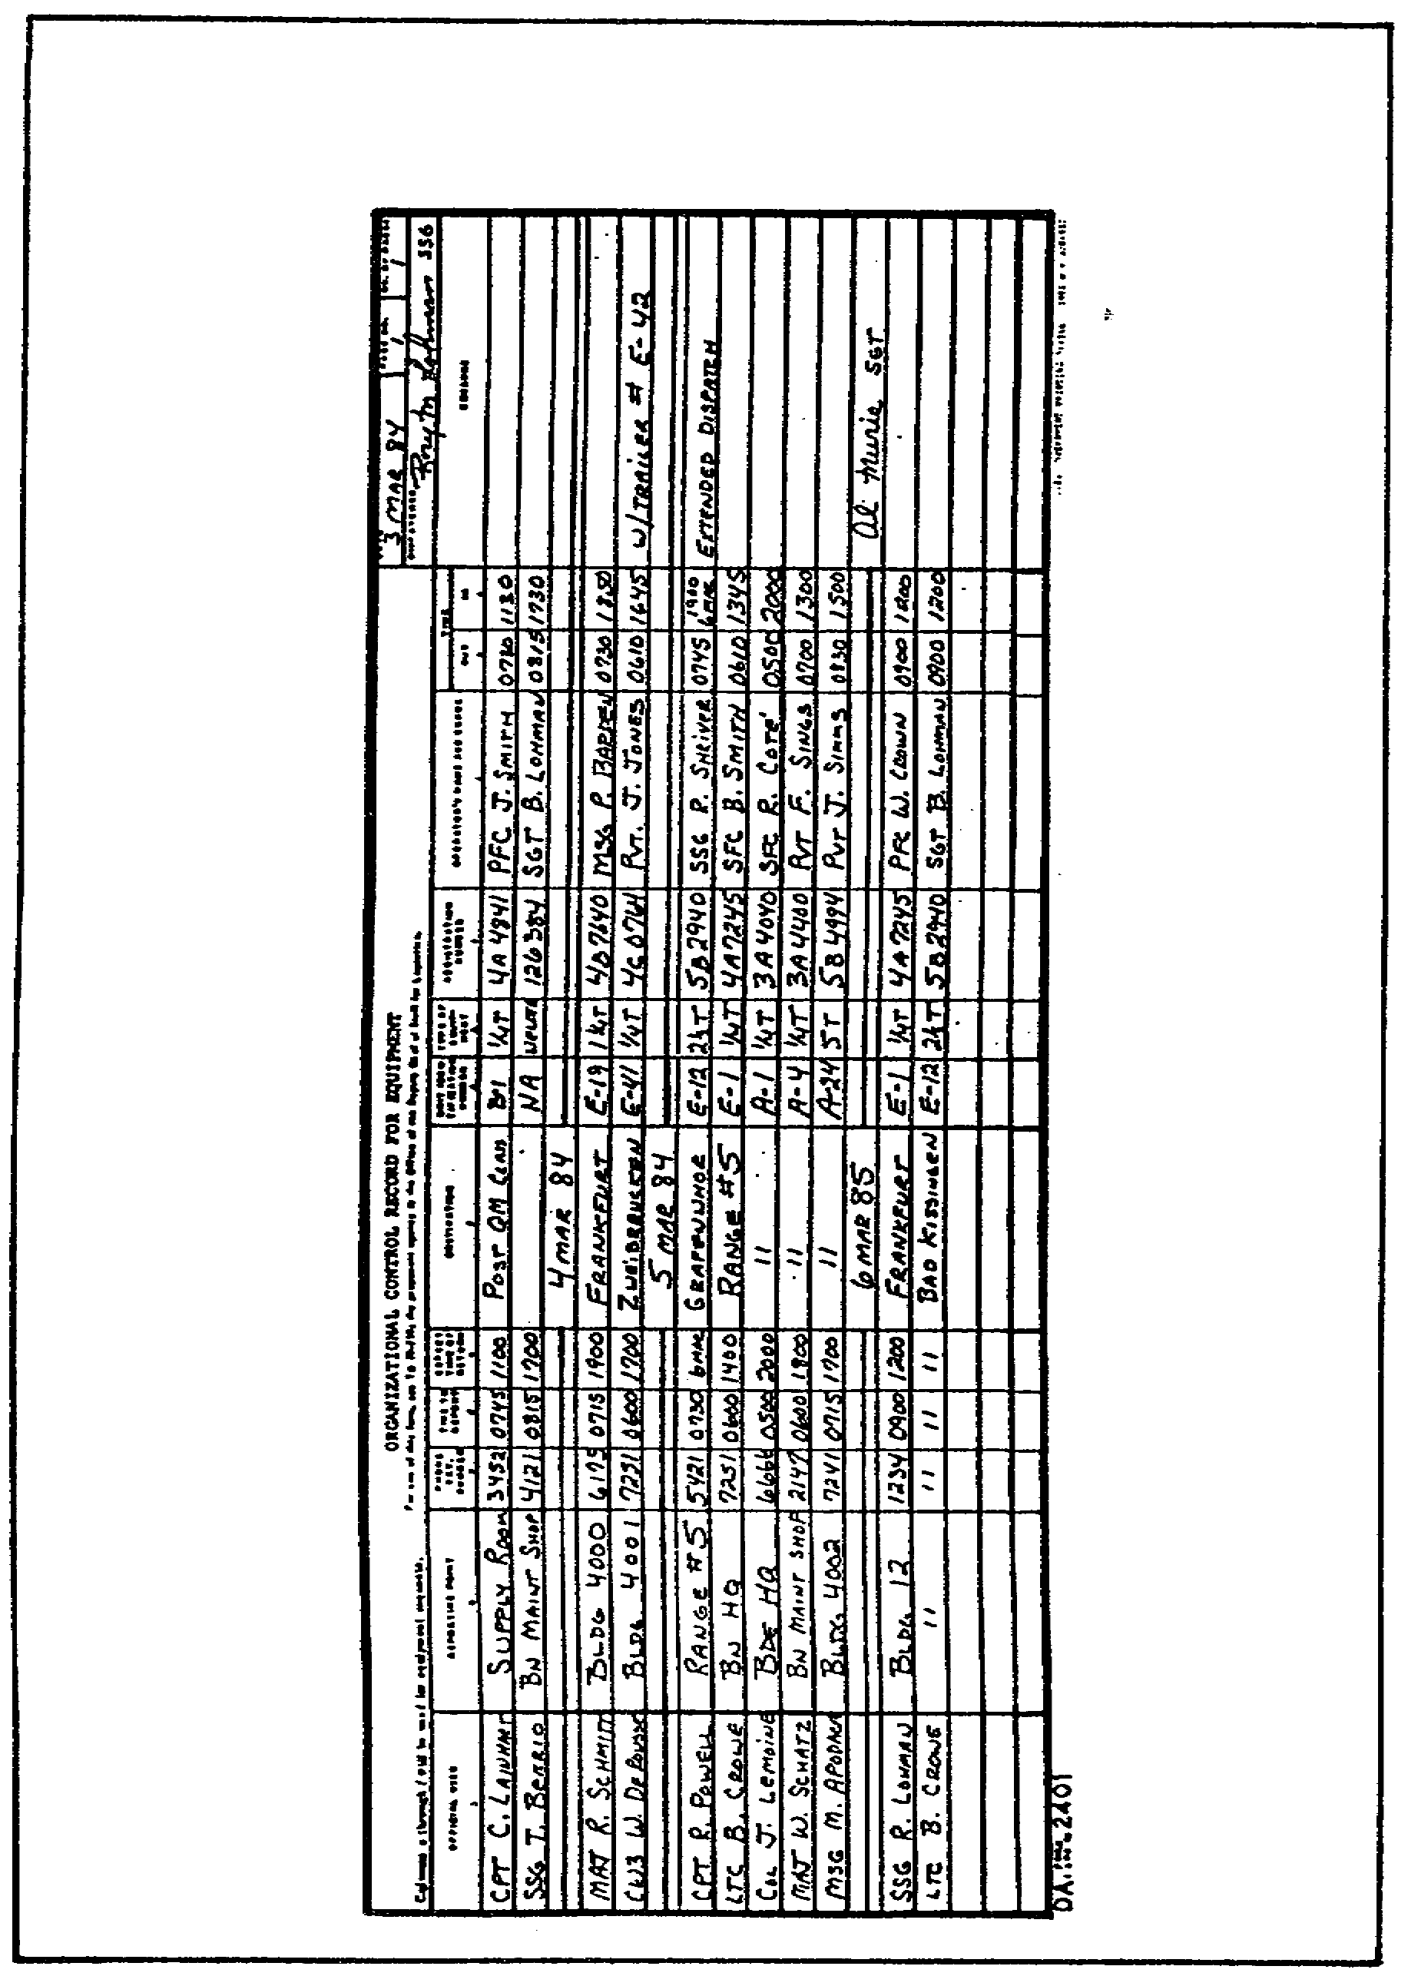

FIGURE 19. ORGANIZATIONAL CONTROL RECORD
FOR EQUIPMENT (DA FORM 2401).

128

OD0973 - Lesson 5/Learning Event 5

General Information

Listed below is some general information relating to the maintenance of DA Form 2401:

o This form may be overprinted when the same equipment is dispatched every day.

o Use a separate form to show the dispatch of "radio taxis." When this form is used for "radio taxis," columns a through m will be filled in as required by local policy.

o The DA Form 2401 goes into effect at the start of the operational day. You can use the same page for more than one day. Draw a line through columns a through m below the last dispatch entry for the day. Write the new date on that line. Do not make a line or date entry for days when the equipment is not issued.

o Make separate line entries for equipment that is towed to a location but will not return with the dispatched vehicle.

o Do not dispatch equipment for motor stables or routine maintenance unless it leaves the equipment or motor pool area.

o Equipment sent to support maintenance on a DA Form 2407 will be dispatched on DA Form 1970 and DA Form 2401.

Disposition

Destroy the form one month after the last entry in column 1 has been closed out. If an accident or unusual situation occurs,-keep the form until it is released by the investigator at the completion of the investigation.

This concludes this learning event on various TAMMS forms. You should now have a working knowledge of the use, general instructions, and disposition of DA Form 2402, DA Form 2408-14, and DA Form 2401.

In the next learning event, the procedures used in monitoring the application of modification work order/product improvement program (MWO/PIP) and associated records will be discussed.

129

OD0973 - Lesson 5/Learning Event 6

Learning Event 6:
DESCRIBE THE PROCEDURES USED IN MONITORING THE APPLICATION OF MWO/PIP AND ASSOCIATED RECORDS

The modification work order (MWO) and the Product Improvement Proposal Project (PIP) are covered in AR 750-10 and AR 70-15 respectively. In this learning event, we will discuss how to request or report a MWO on DA Form 2407 and record certain MWOs using DA Form 2408-5.

USING MAINTENANCE REQUEST (DA FORM 2407) FOR MWOs

Maintenance Requests (DA Form 2407) are usually used to request maintenance from a higher maintenance source.

However, the form can also be used to request installation of a MWO to equipment, or to report that a MWO has been applied (figure 20, on the next page).

NOTE

The responsible sponsoring agency will make sure that equipment owners know when MWOs apply to their equipment. MWOs applied at depot level will be reported as directed by automated procedures. Depot teams and contractors in the field will report applied MWOs on a DA Form 2407.

General Instructions

The following are general instructions for requesting and
reporting MWOs, using DA Form 2407:

o The requesting unit will send all copies of the DA Form 2407 to the activity that will apply the MWO. The equipment normally does not go to that activity until MWO kits are on hand. If MWO kits are already on hand, the equipment will go with the form.

o If NORMAL MWO kits are not on hand when the MWO request is made, the maintenance activity will make a note in block 16a. They should print "Receipt of MWO Request (date)(name or initial) " and return copies 2, 3, 4, and 5 to the unit asking for the MWO.

o When URGENT MWO kits are not on hand, the equipment usually goes to the maintenance activity with the form. The receipt copy (#1) will be returned to the unit.

130

OD0973 - Lesson 5/Learning Event 6

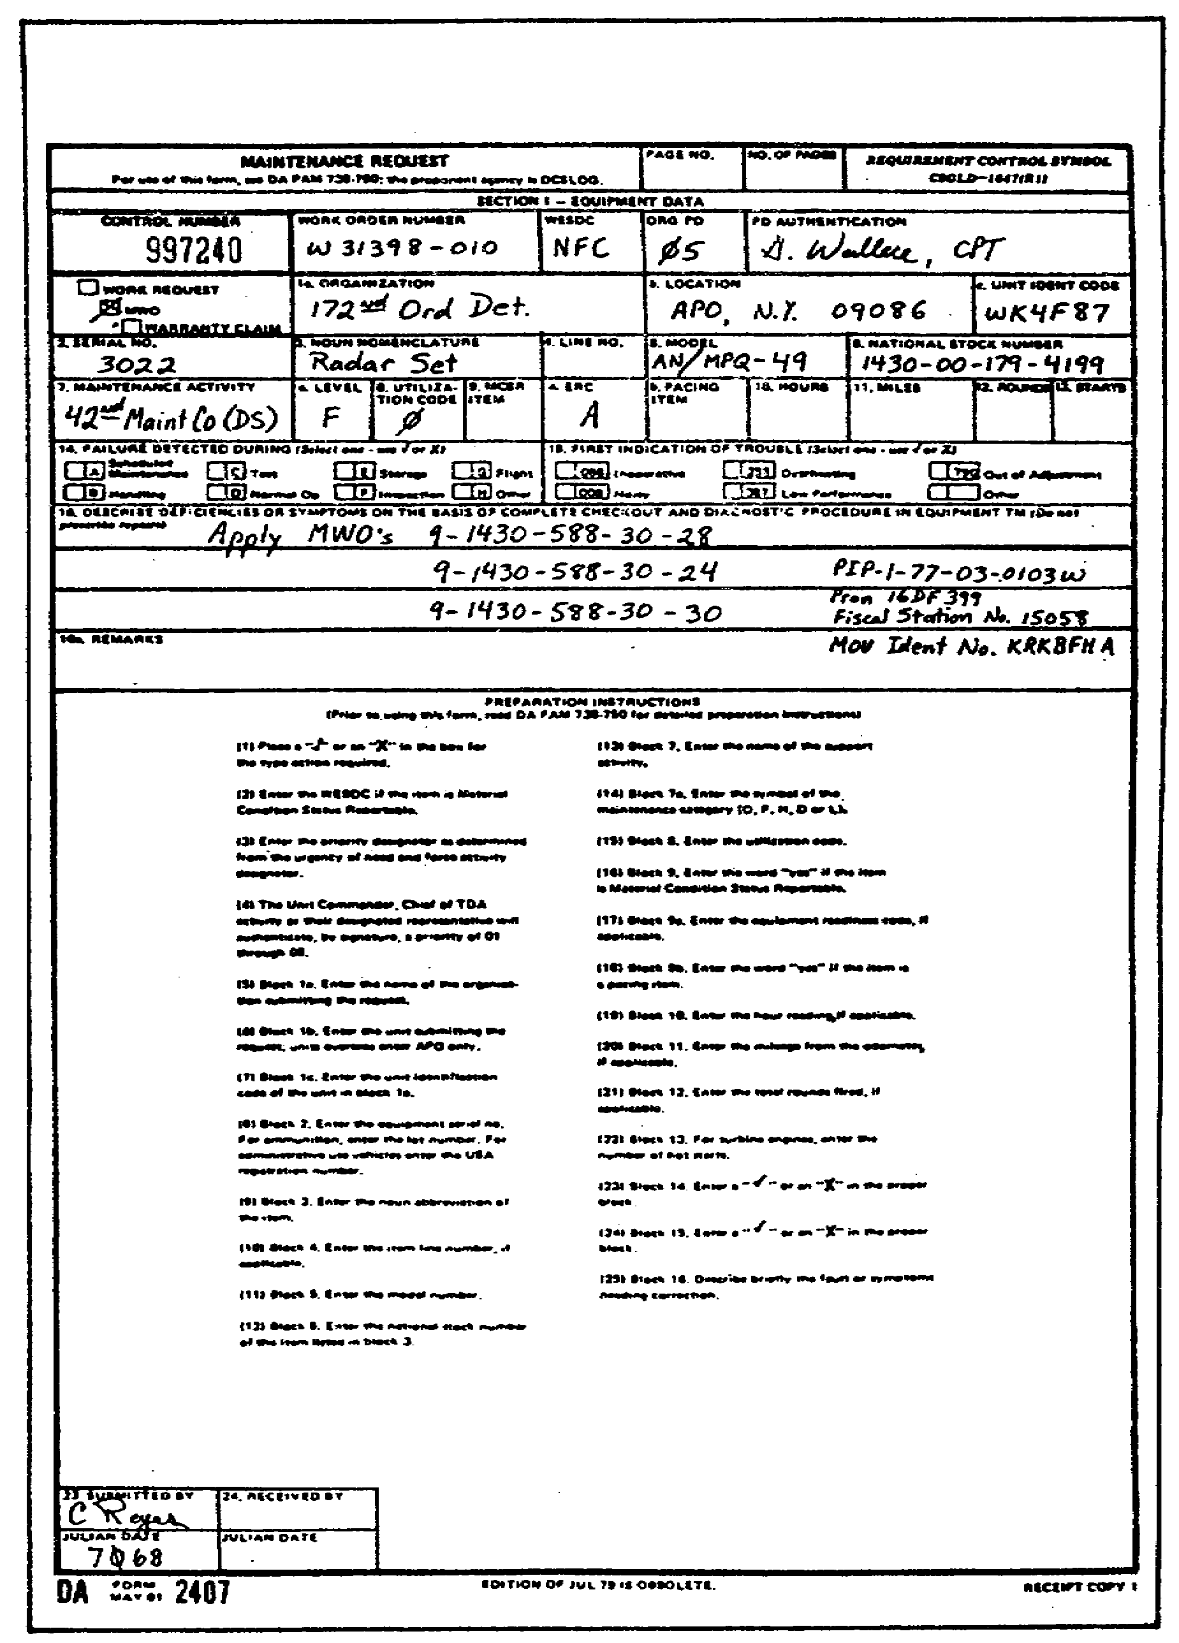

FIGURE 20. DA FORM 2407 USED AS MWO REQUEST.

131

OD0973 - Lesson 5/Learning Event 6

o For other than URGENT MWOs, the maintenance activity will get only the form, until the kits arrive. The maintenance activity will keep only copy #1 of the DA Form 2407. When the MWO kits or parts come in, the unit asking for the MWO will be notified. The unit will then send the equipment and all copies of the DA Form 2407. The maintenance activity will fill in block #24. The unit requesting the MWO will get copy #1 as a receipt. All other copies stay with the maintenance activity.

o When an applied MWO changes the national stock number (NSN) of the end item, send in a DA Form 2408-9 (NSN Redesignation Report).

Disposition

When the MWO has been applied:

o Destroy the receipt copy #1 when the equipment goes back to the owner.

o Copy #2 (NMP Copy) must be sent to the MWO sponsoring agency within three working days. The MWO pub will tell you who the agency is and the proper address.

o Copy #3 (Control Copy) is handled as directed by the MWO pub or Materiel Fielding Plan (MFP). Otherwise, handle as locally directed.

o Destroy copy #4 (Organization Copy).

o Copy #5 (File Copy) is kept on file by the maintenance activity until the next MWO validation.

EQUIPMENT MODIFICATION RECORD (DA FORM 2408-5)

Equipment Modification Record (DA Form 2408-5)(figure 21, on the next page) is required for recording MWOs on certain items. These items include equipment in equipment category code (ECC) B (Air defense systems), and category C (Missile system, surface to surface). DA Form 2408-5 is used as a permanent historical record of MWOs applied to the equipment.

General Information

The following general information pertains to the maintenance and preparation of DA Form 2408-5:

132

OD0973 - Lesson 5/Learning Event 6

o The DA Form 2408-5 is split into two sections:
Modifications Required and Modifications Completed.

The "required" section shows data on published modifications needed. You get this information from the MWO, DA Pam 710-50 or other sources.

The "completed" section shows data, man-hours and the activity that applied the MWO. Get this information from the DA Form 2407. The organization that applies the MWO will usually make the entries in this section.

o Start a DA Form 2408-5 only when you learn that a MWO has been issued on an item you hold.

o MWO entries will be current. The DA Form 2408-5 is the only historical record showing the current configuration of the equipment.

o When one MWO replaces another MWO, compare the two publications.
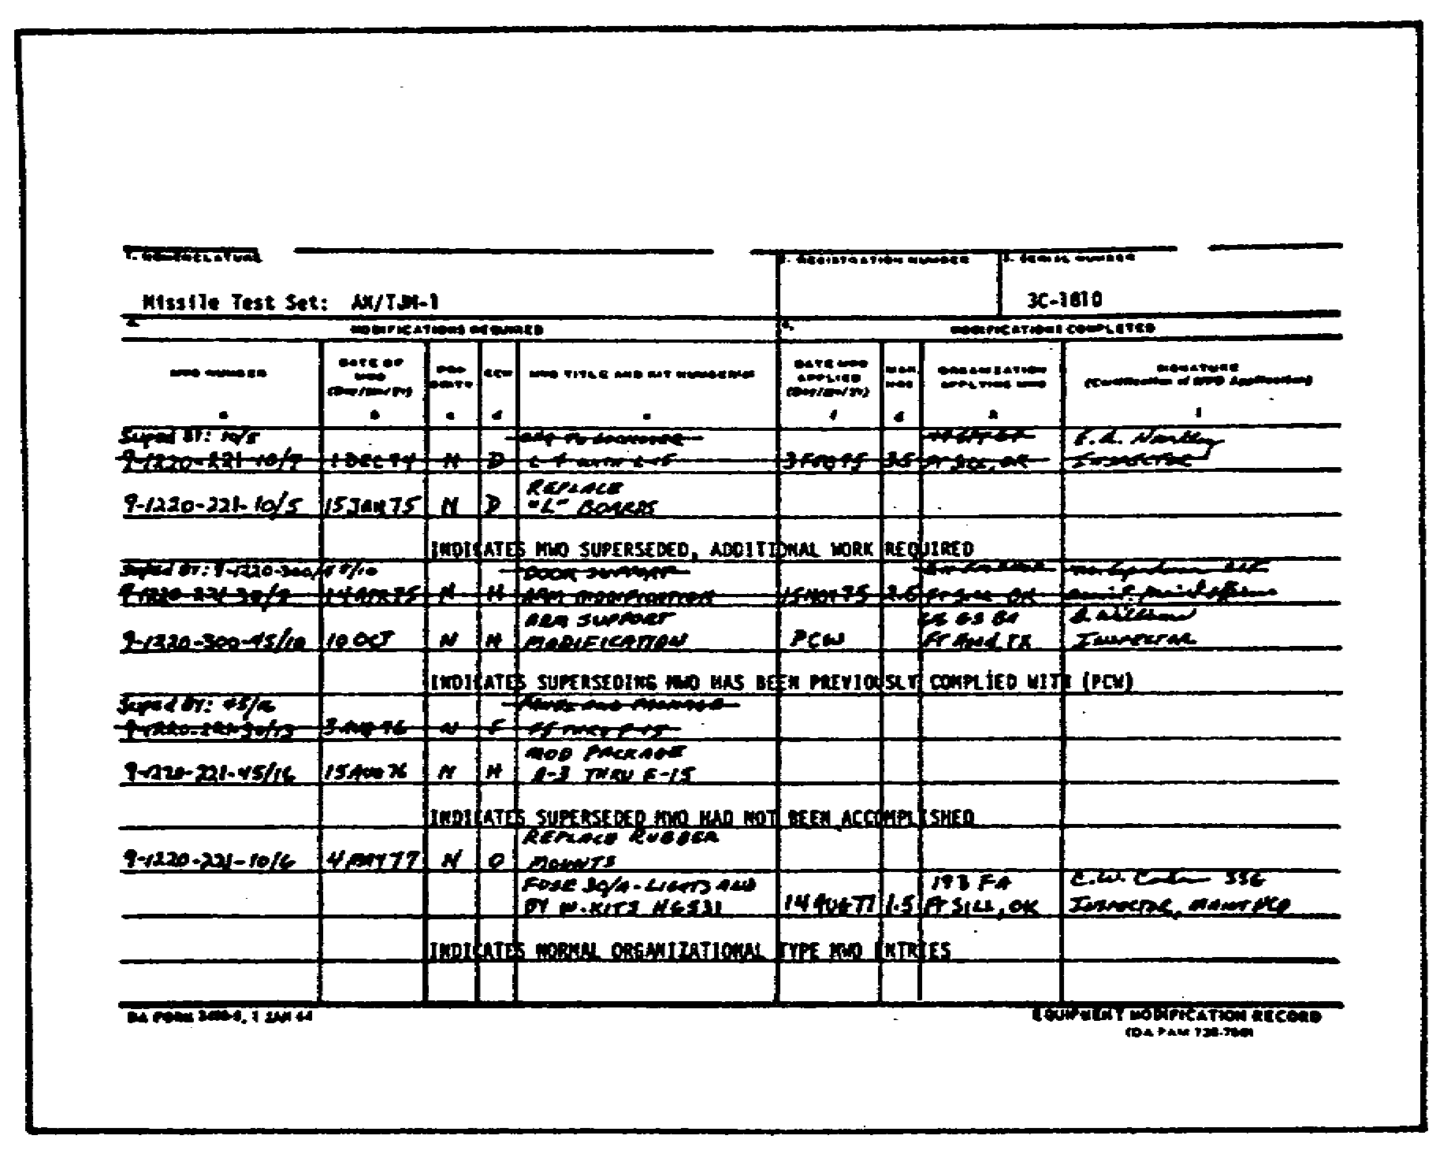

FIGURE 21. EQUIPMENT MODIFICATION RECORD
(DA FORM 2408-5).

133

OD0973 - Lesson 5/Learning Event 6

If the replaced MWO has been applied to your equipment, write up the action on the DA Form 2408-5. If more work is needed on the new MWO, line out the replaced MWO entry. Write "Superseded by (new MWO number) " in columns a and b. Put the new MWO information in columns a through e on the next open line. Put the date the new MWO is required to be completed in pencil in column f. If no more work is needed for the new MWO, fill in columns f through j on the new MWO.

If the replaced MWO has not been applied, line out the replaced MWO entry on the DA Form 2408-5. Write "Superseded by (new MWO number) " in columns a and b. Put the new MWO information in columns a through e on the next open line. Put the date the new MWO is required to be completed in pencil in column f.

o If an MWO is canceled or completed, make sure the DA Form 2408-5 shows that information.

o If an MWO has been applied and entries in columns a through i have been made, take no further action. Do not fill in any blank columns.

o If the MWO has not been applied and entries are in columns a through e, fill in columns f and g. List the publication that canceled or completed the MWO in those columns. In columns h and i, cite the organization making the entry. The person who confirmed the canceled or completed MWO signs his or her name and rank or title next to the organization.

o If a MWO has been applied, but not entered on the DA Form 2408-5, add it to the form. Fill in columns a through e. The information for completing these blocks are on the form. In column f, put the date you determined the MWO had been replaced. In column 5, enter the estimated man-hours listed in the MWO. In column h, print "PCW" (previously complied with). Add the name of the maintenance activity that determined the MWO had been applied. The person who confirmed the MWO signs in column j. Report the already applied MWO on a DA Form 2407.

o If you find a completed MWO entry on the DA Form 2408-5 when the MWO has not been completed, take the following action: line through the incorrect entry; write "re-entered below" on the same line; put the MWO information in columns a through e on the next available line. In pencil, note the date the MWO is required to be completed.

o If a MWO that does not apply is put on the DA Form 2408-5, draw a line through the entry. Put "Not applicable" in column f of the same line.

134

OD0973 - Lesson 5/Learning Event 7

o If a change comes out on a MWO listed on the DA Form 2408-5, draw a line through the entry. Put the new information on the next open line.

o When a component or assembly that has a DA Form 2408-5 is removed for any reason, to include evacuation to depot, attach the form to that item. Protect the form with a cover.

o When a component or assembly that has a DA Form 2408-5 is installed, add the form to the system log.

This completes this learning event on the forms necessary for applying MWOs. Manager's actions in maintaining and completing DA Form 2407 and 2408-5 have been discussed.

In the next learning event, another form, SF Form 91, (Vehicle Accident Report) will be covered.

Learning Event 7:
DESCRIBE THE PROCEDURES USED TO REVIEW THE MOTOR VEHICLE ACCIDENT REPORT (SF 91)

The Operator's Report of Motor Vehicle Accident (SF 91) is used by the vehicle operator to record any accident involving military equipment. When an accident occurs, the driver should always stop and investigate the accident. The only exceptions to this rule might be in combat, or in case of military necessity when the driver is operating under definite orders not to stop.

Even though the accident is minor, or not the driver's fault, it must be reported so that the facts will be clearly presented. This protects both the driver and the government against claims and exaggerations. For purposes of reporting an accident, SF 91 will be used.

COMPLETING SF 91

The motor officer or his NCOIC is usually responsible for training drivers in the proper procedures for reporting an accident. In completing SF 91 (figures 22 and 23, on pages 136 and 137), the driver must keep the following general instructions in mind:

o A copy of SF 91 must be in the vehicle at all times when the vehicle is on dispatch.

135

OD0973 - Lesson 5/Learning Event 7

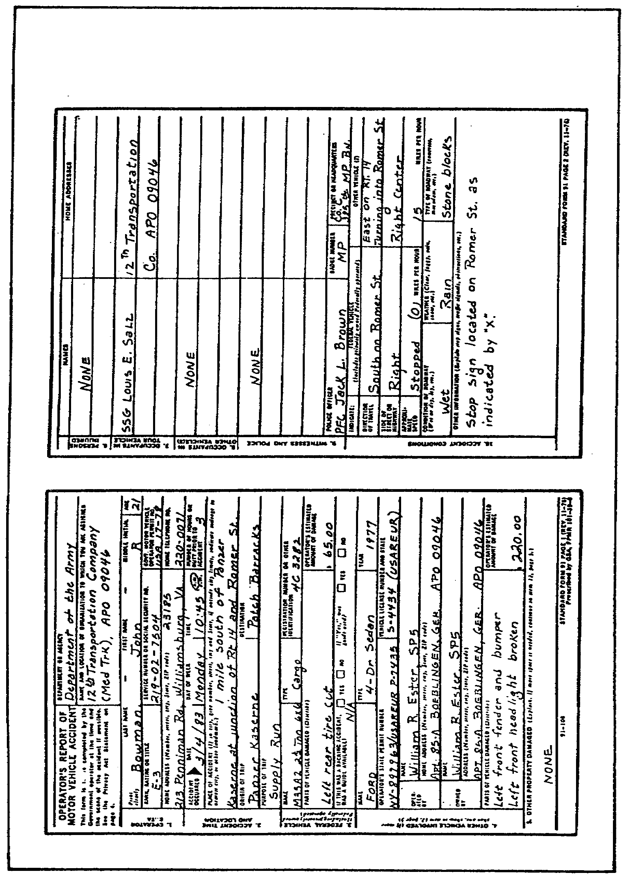

FIGURE 22. OPERATOR'S REPORT OF MOTOR VEHICLE
ACCIDENT (SF 91), PAGES 1 AND 2.

136

OD0973 - Lesson 5/Learning Event 7

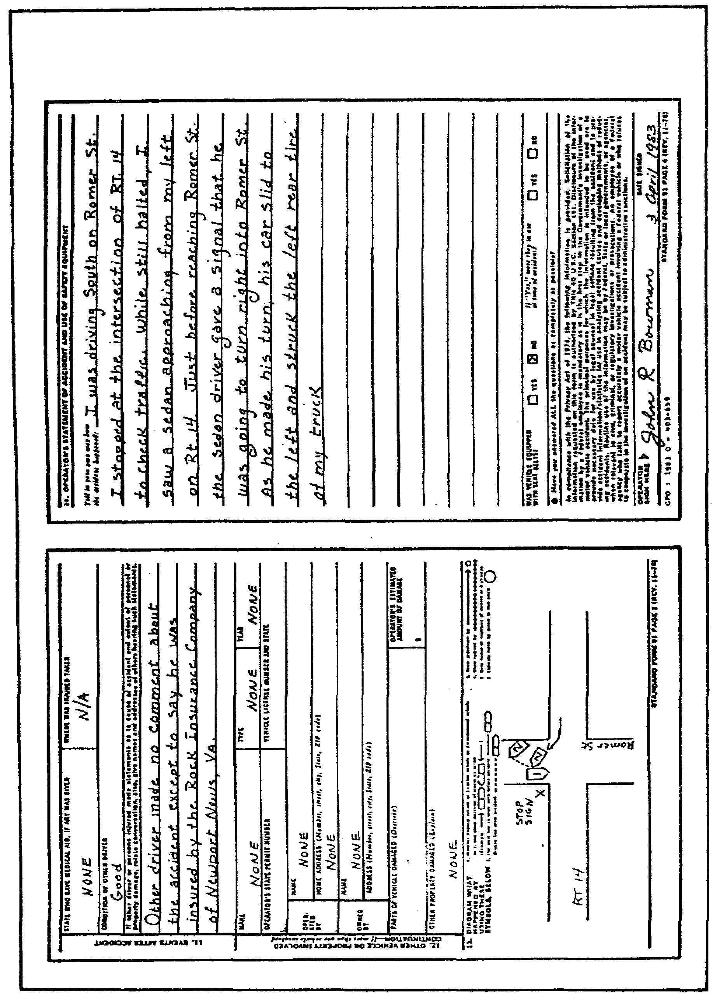

FIGURE 23. OPERATOR'S REPORT OF MOTOR VEHICLE
ACCIDENT (SF 91), PAGES 3 AND 4.

137

OD0973 - Lesson 5/Learning Event 7

o Secure hard-to-get facts first. First, the driver should make sure that the vehicle will not cause another accident and that the injured are cared for. Then the driver should get the names and addresses of the people involved and any witnesses. If the driver does not get this promptly, he may not be able to get the information at all.

o The driver should not leave the scene of the accident until he has carefully noted facts that would be hard to get later. These facts may include: the condition of the road, position of the vehicles, amount of damage, and any other vital details.

o Items on the SF 91 that are known or can easily be gotten (such as the driver's name, make of vehicle, etc.) can be filled in after the driver has done everything else. This can be done even after he has left the scene of the accident.

o The driver must be exact. He must be sure that the report gives a clear picture of what actually happened. If another vehicle was involved, a diagram of the accident should show exactly where the vehicles were before and after the crash. It should show what obstacles blocked either driver's view. Every name should be spelled correctly and every street address listed by number. On highways where there are no house numbers, mileage markers, or telephone pole numbers, intersecting roads should be used. This will help pinpoint the location of the accident.

Damage that can be seen (crushed right rear wheel, crumpled fender, etc.) must be stated on the report. If someone claims that there is damaged property that cannot be seen, note only that he "claims to have bent frame, etc." The same procedure should be followed with injuries.

If the exact information cannot be obtained for any item, write "Unknown," and if there is a blank that does not pertain to the accident, write "NA" or "none." Every block should have an entry. This assures the reviewer that the driver did not overlook anything.

o The driver should never express an opinion, either orally or in writing, to the claimant or their agent. This includes statements concerning liability, investigation findings, or the possibility of claim approval.

o Use of additional paper is authorized. If additional paper is necessary to answer a question, the words "see attached" should be written in that block. The extra sheet of paper should be securely attached to the report form.

138

OD0973 - Lesson 5/Learning Event 7

o Each item should be double checked. In securing information for the report, the driver is acting as an agent of the U.S. Government. Make sure the name the driver provided is the same as the name on his operator's permit. If not, find out why. If there is reason to doubt any information provided, be sure to attach a note calling attention to your doubts.

o The driver must ensure that all information on the form is clear and concise. The investigating officer must form his picture of the accident and his opinions from the report. His decision will be based on the information that the driver reports.

o The driver should sign the report and turn it in to his supervisor.

NOTE

An employee of a federal agency who fails to report accurately a motor vehicle accident involving a federal vehicle may be subject to administrative sanctions.

HANDLING AND DISPOSITION OF SF 91

The completed accident SF 91 is submitted to the operator's supervisor. The supervisor uses the SF 91 in preparing DA Form 285 (Accident Report).

Where accident reports are required by state or local regulations, they are submitted first to the appropriate claims officer. He reviews the forms to ensure that the rights of the U.S. Government are not prejudiced by admission of liability.

See AR 385-40 and AR 385-55 for complete details.

This completes the learning event on procedures used to review the motor vehicle accident report (SF 91).

In the next learning event, the procedures used when filling out the unit materiel readiness report (DA Form 2406) will be discussed.

139

OD0973 - Lesson 5/Learning Event 8

Learning Event 8:
DESCRIBE THE PROCEDURES USED WHEN FILLING OUT AND REVIEWING THE UNIT MATERIEL READINESS REPORT (DA FORM 2406)

To be combat ready, a unit must have sufficient and properly maintained equipment and materiel. Readiness of materiel is a key part of unit operational readiness to accomplish its wartime mission. The motor officer or maintenance manager is expected to prepare and interpret materiel condition status reports. These reports provide an important input to unit status data provided by the battalion headquarters. Moreover, materiel condition status reports provide an overall indicator of unit maintenance effectiveness.

GROUND EQUIPMENT MATERIEL CONDITION STATUS REPORTING

The Materiel Condition Status Report (MCSR) procedures are fully covered in AR 700-138. This learning event is designed to give the motor officer an overview of procedures and terminology necessary for preparing the DA Form 2406.

Reporting Units/Activities

The DA form 2406 will be submitted by all units and activities listed in AR 700-138. Reporting units complete the MCSR at the "parent unit" level (no higher than battalion). For table of organization and equipment (TOE) units, the battalion is the parent unit. TOE separate companies and detachments that are not part of larger units are their own parent units. For TDA units, the property book level is the parent unit.

Frequency of Report

All Active Army units will make a monthly DA Form 2406 covering a one month period ending the 15th day of each month.

U.S. Army Reserve (USAR) and Army National Guard (ARNG) units will make a quarterly DA Form 2406 covering a three month period. These reports will have ending months of 15 March, 15 June, 15 September, and 15 December.

140

OD0973 - Lesson 5/Learning Event 8

Local policy or the unit commander may use the DA Form 2406 for local use and will prescribe the frequency of preparation, submission, and distribution instructions.

Equipment to be Reported

All equipment listed in Appendix B, AR 700-138, that is authorized or on-hand during one or more days of the report period will be reported. Equipment that is used as training aids, borrowed from other units, or reported as part of another system is not reported.

Effect on System (EOS) Codes

Subsystems provide capability to a system. Codes have been assigned to subsystems to identify the effect on system (EOS) problems. Use EOS codes only when the item is identified as a system in Appendix B, AR 700-138.

On the DA Form 2406, EOS codes follow the noun. The EOS code highlights the subsystem causing problems. If more than one subsystem is a problem, use up to two codes.

EOS codes are listed only when the model falls below 90 percent of being fully mission capable (FMC). If all the equipment under one model meets the Army goal of 90% availability, use no codes. Compute availability by dividing the available days by the possible days. This information is found on the subsystems DD Form 314.

Filling out DA Form 2406

The following instructions should be followed when preparing the Materiel Condition Status Report (DA Form 2406)(figure 24, on the next page):

Block 1 - PERIOD OF REPORT. When more than one day is covered, put the Julian Date of the first day in the "FROM" space and of the last day after "TO".

Block 2 - DATE PREPARED. Enter the Julian date the report is completed.

141

OD0973 - Lesson 5/Learning Event 8

FIGURE 24. MATERIEL CONDITION STATUS REPORT
(DA FORM 2406), FRONT SIDE.

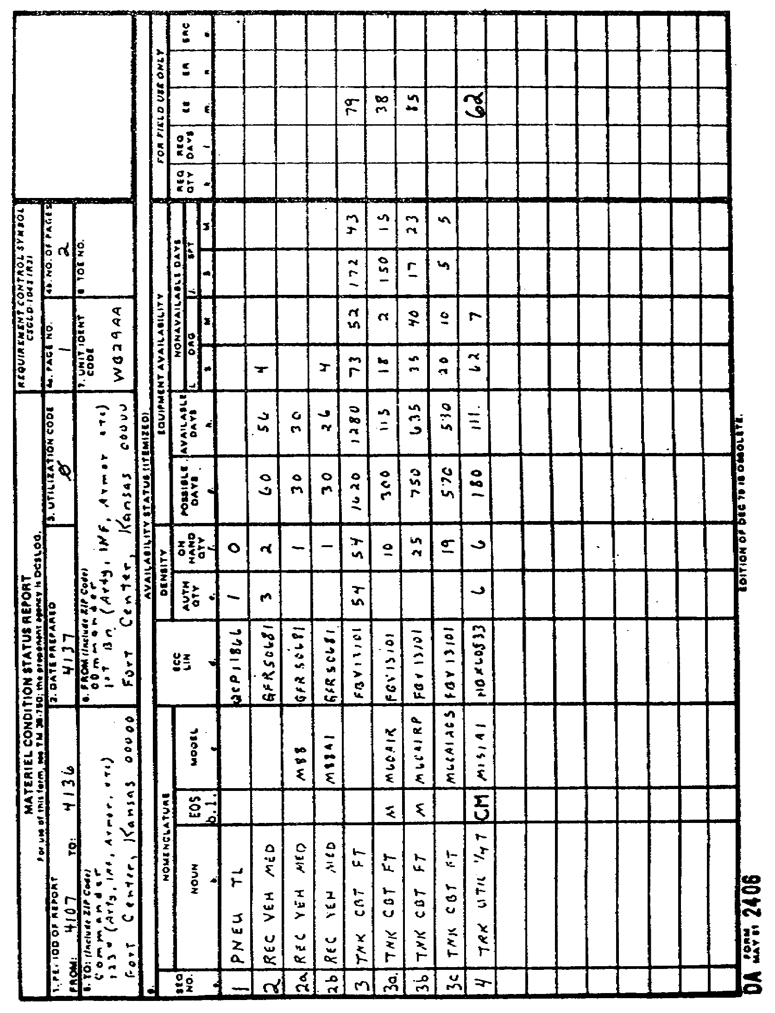

142

OD0973 - Lesson 5/Learning Event 8

Block 3 - UTILIZATION CODE. Put in the utilization code from the table below. Use the code or codes for the parent unit making the report.

CODE DESCRIPTION
0 Active Components (except as otherwise listed)
4 Operational Readiness Float (ORF)
7 Army National Guard, except MATES
8 Army National Guard (MATES)
A Army Reserve Units
H U.S. Army Intelligence and Security Command
K U.S. Army Training and Doctrine Command
Q Equipment assigned to service schools and
training centers

Block 4a - PAGE NUMBER. Enter number of the page you are on.

Block 4b - NUMBER OF PAGES. Enter the total number of pages in this report.

Block 5 - TO. Enter the complete name and address (with Zip or APO) of the parent unit.

Block 6 - FROM. Enter the complete name and address of the unit making the report.

Block 7 - UNIT IDENTIFICATION CODE (UIC). Put in the six character UIC of the unit. This code always begins with W.

Block 8 - Table of organization and equipment (TOE) NUMBER.
Leave blank.

Block 9 -AVAILABILITY STATUS (ITEMIZED). Enter equipment in LIN order in columns 9a through 9o.

Block 9a - SEQ NO. Each line is numbered. If only one model is on hand, a one line entry is needed. If more than one model of the same LIN is or was on hand during the report period, make a line entry for each model. Use the same basic sequence number with a letter after 1--1A, 1B, etc.

Block 9b - NOUN. Put in the noun abbreviation shown in AR 700-138. Use the last 3/8th inch of the block for the effect on system (EOS) code. Make a separate column by drawing a line down the form 3/8th inch from the right hand edge of column 9b.

143

OD0973 - Lesson 5/Learning Event 8

EOS codes are described below:

CODE DESCRIPTION OF PROBLEMS
A Computer
B Trailer/Van
C Communications
D NBC Equipment
E Environmental Control
F Missile
M Prime Mover
N Other Subsystem
P External Power Source
S Shoot
T Maintenance/Shop Equipment

Block 9c - MODEL. Enter the model number exactly as it appears in AR 700-138. Leave blank if the line is an authorized line with separate models below it. Leave blank if the on-hand quantity is zero.

Block 9d - ECC-LIN. List the ECC and LIN. The ECC is written first, followed by the LIN. List the equipment in LIN order.

Block 9e - AUTHORIZED QUANTITY. Put in the number of the items shown in column 9b authorized on the unit MTOE/TDA.

Block 9f - ON-HAND QUANTITY. Put in the number on-hand as of the "TO" date in block 1.

Block 9g - POSSIBLE DAYS. Enter the total number of equipment days the equipment was on-hand during the report period.

Block 9h - AVAILABLE DAYS. Enter the total number of days the equipment was fully mission capable (FMC). This information is taken from DD Forms 314 and DA Forms 2407.

Block 9i - ORGANIZATIONAL MAINTENANCE. Put in the total number of days that the equipment was not mission capable (NMC) at unit level for supply (NMCS) and maintenance (NMCM) during the report period. This is taken from the DD Form 314.

Block 9j - SUPPORT MAINTENANCE. Put in the total number of days the equipment was NMC at support level for supply and maintenance during the report period.

9k THROUGH 9o - These columns are used as a worksheet for the Unit Status Report. To understand these headings, see AR 220-1.

144

OD0973 - Lesson 5/Learning Event 8

Block 10 - NONAVAILABLE STATUS (ITEMIZED). Complete as needed locally. (figure 25, on the next page)

Block 11 - REMARKS. Use as needed to explain any entries on the form.

Block 12 - DATE. Commander puts in date when he or she signs the report.

Block 13 - SIGNATURE. Commander signs here.

Disposition of DA 2406

Materiel Condition Status Reports will be distributed as follows:

The original completed copy of the MCSR goes through local command channels to the data reduction center. The information is then sent to the Commander, U.S. Army Materiel Readiness Support Activity (USAMRSA).

Reserve units keep one copy of all DA Form 2406 reports on file for one year. Active Army units keep copies for six months and then destroy them.

One copy will be sent to higher headquarters. Higher headquarters may also request copies of daily or weekly DA Form 2406s to update their equipment status (ES) information for planning day-to-day operations. When daily or weekly reports are required by higher command, the reports are not forwarded outside local command channels.

One copy will be sent to supporting supply and maintenance activities.

It is also recommended that a copy be provided to the local Logistics Assistance Office.

This concludes this learning event on preparation of the Materiel Readiness Condition Status Report. This report has obvious value to the motor officer as an indicator-of equipment readiness condition. In addition, it provides useful information on bottlenecks in maintenance (combat versus support unit maintenance and supply NMC times). It also provides data concerning the relative contribution of maintenance versus supply to total NMC time.

You have now completed this lesson. You should be ready to take the practice exercise on the next page. If you have any problems with any of the questions, review the text and repeat the exercise.

145

OD0973 - Lesson 5/Learning Event 8
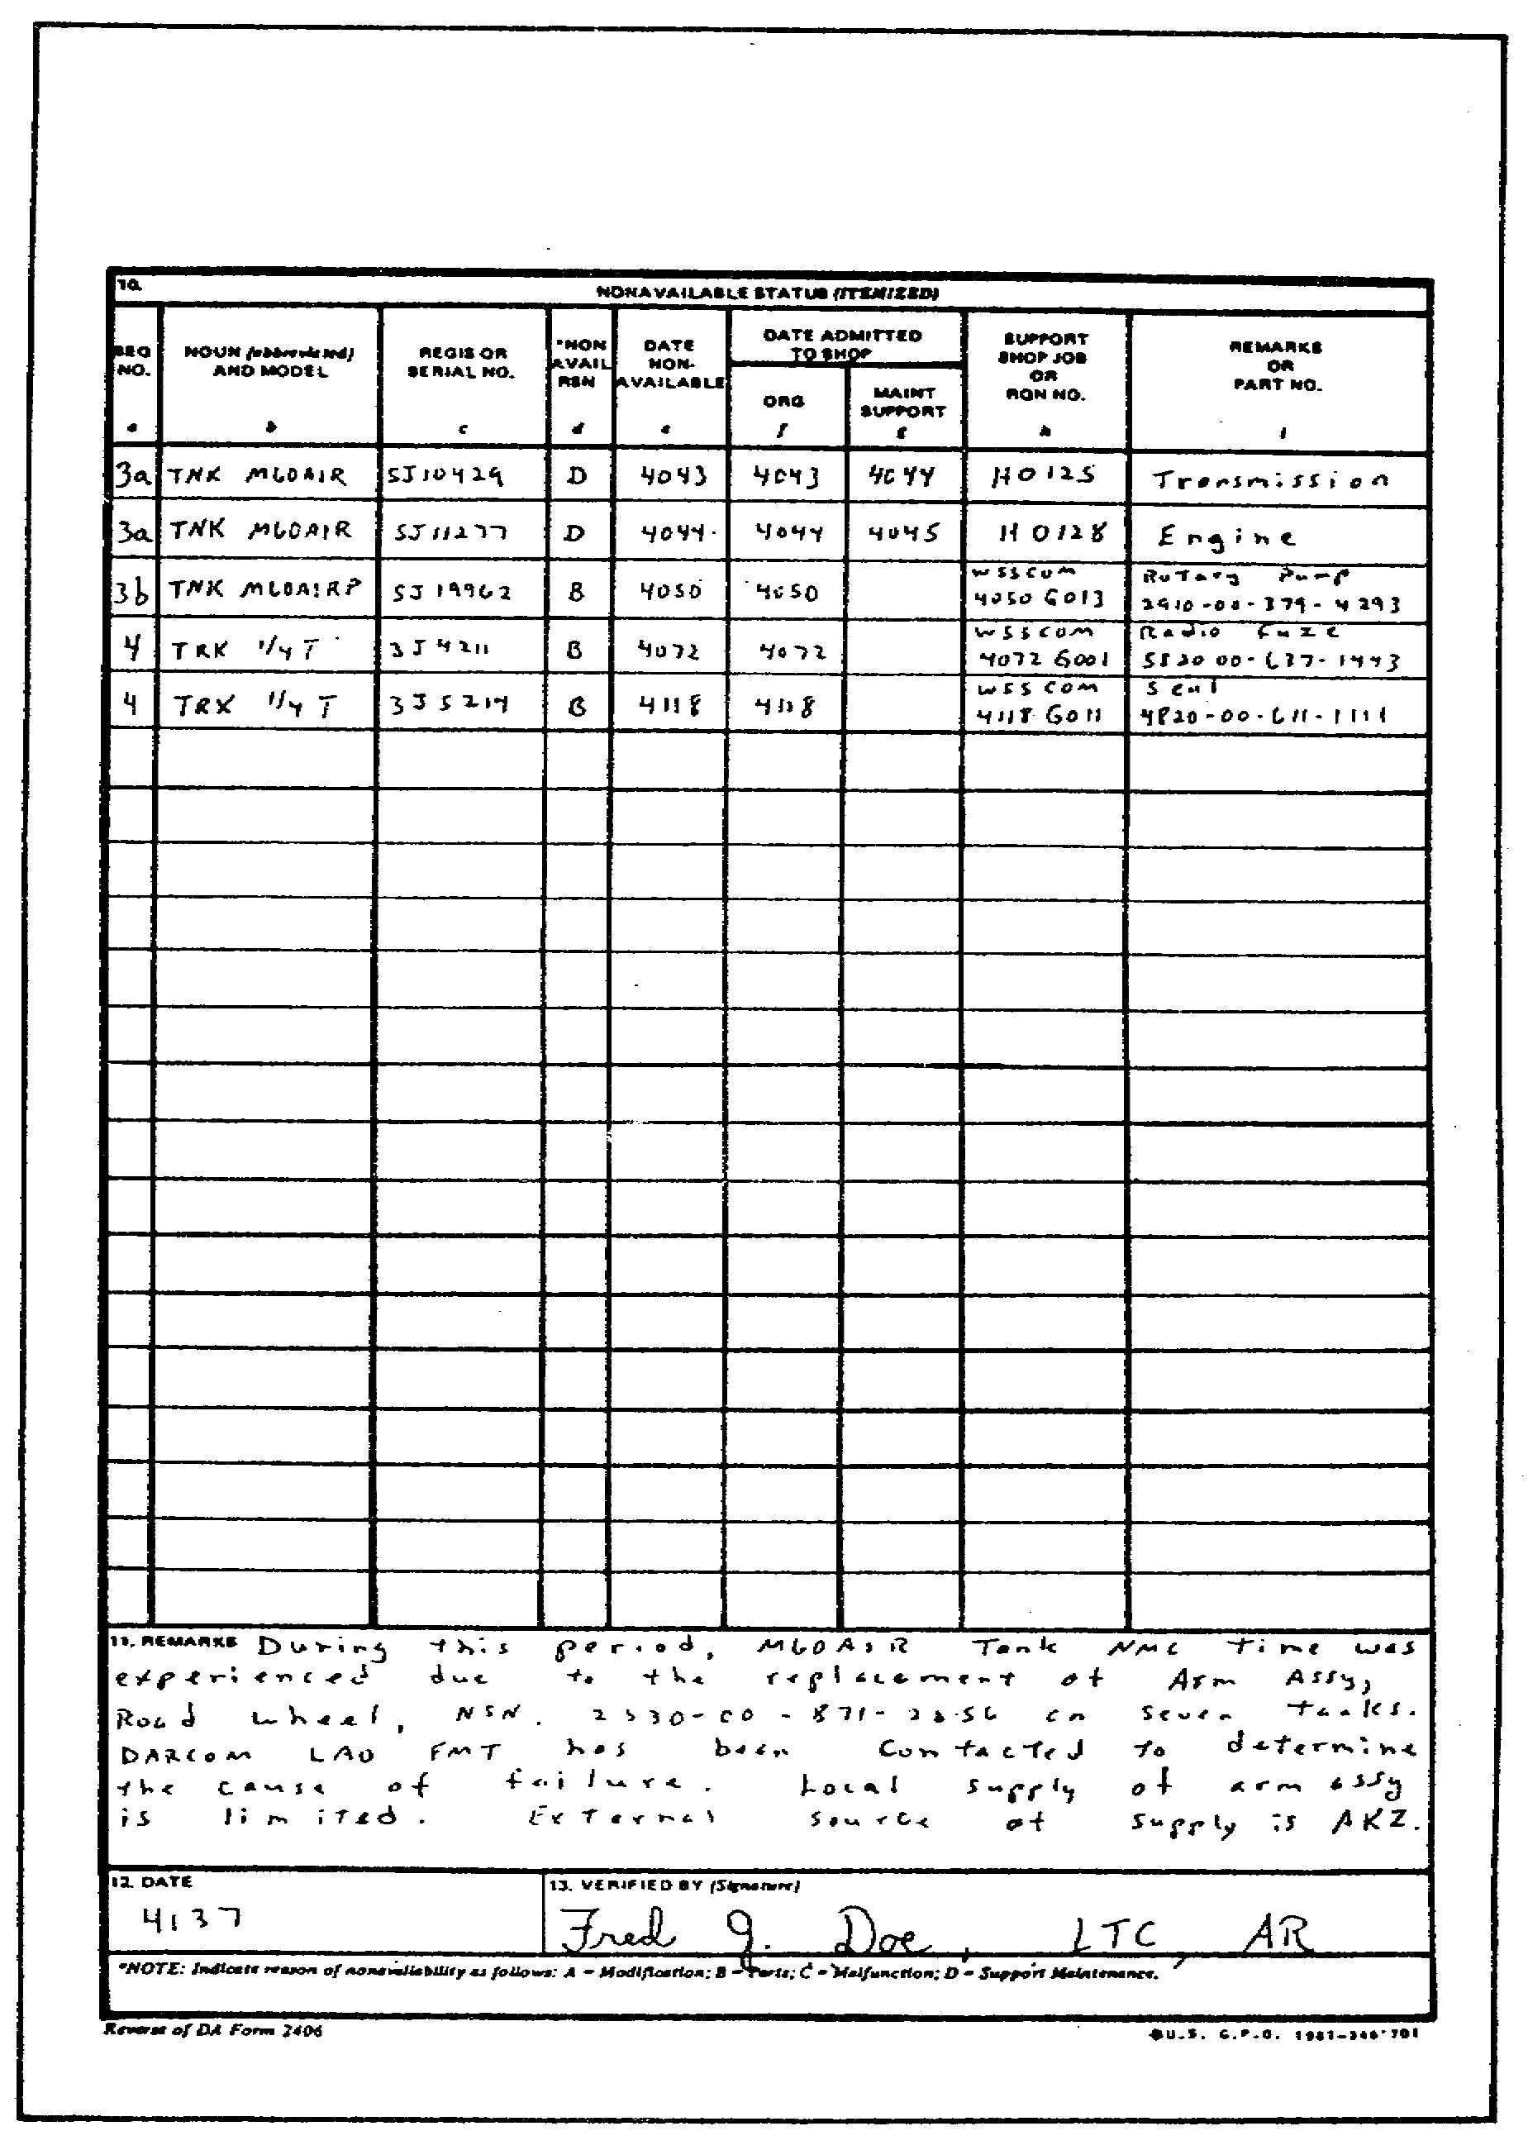

FIGURE 25. MATERIEL CONDITION STATUS REPORT
(DA FORM 2406) REVERSE SIDE.

146

OD0973 - Lesson 5/Practice Exercise 5

PRACTICE EXERCISE 5

INSTRUCTIONS

This practice exercise will show you how much you have learned in this lesson. Answer each question. When you are done, turn the page to check your answers.

SITUATION

You are the motor officer assigned to a unit level motor pool. You are expected to possess sufficient training to be able to supervise and manage all aspects of the motor pool and maintenance operations.

1. The commander has tasked you to brief him and all
section leaders on problem areas in the motor pool. What
are the four steps in preparing for and giving a briefing?

2. Your maintenance element has just completed a major
field training exercise. You are the After Action Review
(AAR) leader. Before opening the AAR, you take a roll call
and find that SP4 Laggard is not present. You send your
NCOIC to find him. Why is it important that all personnel
be present for an AAR.

3. You wish to have an impartial group conduct a courtesy
inspection of your equipment to determine its condition.
The most readily available source of qualified personnel to
perform this inspection would be a/an _____________________
___________________ ________________from the supporting DS
maintenance unit.

4. You have requested a Maintenance Assistance and
Instruction Team (MAIT) to evaluate the facilities and shop
layout of your new maintenance area. The equipment storage
area is located in a place that requires a security
clearance to enter. What staff element must you contact to
obtain security clearance for the MAIT personnel?

5. Your motor sergeant is preparing to conduct a class on
maintenance operations. He would like to have a large
diagram of a vernier caliper for use in his class. What
installation facility do you advise him to check for custom-
made training aids?

147

OD0973 - Lesson 5/Practice Exercise 5

6. Your motor sergeant is preparing the long-range training
calendar for the maintenance section. How many months in
advance should training be scheduled on this calendar?

7. You and your motor sergeant are training a group of new
drivers on preventive maintenance checks and services
(PMCS). The group is told that equipment operators/crews
are required to make _____________ , _________________ , and
operation checks on their assigned equipment.

8. You have noticed that PMCS is not being performed
properly on some of the equipment assigned to the motor
pool. You request that more command emphasis be placed on
PMCS. The unit commander starts visiting the motor pool and
checking random vehicles as they are dispatched. What type
of PMCS inspection is this classified as?

9. One of your maintenance personnel reports that a new
generator is defective. He informs you that the generator
is under warranty. You instruct him to tag the generator
with ___________________ to identify the item, pending the
warranty claim.

10. You have prepared an Uncorrected Fault Record (DA Form
2408-14) for a truck that is pending deferred maintenance.
Where should the DA Form 2408-14 be kept?

11. You are questioning a new dispatcher on what form he
would use to record the operators and the location of the
equipment on dispatch or in use. The correct answer he
should give is ____________________________ .

12. You have prepared DA Form 2407 to have higher
maintenance apply a Modification Work Order (MWO) to an Air
Defense Artillery (ADA) system. Higher maintenance has
already informed you that they have the MWO kit on-hand.
What copies of the DA Form 2407 do you forward to the
maintenance activity with the equipment?

13. One of your motor vehicle drivers has had an accident.
He prepared a Motor Vehicle Accident Report (SF 91) at the
scene of the accident. In reviewing the SF 91, you find
that several blocks do not have any entries. The driver
informs you that he was unable to obtain this information.
What entry should the driver have made in these blocks?

148

OD0973 - Lesson 5/Practice Exercise 5

14. As the motor officer, you are required to submit a
monthly Materiel Condition Status Report (DA Form 2406).
This report will cover a one month period ending the _____
day of each month.

15. While preparing the DA Form 2406 (Materiel Condition
Status Report), you must fill in the correct noun
nomenclature and model for each reportable item. The noun
nomenclature and model must be exactly as listed in what
publication?

149

OD0973 - Lesson 5/Practice Exercise Answers

LESSON 5. PRACTICE EXERCISE - ANSWERS

1. Analyzing the situation (page 97, para 1)
Constructing the briefing (page 97, para 8)
Delivering the briefing ·(page 100, para 1)
Follow-up (page 100, para 6)

2. The person missing may have the key bit of information
critical to reconstructing what happened. (page 104,
para 2)

3. Technical Assistance Team (page 105, para 6)

4. Battalion S2 (Intelligence) (page 110, para 7)

5. Training Aids Support Center (TASC) (page 116, para 3)

6. at least 12 months in advance (page 118, para 1)

7. before, during, and after (page 118, para 5)

8. Unit/Vehicle Commander Spot Check (page 120, para 12)

9. Exchange Tag (DA Form 2402) (page 123, para 2)

10. In the Equipment Record Folder or in a protective cover
(page 127, para 2)

11. DA Form 2401 (Organizational Control Record for
Equipment)(page 127, para 9)

12. All copies (page 130, para 5)

13. "Unknown" (page 138, para 6)

14. 15th (page 140, para 4)

15. AR 700-138 (page 143, para 11; and page 144, para 2)

If you had a hard time getting the right answers, go back and review the lesson. If you did well on this practice exercise, you should be ready to start the next lesson.

150

OD0973 - Lesson 6/Learning Event 1

LESSON 6

RECOVERY OPERATIONS

TASK

Describe the supervisory procedures used to monitor recovery operations.

CONDITIONS

You are assigned as the main support battalion motor officer in a command that has both wheeled and track vehicles assigned. Your unit is located in a battle area near enemy forces. As the motor officer, you incur an additional duty as the recovery manager, given the necessary references to perform your mission.

STANDARD

Demonstrate your comprehension of the task in accordance with FM 20-22 and FM 29-2.

REFERENCES

FM 20-22
FM 29-2

INTRODUCTION

Recovery is a critical part of unit maintenance operations. The commander organizes recovery resources to best support the unit mission and specific operations.

151

OD0973 - Lesson 6/Learning Event 1

Learning Event 1:
DESCRIBE THE SUPERVISORY PROCEDURES USED TO MONITOR RECOVERY PROCEDURES

RECOVERY

The word "recovery" defines the function of removal of equipment from the battlefield. Recovery is part of the repair process. The most important reasons for recovery are to:

o Return immobilized equipment to operation.

o Retrieve equipment for repair and return to use.

o Retrieve equipment so that it may be used as a source of repair parts through controlled exchange or cannibalization.

o Retrieve abandoned materiel for further use.

o Prevent enemy capture of materiel.

o Obtain enemy materiel for intelligence purposes or for use by U.S. or Allied forces.

Responsibility for Recovery

The using unit has recovery responsibility within its area of operations. This includes:

o Providing security against further damage.

o Decontaminating.

o Removing human remains and explosives.

o Arranging for recovery support for items beyond its organic support.

o Assisting in the repair or recovery effort.

The maintenance element is normally assigned the recovery mission since it has the heavy equipment to lift or to tow heavy items. The remainder of the unit is still responsible for recovering smaller items that do not require heavy equipment.

When unit maintenance is unable to accomplish recovery with unit resources, assistance is requested from intermediate direct support (IDS).

152
OD0973 - Lesson 6/Learning Event 1

Supporting IDS maintenance units provide backup recovery support. Their capability in this area, however, is limited.

Personnel

The unit authorization document is the basis for the number, MOS, and grade of unit recovery equipment operators. These personnel also perform as unit level mechanics. They assist in repair activities when not engaged in recovery operations.

Recovery personnel must be skilled in the technical aspect of recovery. They must also be skilled in related tasks, such as using the basic issue items (BII) on their equipment and operating in a tactical environment.

This includes using welding equipment and cutting torches. They must be familiar with the 50 cal. machinegun and the radio equipment on track recovery vehicles. They must also be able to use a map and compass to find disabled equipment. The tactical situation may require them to use smoke to screen the recovery operation from the enemy. They may have to wear chemical protective clothing, identify chemical agents, and decontaminate equipment.

Equipment operators and other unit mechanics should also be trained in recovery. This makes them better able to assist and perform recovery in an emergency.

Equipment

Assigned recovery equipment is determined by the unit's authorization document. In addition to wreckers and recovery vehicles, other items may be used for recovery. Some vehicles are equipped with a winch. A like or heavier vehicle may be used to extricate or tow another. Other vehicles or equipment, such as heavy engineer or quartermaster items, may be available. Field expedient devices may be fabricated to assist in some types of recovery.

Command and Control

The unit commander establishes procedures for recovery operations. These are normally included in the SOP.

Recovery assets are centrally managed. In combat units, a recovery manager, normally the battalion motor officer (BMO), is appointed at the battalion level. In other units,

153

OD0973 - Lesson 6/Learning Event 1

the motor sergeant may perform this function. Central management is important for support of combat operations since recovery and repair must be coordinated.

The recovery manager controls the operations based on guidance from the unit commander. Duties include identifying recovery missions, developing recovery plans, and directing their execution.

At times, mainly in peacetime, the commander may delegate management control of recovery operations after normal duty hours to the staff duty/officer or other personnel. Detailed procedures should be spelled out in the unit SOP.

Communications

Communications are vital to the success of the recovery mission. Track recovery vehicles have an organic radio. Portable radios or radio-equipped escort vehicles may be used to support other operations. When communications equipment is not available, the recovery team must depend on the supported unit or other nearby units for support. Use of commercial communications systems should not be excluded, when available.

Recovery Management

The recovery manager must integrate recovery operations into the overall support effort. To do this, informal charts may be used to provide visibility to the recovery situation.

Recovery Equipment Status. The recovery manager must know the status of the battalion's recovery equipment. Figure 26, on the next page, is a sample status chart. The "Bumper Number" and "Type Equipment" should list all recovery assets in the unit. A mission number is entered when equipment is committed to a specific recovery.

Recovery Log. Centralized control of recovery operations requires control of recovery requests and operational information. A sample control log is shown in figure 26.

The log provides space for information about the recovery requests and operations. The mission number should be controlled by the recovery manager and entered only after the mission is accepted. If self-or like-vehicle recovery

154

OD0973 - Lesson 6/Learning Event 1
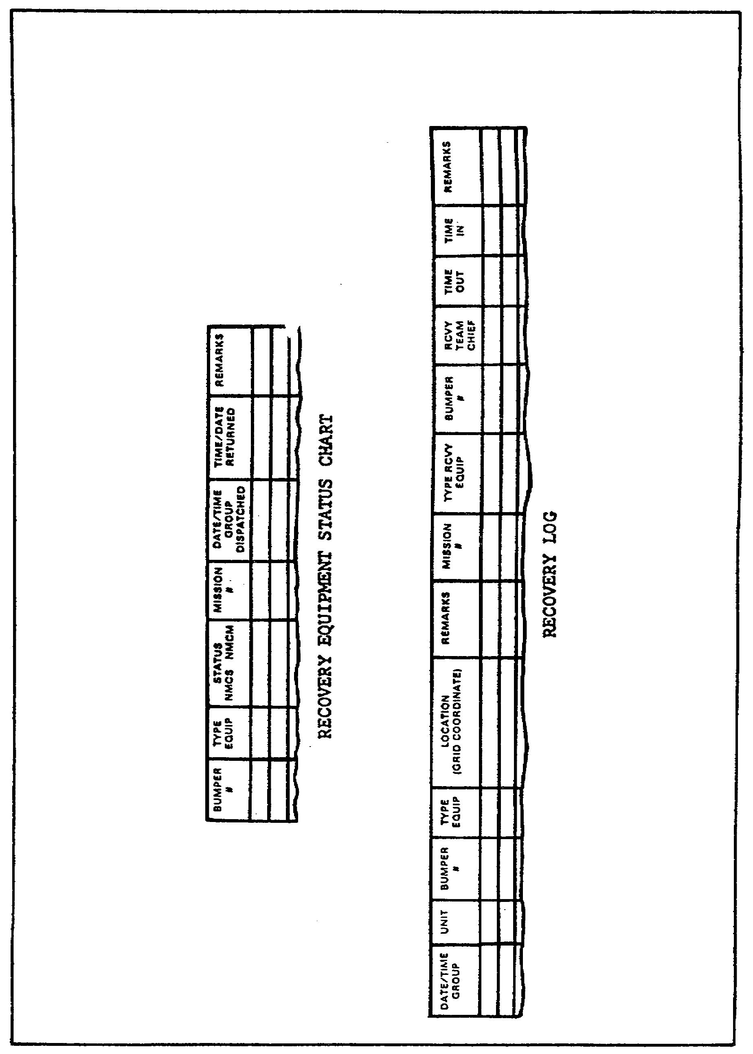

FIGURE 26. EQUIPMENT STATUS CHART
AND RECOVERY LOG.

155

OD0973 - Lesson 6/Learning Event 1

is performed, appropriate remarks should be entered in the Equipment Type" column. The "Remarks" column should explain refused recovery requests. Some units may adapt DA Form 2401 for use as a control log.

RECOVERY PROCEDURES

Technical aspects of recovery are contained in FM 20-22. The recovery manager coordinates recovery operations. He must integrate recovery operations with the overall repair effort to best support the commander's priorities and the tactical situation. The goal is timely return of equipment to operation with the least expenditure of resources.

Recovery Principles

The following general principles apply to recovery operations:

o The using unit is responsible for recovery of its disabled equipment. When it lacks the physical means to recover an item, assistance is requested from the supporting maintenance element.

o Management of recovery operations is centralized at battalion level wherever possible. This does not preclude delegation of recovery authority for specific operations to company maintenance teams.

o The commander organizes the recovery resources to best support the unit's mission. Changes in the type and quantity of supported equipment, as well as the tactical situation, may require reorganization of the recovery assets.

o Recovery operations must be coordinated with the maintenance effort. Maintenance personnel repair equipment as far forward as possible. This is determined by the tactical situation, amount of damage, and the available resources. Maintenance time guidelines are used for making repair-or-recover decisions. The estimated repair time helps to determine the maintenance activity to which the item should be recovered. These maintenance time guidelines are usually set by SOP or by the combat and combat services support commanders involved.

o A 24-hour capability is required. Both peacetime and wartime operations require continuous, responsive, recovery support. Where applicable, roadside breakdown responsibility

156

OD0973 - Lesson 6/Learning Event 1

may be rotated among maintenance units on an area basis, to provide recovery support beyond unit capability.

o The proper recovery equipment should be used for the recovery mission. Wreckers usually recover wheeled vehicles. Track recovery vehicles recover track equipment. Selecting the proper recovery vehicle for the mission may become critical when supporting an increasing work load with limited recovery assets.

o Recovery vehicles should not return equipment further to the rear than necessary. This keeps recovery vehicles available in the forward areas. IDS units should use heavy equipment transporters to evacuate heavy items received from using units.

o Accurate location information must be provided to the recovery manager and crews. Ground guides may be required when specific location information is not available, or where the tactical situation is not well defined.

o Multiple recovery involves towing more than one disabled vehicle at a time. Route selection for towing of multiple vehicles is important. Safe operation requires that the combined load does not exceed the recovery vehicle's braking ability on a steep grade.

o If a recovery mission might interfere with combat operations, or compromise security, it must be coordinated with the tactical commander involved.

o When recovery assets are limited, the commander must set recovery priorities. These will depend on the commander's need for the item and on the tactical situation. The type of disability will also affect the priority when two or more like items must be recovered. In general, combat vehicles will be recovered before tactical vehicles.

The following priority sequence will usually provide the maximum return for the recovery effort expended:

1. Classified items.

2. Terrain stuck items.

3. Items with failed or damaged components needing little repair.

4. Items requiring long recovery and repair times to return them to service.

5. Contaminated items.

157

OD0973 - Lesson 6/Learning Event 1

6. Uneconomically repairable items.

7. Enemy materiel.

o Local alternative options should be considered and tried before a recovery mission is initiated. Field expedient repair and self-or like-vehicle recovery may do the job without a recovery vehicle.

o Recovery support may be provided on a unit or area basis. Using units usually provide support on a unit basis. Maintenance units may have an area support mission for unit backup support and for out-of-sector units operating in the area.

Initiation of Recovery

Action to recover the vehicle begins at the location the item became disabled. When the equipment operator/crew detect an inoperable condition, they assess the damage. They will initiate action based on their analysis of the damage and the tactical situation.

The request for assistance must provide enough information for the maintenance element to develop a plan of action. Information required usually includes:

o Unit identification.

o Equipment identification.

o Location (map coordinates when possible).

o Nature of disability.

o Evaluation of on-site repair capability.

o Repair parts required.

o Organic recovery capability.

o Tactical situation and security requirements.

o Recommended route of approach.

The operator/crew normally remains with the equipment, if the tactical situation permits. When maintenance personnel arrive, the operator/crew assist in the repair or recovery operation. They should stay with the vehicle until it reaches support maintenance. Further operator/crew

158

OD0973 - Lesson 6/Learning Event 1

disposition is then provided by higher headquarters weapons systems replacement operations.

Repair and/or Recovery Plan

The battalion recovery manager develops a plan of action for the disabled item, based on the request for assistance. He reviews the tactical situation, work load, and the availability of maintenance and recovery personnel. He then assigns a priority to the recovery mission.

When the extent of damage cannot be determined, the maintenance element usually plans a recovery mission. In this case, they will also send along a maintenance team to attempt on-site repair.

The team takes along required special tools, test equipment, repair parts, nuclear, biological and chemical (NBC) defense items, and communications equipment. Recovery equipment with the team supports operations and performs recovery if on-site repairs cannot be done.

When security is required by the recovery/maintenance element, it is normally provided by the supported unit. Ground guides from the using unit should be requested when the location of the disabled vehicle is in question.

Conduct of Repair and/or Recovery

The repair and/or recovery plan guides the support to be provided. Repair and recovery personnel usually work in close coordination and most often are members of the same maintenance team.

Preparing for On-Site Support. The BMO assigns the repair or recovery mission to a maintenance team. The unit SOP should contain detailed checklists to assist in preparing for on-site support. Preparations should include:

o Verification of location and status of the disabled equipment.

o Update on the current tactical situation, special security, NBC requirements, and road and movement restrictions.

o Selection of primary and alternate routes.

159

OD0973 - Lesson 6/Learning Event 1

o Availability of communications and communication requirements.

o Individual clothing and equipment, including NBC items.

o Basic load of rations and ammunition.

o Additional decontamination equipment for decontamination of the disabled vehicle, if required.

o Selection of appropriate support equipment, vehicles, and personnel for the mission.

o Serviceability and readiness of support equipment.

o Repair parts and supplies.

o Applicable special instructions.

The unit SOP governs the tactical movement of the teams to the disabled vehicle site.

On-Site Support. The tactical situation influences on-site repair and recovery operations. When the disabled vehicle is subject to enemy observation and fire, it must be moved to a secure location. Smoke may be used to screen this combat recovery operation. When use of smoke may bring undue enemy attention, or interfere with friendly tactical operations, it must be coordinated with the tactical unit commander.

Abandoned or unmanned equipment requires special precautions. Before repair or recovery can begin, the item should be checked for contamination and booby traps. Weapons must be boresafe and not subject to accidental discharge. Maintenance personnel should be trained to recognize booby traps. When booby traps are suspected or found, the supporting explosive ordnance disposal (EOD) unit must be requested to make the item safe. Maintenance personnel should also be trained in disarming the weapons systems of the supported equipment. Assistance in making the weapons boresafe may be requested from tactical units familiar with the equipment.

When chemical contamination is possible, personnel must be in full mission-oriented protective posture (MOPP). If the item is contaminated, the team may perform partial decontamination. This is accomplished using equipment and supplies from the disabled vehicle, or with materials brought along for this purpose. If decontamination is

160

OD0973 - Lesson 6/Learning Event 1

beyond the team's capability, assistance may be requested from the owning unit or the supporting chemical defense unit.

When the item has been made safe, the maintenance team proceeds with the maintenance operation. The equipment is inspected to assess the damage, and determine repair or recovery requirements. The original plan of action may have to be modified, based on their findings. Once repair requirements have been determined, the BMO is informed of the situation and the item is scheduled for repair. On-site repair may be possible by sending forward additional parts or personnel. The recovery destination may need to be modified. When communication is not possible, the team proceeds with the original plan, or modifies it based on judgment and unit SOP.

Recovery. Maintenance teams normally recover equipment to the battalion unit maintenance collecting point (UMCP). Recovery to the supporting maintenance unit is possible; however, this should be done only if the item cannot be repaired at the UMCP by IDS maintenance support team (MST) personnel.

The recovery destination is influenced by many factors. Among them are the tactical situation, the need for recovery vehicles, work load, maintenance resources at the UMCP, and the extent of repairs required. Maintenance time guidelines are used with these factors to decide which maintenance activity can repair as far forward as possible using the least amount of maintenance resources.

The same tactical procedures are used for moving to the designated maintenance activity as for reaching the disabled vehicle. Recovery personnel should periodically check the rigging and equipment for proper adjustment. Special attention must be given to clearance and weight limitations when using underpasses and bridges.

Peacetime Operations

On-site operations during peacetime must place special emphasis on safety. The disabled item may frequently be on the roadside and present a hazard to normal traffic. Devices to warn oncoming traffic are essential. The operator/crew should leave the vehicle and wait for assistance off the shoulder of the road. Based on the size and weight of the equipment involved, the recovery effort may be subject to road restrictions. Traffic control assistance from civilian authorities may be necessary.

161

OD0973 - Lesson 6/Learning Event 1

SPECIAL CONSIDERATIONS

The recovery manager must be alert to new situations and changing requirements. Planning and prior preparation are needed for continued effective recovery support. Specific procedures developed by individual units should be part of the unit SOP.

Impact of NBC Operations

Recovery operations are more difficult when personnel may be exposed to NBC attack, or have to deal with contaminated equipment. The unit commander, recovery manager, and crew, should consider the following when preparing to conduct operations in an NBC environment:

o Operations in full Mission Oriented Protective Posture (MOPP) are very time consuming. Additional time must be programmed by the manager. Heavy work in full MOPP requires up to three times the normal amount of time.

o Automatic chemical alarms on vehicles do not react fast enough to prevent passengers from being exposed to the agent. Therefore, vehicle movement in an NBC environment is usually done in full MOPP.

o Recovery crews should have extra protective clothing. They should also have extra decontamination apparatus, nitrogen cylinders, super tropical bleach, and DS2 decontamination compound. Decontamination powder should be kept in a shuffle box on the recovery vehicle to avoid tracking contamination into the vehicle.

o Recovery personnel should avoid getting grease, oil, and fluids on their protective clothing. Wet weather gear, fuel handlers' aprons, and rubber sleeves may help; however, the heat build-up is greatly increased.

o Recovery teams should be well trained in the technical aspects of recovery operations. This allows them to complete the recovery while contacting the contaminated vehicle as little as possible.

o Units operating in an uncontaminated area should establish NBC inspection points. These points will monitor recovered equipment entering the area. Contaminated vehicles should be processed through a decontamination station.

o Recovery crews should know the procedures for changes in the MOPP and the rate of work. When there is no

162

OD0973 - Lesson 6/Learning Event 1

immediate threat, a reduction in the protection level may be considered.

o STANAG 2002 and FM 21-40 provide guidance for marking contaminated areas. No standardized marking system presently exists for contaminated equipment. Contamination information, especially for abandoned equipment, is very important to recovery personnel. The recovery manager and recovery personnel must find out what type of equipment marking is in effect.

Support of Offensive Operations

Offensive operations involves rapid movement and maneuver. The tactical situation is dynamic and subject to change.

Recovery support must be included in the maintenance support plan for the operation. The recovery manager must assess the situation and determine the recovery support required.

The recovery work load may increase during the support of offensive operations. Success in the operation may lead to exploitation and pursuit, with sustained rapid movement and equipment scattered over a wide area.

Command, control, and communications are difficult during offensive operations. In rapidly changing situations, maintenance and/or MSTs, including recovery crews, may be attached to combat elements.

Recovery is simplified when combat and supporting maintenance elements are moving in the same direction. Disabled vehicles can be recovered to the main supply routes to wait for maintenance personnel. When this is done, security must be provided for the disabled item. Accurate location information should be provided to the supporting maintenance element.

Support of Defensive Operations

Defensive operations are not usually as scattered or mobile as offensive operations. Support is more centralized. Command, control, and communications are simplified.

Static Defense. Position defense and other static defense operations reduce movement and maneuver. Maintenance and recovery requirements are normally reduced and more time is available. When supporting a static defense situation, recovery managers should anticipate requirements. They
163

OD0973 - Lesson 6/Learning Event 1

should know the location of friendly forces and likely enemy avenues of approach. This will allow the manager to develop plans for recovery support. These plans should include alternate recovery routes against unexpected changes in the tactical situation.

Area or Dynamic Defense. An area or dynamic defense requires movement and maneuver by the defending force. From a recovery standpoint, the situation is similar to offensive operations and the recovery workload may increase. The maintenance element, to include recovery crews, may move more often. This reduces the time available for recovery operations.

Recovery of Foreign Materiel

Technical recovery procedures for foreign and U.S. materiel are the same. The unit commander in the area the item is found has recovery responsibility. The following considerations apply:

o Abandoned enemy equipment may be booby trapped. Explosive Ordnance Detachment (EOD) or technical intelligence personnel may be required to disarm enemy items and weapons systems.

o Disposition guidance for enemy materiel should be provided by the supporting military intelligence element. The unit SOP should contain automatic disposition instruction for common items. It should also identify items to be reported for technical intelligence evaluation. Enemy equipment is usually reported through intelligence channels.

o Enemy materiel may be recovered to an UMCP, supply activity, or the technical intelligence element. Disposition is based on instructions from the military intelligence element.

Communications Security

Communications equipment should be used as little as possible during combat recovery. Every time a radio is used, it sends out a signal. The enemy can use those signals to locate specific areas without even reading the message. If a radio is required, use it carefully. Know what must be said before keying the microphone.

164

OD0973 - Lesson 6/Learning Event 1

You have now completed this lesson on equipment recovery procedures. You should have the information necessary to perform the duties of a battalion recovery officer, or a unit motor officer that has been assigned recovery responsibilities.

Now you should be ready to take the practice exercise on the next page. If you have problems with any of the questions, review the text and repeat the exercise.

165

OD0973 - Lesson 6/Practice Exercise 6

PRACTICE EXERCISE 6

INSTRUCTIONS

This practice exercise will show you how much you have learned in this lesson. Answer each question. When you are done, turn the page to check your answers.

SITUATION

You are assigned as the motor officer for a main support battalion. Your unit is presently supporting combat elements of an mechanized infantry brigade. One of your additional duties is to function as the recovery manager for your unit's area of operation (AO).

1. You have made an inventory of all recovery assets
available to you. Some of these assets are presently
deadlined and undergoing maintenance. How can you keep
track of what vehicles are available for recovery missions?

2. One of your mechanics requests information on how
he can learn about recovery operations. You inform him
that the technical aspects of recovery are located in
__________________ .

3. You have received a call to recover two small vehicles
from the battlefield, but you only have one recovery vehicle
available to do the job. When considering multiple
recoveries, you must determine if the combined load will
exceed the recovery vehicle's _______________ ________________
on a steep grade.

4. You have received calls to recover a combat vehicle and
a tactical vehicle. You only have sufficient recovery
assets available to recover one vehicle at a time. Which
vehicle should be recovered first?

5. During a major operation, you have received numerous
requests for recovery of combat vehicles. You must assign
priorities to the following missions: (1) a tank stuck in
a ravine, (2) an enemy personnel carrier with minor damage,
(3) a self-propelled howitzer with minor damage, and (4) a

166

OD0973 - Lesson 6/Learning Event 1

self-propelled rocket launcher with possible NBC contamination. What priority would you assign to these four vehicles for recovery?

6. You have received a request for recovery of an abandoned
tracked vehicle. You inform-the recovery crew to take
special precautions before beginning recovery operations.
Abandoned or unmanned equipment should always be checked for
______________________ and __________ ____________ .

7. You have received notice that NBC contaminants may have
been used in the area. You issue the order that all
recovery operations will be performed in full MOPP. You
must adjust your recovery schedule because heavy work in
full MOPP requires up to _____________ times the normal
amount of recovery time.

8. You have just recovered an enemy vehicle that had been
abandoned on the battlefield. Who should be contacted for
disposition guidance for this vehicle?

167

OD0973 - Lesson 6/Practice Exercise Answers

LESSON 6. PRACTICE EXERCISE - ANSWERS

1. Use an Equipment Status Chart (page 154, para 6)

2. FM 20-22 (page 156, para 2)

3. braking ability (page 157, para 5)

4. the combat vehicle (page 157, para 7)

5. Priority 1----the tank stuck in the ravine

Priority 2----the self-propelled howitzer with minor damage

Priority 3----the self-propelled rocket launcher with possible
NBC contamination

Priority 4----the enemy personnel carrier with minor damage
(page 157, para 8)

6. contamination and booby traps (page 160, para 11)

7. three (page 162, para 3)

8. the supporting military intelligence element
(page 164, para 5)

If you had a hard time getting the right answers, go back and review the lesson. If you did well on this practice exercise, you should be ready to take the exam.

168

